|  |  |
| --- | --- |
| **Asian Development Bank** | **Government of Vietnam**  **Ministry of Natural Resources**  **and Environment** |

**TA7629-VIE: Capacity Building for River Basin Water Resources Planning**

**Component 2: Planning Tasks for the Red-Thai Binh River Basin**

**REFERENCE DOCUMENT**

**Guidelines on the use of Water Resource Indicators for the preparation of a Status Report for a River Basin**

Prepared for**:**

**The Department of Water Resources Management on behalf of the Government of Viet Nam and the Asian Development Bank**

Prepared by

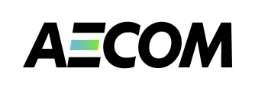**AECOM Asia Co. Ltd.**

**April 2013**

**Acknowledgments**

This component of *CDTA 7629-VIE: Capacity Building for River Basin Water Resources Planning* supports the Ministry of Natural Resources and Environment in undertaking activities related to the preparation of planning tasks for the management of water resources of the Red-Thai Binh river basin. Planning tasks are prescribed in the revised Law on Water Resources and precede the formulation of a Water Resources Plan. Planning tasks make prioritised recommendations and a framework for the preparation of river basin planning. The CDTA also aim to develop and pilot a cost-effective framework for formulating planning tasks that could be replicated in other basins of Viet Nam.

The contributions to this report are acknowledged: Des Cleary (Water Basin Planning Expert (International), who led the preparation of the report), Ms. Nguyen Thi Phuong Lam (Deputy Team Leader), and Dr. Eric Biltonen (TA Team Leader, lead editor and finalization).

**Limitations Statement**

The sole purpose of this report and the associated services performed by AECOM is to set out guidelines for the use of water resources indicators in preparing a Status Report for a river Basin, as part of undertaking river basin planning tasks as set out in Law on Water Resources; and in accordance with the scope of services set out in the contract between AECOM and ADB.

AECOM’s consultant prepared this report primarily based on the Terms of Reference provided by the ADB and an inception report prepared by consultants engaged by the ADB to lead the TA. The passage of time may require re-evaluation of the findings, proposals and conclusions expressed in this report.

No warranty or guarantee, whether express or implied, is made with respect to the information reported or to the findings, observations and conclusions expressed in this report. Further, such information, findings, observations and conclusions are based solely upon information in existence at the time of report preparation.

**TA7629-VIE: Capacity Building for River Basin Water Resources Planning**

**Component 2: Planning Tasks for the Red-Thai Binh River Basin**

**Guidelines on the use of Water Resource Indicators for the preparation of a River Basin Status Report**

**TABLE OF CONTENTS**

1. INTRODUCTION 5

2. The Indicators 7

3. SURFACE WATER RESOURCES INDICATORS 10

3.1. Water Distribution Indicators 10

Data sources and comments 12

3.2. Dry Season Water Indicator 13

3.3. Effects of the Dry Season on water resources 14

3.4. Effects of infrastructure: dams and inter-basin diversions 16

Explanation of the infrastructure indicators – reservoir and inter-basin diversions 16

Data sources and comments 19

3.5. Water Availability Indicators 20

Explanation of Water Availability Indicators 21

Data sources and comments 22

3.6. Water Exploitation Indicators 23

Explanation of water exploitation indicators 23

Composite graphs for integrated analysis 26

Data sources and comments 29

3.7. Flood Indicator 30

Explanation of flood indicators 30

3.8. Climate change Indicators 31

Explanation of climate change indicators 31

4. Groundwater Indicators 32

Explanation of groundwater indicators 32

Data sources and comments 41

5. Social Development Indicators 42

5.1. Population Indicators 42

Explanation of Population Indicators 42

Data sources and comments 44

5.2. Poverty and employment indicators 45

Explanation of poverty, ethnicity and employment indicators 45

Data sources and comments 47

5.3. Water related services indicators 48

Explanation of water related services indicators 48

Data sources and comments 51

5.4. Water related disaster indicators 51

Explanation of water related disaster indicators 51

Data sources and comments 52

6. Economic Indicators 53

6.1. GDP Indicators 53

Explanation of GDP indicators 53

Data sources and comments 55

6.2. Subsector economic indicators 56

Explanation of subsector economic indicators 56

Data sources and comments 61

7. Environmental indicators 62

7.1. Conservation and land use indicators 62

Explanation of conservation and land use indicators 62

Data sources and comments 64

7.2. Water flow indicators 65

Explanation of water flow indicators 65

Data sources and comments 67

7.3. Water quality indicators 68

Data sources and comments 72

8. Water Management Indicators 73

8.1. Basic survey indicators 73

Explanation of basic survey indicators 73

Sources of data 75

8.2. Licensing indicators 76

Explanation of licensing indicators 76

Data sources and comments 77

8.3. Environmental instrument indicators 77

Explanation of Environmental instrument indicators 77

Data sources and comments 82

8.4. Efficient service provision indicators 82

Explanation of efficient service provision indicators 82

Data sources and comments 83

8.5. Capacity indicators 83

Explanation of capacity indicators 83

Data sources and comments 85

Appendix: Summary Explanation of indicators 86

**ABBREVIATIONS**

|  |  |  |
| --- | --- | --- |
| ADB |  | Asian Development Bank |
| DoNRE |  | Department of Natural Resources and Environment (Provincial) |
| DWRM |  | Department of Water Resources Management (MoNRE) |
| EIA |  | Environmental Impact Assessment |
| EVN |  | Electricity Viet Nam |
| GDP |  | Gross Domestic Product |
| GSO |  | General Statics Office (of Viet Nam) |
| GWh |  | Gigawatt hour |
| HCMC |  | Ho Chi Minh City |
| IWRM |  | Integrated Water Resources Management |
| MARD |  | Ministry of Agriculture and Rural Development |
| MDG |  | Millennium Development Goals |
| MoC |  | Ministry of Construction |
| MoH |  | Ministry of Health |
| MoLISA |  | Ministry of Labour, Invalids, and Social Affairs |
| MoNRE |  | Ministry of Natural Resources and Environment |
| NGO |  | Non-Government Organisation |
| NWRC |  | National Water Resources Council |
| RTBRB |  | Red-Thai Binh River Basin |
| SoE |  | State of Environment |
| SPP |  | Stakeholder Participation Plan |
| TA |  | Technical Assistance |
| VEA |  | Viet Nam Environment Administration (MoNRE) |
| VND |  | Vietnamese Dong |
| VWSA |  | Viet Nam Water Supply and Sewerage Association |
| WASECO | | Water Supply and Sewerage Companies |
| WHO |  | World Health Organization |
| WSR |  | Water Sector Review |

**TA7629-VIE: Capacity Building for River Basin Water Resources Planning**

**Component 2: Planning Tasks for the Red-Thai Binh River Basin**

**Guidelines on the use of Water Resource Indicators for the preparation of a Status Report for River Basin**

# INTRODUCTION

These guidelines are intended to assist water resources planners in the calculation and interpretation of Water Resource Assessment Indicators developed in support of the formulation of Planning Tasks for Water Resources Planning.

Planning Tasks are established under Article 20 of the 2012 Law on Water Resources (LWR), and are intended to be undertaken as a rapid assessment of the river basin to develop a framework for more detailed river basin planning. The planning tasks play a critical role in river basin planning, so they must 1) be based on good information to ensure that planning efforts are focused on the most important issues and 2) be designed to provide the necessary guidance to satisfy the required contents of the river basin plans. Planning Tasks focus on high level issues, objectives, and solutions. According to Article 20 of the LWR, planning tasks will contain:

* An overall assessment of the natural, economic and social conditions, the status of water resources, situation of the protection, exploitation, and use of water resources, prevention, combat against and overcoming of the harms caused by water.
* A preliminary definition of the functions of water sources, the needs for water supply and water drainage, issues to be addressed in the protection, exploitation, and use of water resources, prevention, combat against and overcoming of the harms caused by water.
* A definition of the subjects, scope and contents of the plans in order to achieve the water resources objectives and solve the identified issues.
* Propose general solutions, funds, plan and schedule of the formulation of planning.

Planning tasks should set on a preliminary basis both long term outcomes for the river basin (vision, water sources functions, and objectives) and also five-year targets for overall water management. This is based on a principle of continuous improvement in water resources management and on the social and economic benefits the community receives from its water sources and their dependent ecosystems.

A key component for formulating the Planning Tasks is the development of the Status Report. The status report provides a status summary of the key water resource and management issues for river basin. The main aim of Planning Tasks is to prepare “terms of reference” for the preparation of a river basin water resources planning activity as relevant to MONRE’s management function, but not to do an overly detailed, comprehensive analysis. That is, a status report helps to build a framework for in-depth river basin planning

The assessment indicators allow for a systematic analysis of key issues in each sub-basin, as well as allow sub-basin comparisons and progress tracking over time. The indicators allow a uniform analysis across sub-basins. These guidelines focus on the calculation and interpretation of a set of Assessment Indicators that provide the bulk of that analysis for the status report.

There are many activities involved in the formulation of the planning tasks. These activities are designed to provide the data and information (INPUTS) necessary to develop the Planning Tasks (OUTPUTS), as shown in Figure 1‑1. The Planning Tasks provide the framework for the full water resources planning for river basins. The river basin planning is necessary so that water resources are effectively managed for the mutual benefit of all stakeholders with an eye for balancing the interests of different sector, different areas, and different users. This is especially necessary when water resources are not available in sufficient quantities and quality to meet all demands. Planning provides water resource policy decision makers and managers with sound information and analysis to make well-informed decisions to meet current and future challenges. Without planning, water management will lack purposeful direction and may possibly cause harm to the people who depend upon the water resources.

**Planning Tasks**

**INPUTS for Planning Tasks**:

* Physical data: topography, river, water…
* Socio-economic data
* Sector water use data: agriculture, industry, hydropower, aquaculture, navigation
* Eco-environmental data: fauna, flora, water quality, conservation…
* Water resources management data
* Others

**OUTPUTS of Planning Tasks**:

* Main issues and priority
* Agreed overall objectives and general solutions
* Provide framework and plan of activities for managing of river basin (water allocation plan; water protection plan; natural hazard plan – what, scope and context)
* Prepare TOR for river basin planning

**Water resources/river basin planning:**

* To assess natural and socio-economic conditions and status of water resources to forecasting future condition
* To identify objectives for water allocation, protection and natural hazards
* To establish strategy/solutions – what need to be done to achieve the objectives
* To establish specific measures and rules for management of river basin

**Water Resources Planning for economic SECTORS**

**Water Resources Planning for provinces and centrally run Cities**

Figure 1‑1: Formulation of Planning Tasks and River Basin planning cycle

# The Indicators

A set of indicators has been developed to assess the basin and sub-basins. The assessment indicators have previously been shown to be both effective and appropriate for the Viet Nam context.[1] The indicators make use of existing available data and information and allow a standardised method of analysis that may be applied in other basins. They may be reapplied in the future to assess progress.

The indicators are summarised as follows

(i) Water Resources (18 indicators): quantity, international linkages, dry season effects, water use, water storages, flooding effects, and climate change effects.

(ii) Groundwater (13 indicators): groundwater recharge, availability, water use, water level drawdown, and groundwater quality.

(iii) Economic (12 indicators): GDP, economic structure, sector production (industry, agriculture, irrigation, hydropower, navigation), and economic value for water use.

(iv) Social (13 indicators): population, population structure, poverty, ethnicity, employment, water services (clean water, sanitation), and flood impacts.

(v) Environment (12 indicators): vegetation cover, biodiversity, conservation areas, cultural heritage areas, natural river flows, water quality, and river obstructions.

(vi) Management (16 indicators): basic survey (surface water, groundwater, water quality, environment, licensing, application of Government decisions (Decision 64, Decree 67), use of EIA, inspections, and efficient service provision.

The indicators illustrate the current situation and some future projections. Data and information obtained from the General Statistical Office of Statistics forms the core data sets, such as population, area, GDP, etc.; although, other data sources are used as needed and available. Data should be checked to ensure that they are current and accurate. For formulation of the planning tasks, absolute accuracy is not essential and data and information collection efforts should be appropriate with the available time line and budgets. The data only need to be able to illustrate an indicative idea of the magnitude of issues and challenges, and the relativity of the issues between sub-basins.

Assessment Indicators are intended to act as a policy tool that can assist with the identification and analysis of key issues that deserve greater attention within national and provincial water management programs. The indicators help to identify sub-basins that are at a critical stage for a particular issue. This information is useful in identifying management priorities, potential options for water resources planning, and issues for each sub-basin that might benefit from increased investment and management attention.

The Indicator Guidelines describe in detail:

1. How each indicator is defined;
2. How to calculate each indicator, including the required data;
3. How the results are interpreted; and
4. The implications of each indicator for the planning tasks.

A summary table of all indicators is provided in Appendix 1. Planners should study these indicators to understand the information that will come from such analysis. Planners should also consider whether additional indicators may be useful to analyse a particular issue in a river basin. Ultimately, the planners must select which indicators they actually wish to use.

To aid the reader in developing an understanding of the indicators, examples using a fictitious river basin have been created to illustrate the use of each indicator and how it may be interpreted. **Please note that the examples are not based on a real basin and the data is not real, but designed so that the example analysis can illustrate different aspects of the indicators.**

Figure 2‑1: Example River Basin

Figure 2‑1 depicts an *Example River* Basin that has 5 sub-basins and an outlet to the sea. It receives water inflows from another country, but does not pass flows to another country. There are a number of major dams in the sub-basins, and infrastructure has been build to divert water between sub-basins. This *Example Basin* is used throughout these guidelines to illustrate many issues and how the indicators help to highlight these issues. You will see reference to the *Example Basin* throughout the guidelines in blue text.

Additionally, a number of Excel worksheets have been prepared to illustrate the calculations for the indicators. These are available online at:

http://www.vnwareresources.com/

* Worksheet 1 - Example calculation sheets - Surface Water
* Worksheet 2 - Example calculation sheets - Groundwater
* Worksheet 3 - Example calculation sheets - Social
* Worksheet 4 - Example calculation sheets - Economic
* Worksheet 5 - Example calculation sheets - Environmental
* Worksheet 6 - Example calculation sheets - Management

A final worksheet has been prepared for the analysis of the results of the indicators:

* Worksheet 7 - Example calculation sheets - Analysis

The worksheets are designed to be used as a template for your own calculations. You need only fill out the base data which is automatically linked between worksheets. For this reason, you should keep the worksheets together in the same folder and when you open them to allow the connections to be made. The indicator calculation is automatically done for you and an associated chart created. The core elements of the chart are automatically calculated, but you may have to adjust some elements of the chart (such as text boxes) that cannot be automated.

# SURFACE WATER RESOURCES INDICATORS

## Water Distribution Indicators

These indicators are used to analyse the relative contributions of the sub-basins to the overall Basin water resources, the total water volume in the sub-basins, their sources of water, and the movement of this water. The indicators show the inter-linkages between international parts of the sub-basins and the inter-linkages between the sub-basins, as depicted previously in Figure 2‑1.

The status of the River Basin should be placed in the National context to show the significance of this river basin as compared to the National total water volume. It should show the total national water volume; the volume provided by the Basin; and how much is provided in the dry season.

For the fictitious Example River Basin, the total water volume is given as 77,500 million m3 (including water volumes from other countries). This represents 16.5% of the total water of the country as a whole. In the dry season, the significance of this Basin is greater – this Basin provides 17.2% of the national dry season water volume.

WRI-1 is a two part sub-basin water index. The first part, WRI-1a, shows the total water volume generated within the sub-basins as a proportion of the total Basin water volume, including water generated within the international portion of the same sub-basin. WRI-1b shows similar statistics but considers only water generated within Viet Nam. To prepare this indicator you will need to obtain the following information:

1. The Basin total water volume and total water volume generated in each sub-basin within Viet Nam.
2. For international Basins: the total water volume in the international part of the Basin and the total water volumes generated within the international part of each sub-basin. Note: only applies if a Basin has an international component providing water to the Basin.

For the fictitious Example River Basin, the total water volume within Viet Nam is 61,600 million m3; 79% of the total water of the Basin as a whole. In other words, 21% of the Basin total water volume is from the neighbouring country.

Figure 3‑1 shows that example sub-basin 2 provides the bulk of the total water volume of the Basin at around 45%. Sub-basin 5 provides relatively little water to the Basin as a whole (about 5% of the total). There is no significant difference in the relative contributions of the sub-basins between the total water volume for the Basin as a whole and that only within Viet Nam.

|  |
| --- |
| Description: Macintosh HD:Users:Des:Work:Post 2011:AECOM - ADB - Red R:Figures:WRI 1.png  Figure 3‑1: National water indicators - basin contributions |

WRI-2 is the international water indicator for the sub-basins. This shows the proportion of the total water volume of the sub-basin that: (a) comes from another country or (b) flows to another country. This indicates: (a) the dependence of this sub-basin on water inflows from another country, and (b) the dependence of other countries on the water from this sub-basin.

To generate this indicator you will need to obtain the following information:

(ii) Total water volume for the sub-basin.

(ii) Total water volume provided from the international part of the Basin.

(iii) Total water volume in the sub-basin that flows from Viet Nam into another country.

*Note: WRI-2 only applies when an international component provides water to the Basin.*

This indicator shows: (a) the significance of water flows from another country to Viet Nam in terms of location and water volume, the importance of water management decisions by those countries, and the need for effective cooperation on these shared resources; and (b) the significance to other countries of water flows from Viet Nam in terms of location and water volume, the potential impact of water management decisions in Viet Nam on those countries, and the need for effective cooperation on these shared resources.

Figure 3‑2 shows that three of the sub-basins rely of water flowing in from another country – Sub-basins 1, 2 & 3. Sub-basin 1 is most dependent on international flows, with 38% of its water originating from another country. About a quarter of the flows of Sub-basin 2 originate from another country.

For the fictitious Example River Basin, Figure 3‑2 shows that there are no flows from Viet Nam to another country, so here the indicator does not apply. However, if there were flows into other countries, then the chart would show these.

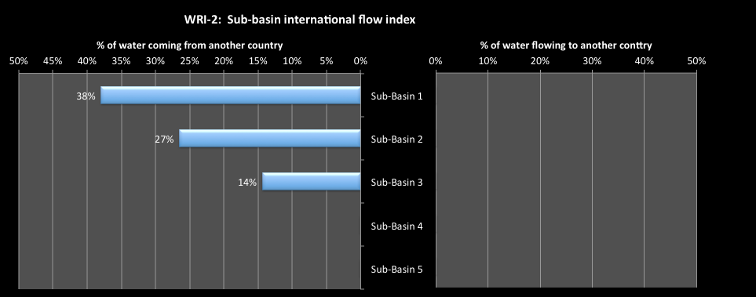**Figure 3‑2: International water indicators**

WRI-3 is the inter-basin discharge indicator for the sub-basins. This indicator shows the proportion of the total water resources volume generated in the sub-basin (national and international) that under current conditions and water use patterns (a) comes from another sub-basin or (b) flows to another sub-basin. For each sub-basin this indicates: (a) the dependence of other sub-basins on the discharged water from this sub-basin; and (b) the dependence of this sub-basin on water discharges from another sub-basin.

To generate this indicator you will need to obtain the following information:

1. Total water volume for the sub-basin generated in the sub-basin, including the total water volume from another country.
2. Total water volume in the sub-basin that discharges out of the sub-basin to other sub-basins.
3. Total water volume that flows into the sub-basin from other sub-basins.

This indicator demonstrates: (a) the significance of water generated within the sub-basin that discharges to other sub-basins in terms of location and water volume, the potential impact of water management decisions in the sub-basin on other sub-basins, and the need for effective management of these shared resources; and (b) the significance to a sub-basin of water inflows from other sub-basins in terms of location and water volume, the importance of water management decisions within those sub-basins, and the need for effective management of these shared resources.

Figure 3‑3 shows that sub-basin 1,2, 3 and 5 contribute significant total water volume to other sub-basins (mostly to Sub-basin 4). For Sub-basin 2, 52% of the total water volume generated within that sub-basin, including the water volume coming in from another country, discharges to another sub-basin – in this case Sub-basin 4. 43% of Sub-basin 3 total water volume discharges to other basins – Sub-basins 2 & 4. Sub-basins 1 & 5 discharge 20% and 7% of their total water volume to Sub-basin 4

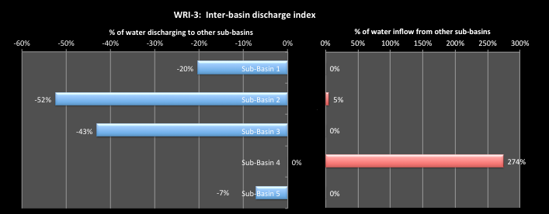On the other hand, the total water that naturally occurs in Sub-basin 4 is increased by 274% by the inflows from the other sub-basins. As the main population and economic activity takes place in this sub-basin, this demonstrates the importance of good water sharing arrangements for the Basin as a whole. Five percent of the total water volume in Sub-basin 2 is received from Sub-basin 1.

Figure 3‑3: Inter-basin discharge indicator

### Data sources and comments

Various data sources will be used to determine the discharge from the river basins. And these may include:

1. The National Water Resources Profile, 2003.
2. Dr. Tran Thanh Xuan, 2007, Hydrology and water resources in river basins of Vietnam
3. Water resources of main river systems of Vietnam, 2012.
4. Government of Viet Nam, 2006, National Water Resources Strategy to 2020
5. Office of National Water Resources Council, 2005, Water exploitation and use in 9 big river basins in Vietnam.
6. JICA, 2002, Study on Nationwide Water Resources Development and Management in the Socialist Republic of Vietnam.
7. MARD, 2007, “The big river basins in Vietnam” (country report to NARBO).
8. Dr. Ngo Dinh Tuan, *River Basins in Viet Nam* (for ADB TA3528).

The following should be noted with respect to the data that will be used:

1. The length of the data set for each basin will vary – this is unavoidable.
2. Figures will not represent strictly ‘natural’ flows, as they will be derived from actual measured discharge that has been ‘impacted’ by extractions. Generally, the discharge is most likely to be measured upstream of major extractions and adjusted for any flow inputs downstream of this. The extent to which the flows represent ‘impacted’ rather than ‘natural’ is a function of the data set used. The shorter and more recent the data set, the more the figures represent ‘impacted’ flows.
3. Information from other countries regarding the discharge from the basins and sub-basins into Viet Nam is difficult to obtain. In some cases, the statistic may not be able to be calculated.

## Dry Season Water Indicator

This indicator analyses the variation in rainfall across the year, specifically the wet and dry seasons. The Water Sector Review[2] showed that dry season water availability in Viet Nam is of increasing concern. An analysis of the average dry season volumes from each sub-basin allows a comparison of the dry season water volume with the annual total water volumes.

In Viet Nam, the length of the dry season is generally defined as including those months wherein the average discharge for that month is less than the average monthly discharge for all months of the year. Where a major reservoir exists in the basin, flow figures prior to the construction of the reservoir should be used to calculate “near natural” dry season discharge.

WRI-4 is the dry season water index for the Sub-Basin. This is the natural dry season water volume generated in the sub-basin divided by the annual total water volume generated in the sub-basin, taking into account all international water inflows and outflows. It indicates what proportion of the total water volume is available in the dry season (when water demands are highest) and the length of the dry season. A small ratio and a large number of months indicate that water shortages can be acute and conflicts over access to water may be significant. WRI-4 provides an indication of the natural situation. Later indicators recognise that the available water volume in the dry season has been increased by water reservoir storage and by inter-basin diversions using infrastructure, such as by hydropower dams. However, this indicator focuses on the natural situation as a starting point.

To generate this indicator you will need to obtain the following information:

1. The total water volume for the sub-basin.
2. The number of months of the dry season, and the specific months.
3. The water volume for each dry season month in each sub-basin.

For the fictitious Example River Basin, Figure 3-4 presents the results of the example analysis .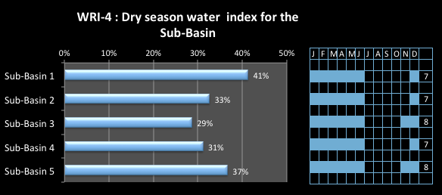

**Figure 3‑4: Dry season water indicator**

Sub-basins 3 and 5 have the longest dry seasons at 8 months, shown on the right hand side of the chart. The left hand side shows the average dry season water volume of a sub-basin as a percentage of the total annual water volume of the basin. Sub-basins 2, 3 & 4 all receive less than one third of their total water volume over the long dry period, making water scarcity a major issue. The lowest indicator value is for Sub-basin 3 at only 29% of the total water volume available over an 8 month period.

## Effects of the Dry Season on water resources

The dry season will have a significant effect on available water resources and water movement within the Basin.

WRI-5 is the dry season international water index. This is the proportion of the dry season water volume of the sub-basin that: (a) comes from another country; or (b) flows to another country from Viet Nam. It shows: (a) the dependence of a sub-basin on water inflows from another country during the dry season and (b) the dependence of other countries on the water outflow from the sub-basin in the dry season. High indicator values will indicate the need for good international agreements on water sharing and water quality.

To generate this indicator you will need to obtain the following information:

1. Dry season water volume in sub-basin
2. Dry season water volume for the sub-basin generated in other country
3. Dry season water volume for the sub-basin generated in Viet Nam and discharging to another country.

For the fictitious Example River Basin, Figure 3-5 the chart that can be compared with the total yearly situation WRI-2.

In the Example Basin, Sub-basins 1 and 2 depend on water volumes from another country to provide almost one third of their dry season water volume. This is a very high dependency on international waters in dry seasons and shows the importance of securing an agreement for sharing of those waters. Sub-basin 3 receives 11% of its dry season water volume from another country. In the Example River Basin, there are no flows into other countries. Compared to WRI-2, Sub-basin 2 has a slightly greater dependence on international water volumes in the dry season – at 32% compared to 27% for the full year – and Sub-basins 1 and 3 have slightly less dependence.

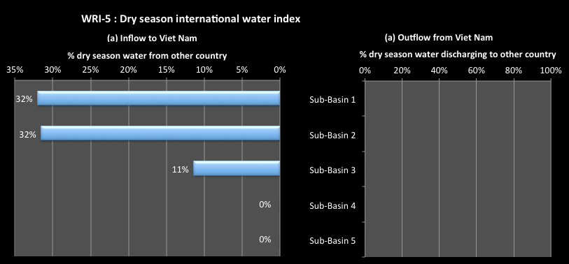**Figure 3‑5: Dry season international water index**

WRI-6 is the water productivity index. This relates the water volume generated in the sub-basins to the sub-basin areas, to determine those areas that are providing the most water to the Basin. This is calculated for the annual water situation and for the dry season, using naturally generated flows to indicate the natural productivity of the catchments. This is complicated by the fact that sometimes an area may have a high runoff per unit area, but may contribute relatively little water volume to the basin. Therefore, the indicator is weighted to reflect the overall significance of the water volume the sub-basin produces. The weighting factor is the proportion of the total Basin water produced by the sub-basin.

The result is an index of significance of water productivity. A high number indicates high significance of the sub-basin in terms of water productivity, both annually and in the dry season. These areas need to be protected by catchment management activities to ensure they can generate water into the future. For preparing planning tasks, analysis at the sub-basin scale is appropriate. However, for the preparation of a river basin plan dealing with water quantity or water allocation, then analysis at smaller levels of sub-areas within the sub-basin may be required.

To generate this indicator you will need to obtain the following information:

1. The Basin total water volume and total water volume generated within each sub-basin, within Viet Nam, both on an annual basis and for the dry season.
2. Total Basin catchment area and catchment area for each sub-basin in Viet Nam.
3. For international Basins, the water volume in the international part of the Basin and the water volumes generated for the international part of each sub-basin, both on an annual basis and the dry season.
4. For international Basins, the total catchment area of the international part of the Basin and the catchment areas of the international part of each sub-basin.

*Note: Item (iii) & (iv) will not apply when there is no international component providing water to the Basin.*

For the fictitious Example River Basin, **Figure 3‑6** shows that for the water generated both within and outside of Viet Nam, sub-basin 2 is by far the most water productive area of the Basin. Sub-basin 3 is the second most productive for water generation, while the other sub-basins are less. For the areas outside of Viet Nam, sub-basin 3 is also the most productive, but Sub-basin 1 shows high productivity as well, particularly compared to the Viet Nam part of this sub-basin.

In the dry season, Sub-basin 2 is again the most productive area, particularly for areas outside of Viet Nam. This demonstrates the importance of establishing strong relationships with other countries to protect these highly productive areas.

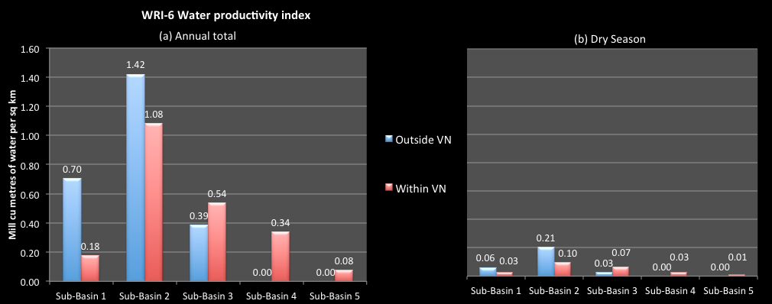**Figure 3‑6: Water productivity indicator**

## Effects of infrastructure: dams and inter-basin diversions

Previous indicators have looked at the natural situation of water; however, natural flows are often significantly modified through the construction of dams and reservoirs, the control on river flows offered buy those reservoirs, and the diversion of water resources from one river system to another. These effects are demonstrated by the next indicators.

### Explanation of the infrastructure indicators – reservoir and inter-basin diversions

WRI-7 is the water storage share index indicator. This shows the total active reservoir storage of the sub-basin as a percentage of total volume of reservoir storage in the Basin, both for current conditions and projected to 2025. It indicates the significance of the sub-basin storage to the Basin as a whole. A high percentage means this sub-basin contains a significant proportion of Basin storage.

To generate this indicator you will need to have the following information:

(i) Total reservoir active volume in Basin, currently and for 2025.

(ii) Total reservoir active volume in sub-basin, currently and for 2025.

For the fictitious Example River Basin, the total reservoir storage volume in the Example Basin is currently around 2.4 billion m3. **Figure 3‑7** shows that, of this, 75% is located in Sub-basin 2 and a further 13% in each of Sub-basin 1 & 3. There is no storage in sub-basins 4 & 5. In 2025, the projected storage volume is 4.36 billion m3, an 82% increase, particularly in Sub-basins 2 & 3, which significantly changes the indicator figures. By 2025, 48% of the Basin storage volume will be in Sub-basin 2, and the proportion for Sub-basin 3 is up to 38%.

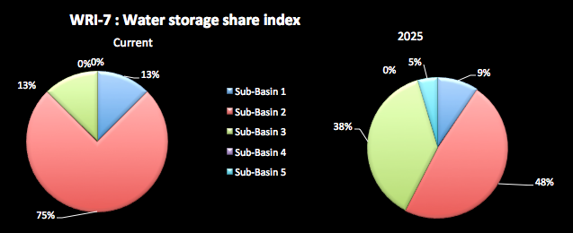**Figure 3‑7: Water storage share index**

WRI-8 is the water storage control index for the Sub-Basin. This shows the active reservoir storage in a sub-basin divided by the total water volume for the sub-basin. It gives an indication of the proportion of surface water volume in a basin that can be controlled by the reservoirs. A high ratio means that the reservoirs can exert significant control over river flows. This may mean either good flood control potential or that river health or the needs of lower river communities may not be met.

To generate this indicator you will need to have the following information:

1. Total reservoir active volume in sub-basin, currently and for 2025.
2. Total water volume for sub-basin.

For the fictitious Example River Basin, Figure 3‑8 shows that under current conditions, the reservoir storage volume is generally a relatively a small proportion of total water volume in the sub-basins. The maximum index value is only 5% for Sub-basin 2. This does not change significantly if the projected storages to 2025 actually proceed. This shows that the storages would generally not have a big impact on river flows in the Basin.

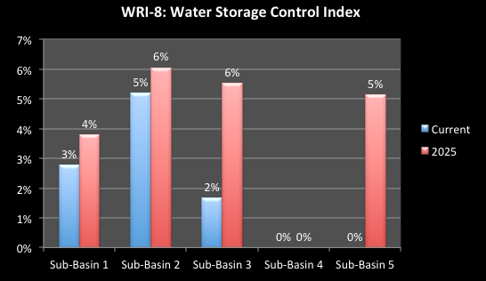

Figure 3‑8: Water storage control index

WRI-9 is the water storage purpose index for Sub-Basin. This is the proportion of total reservoir active volumes in the sub-basin used solely for hydropower and other single purpose use, such as urban water supply; and the proportion for multi-purpose use. It shows the predominant use of reservoirs in the sub-basin, and the proportion of single purpose storages to multi-purpose storages. A high ratio of single purpose storages means that generally storages are sector based with little integration.

To generate this indicator you will need to have the following information:

1. Total reservoir active volume in sub-basin, currently and for 2025.
2. For each reservoir, its active storage volume and its purpose.

For the fictitious Example River Basin, Figure 3-9 shows that under current conditions, 3 of the sub-basins have reservoir storage, and Sub-basin 3 only has single purpose storages (for hydropower). Sub-basin 2 has storages for “Other” purposes which in this case are for urban water supply. Currently, Sub-basins 1 and 2 have irrigation storages, which are multi-purpose use. Hydropower storage volumes dominate all sub-basins.

The projected 2025 storages volumes show that an irrigations dam is proposed for sub-basin 5, which would be the only storage in that sub-basin. As well, a small storage is proposed for Sub-basin 3 for other purpose (urban water supply). But again, hydropower storage dominates.

The figure also shows the benefits derived from the reservoir storages, and makes a distinction between the storages that add to the water security of the Basin and hydropower storages. Water security is a condition where management measures ensure adequate water supply for the country or basin at all times. Energy security is a condition where sources and production means are in place to ensure production for adequate energy supplies for the country or basin at all times. Water storages for irrigation, water supply, or flood mitigations are all providing water security benefits – additional water supply or protection from water disaster impacts. However, hydropower storages are built and operated primarily to provide energy security to the country. As such, they do not explicitly provide water supply benefits, although these can occur as incidental benefits. The figure shows that the energy security benefits of the reservoirs are much larger than the water security benefits.

Figure 3-9 shows that most of the water storage is in the sub-basin 2, resulting in that sub-basin having the highest water storage per capita figure (2,571 m3 per person). However, the storages are dominated by hydropower, for energy security, and the water security storage volume is quite low at 571 m3, mostly because of the irrigation storage. The other sub-basins have low or zero overall, storage per capita.

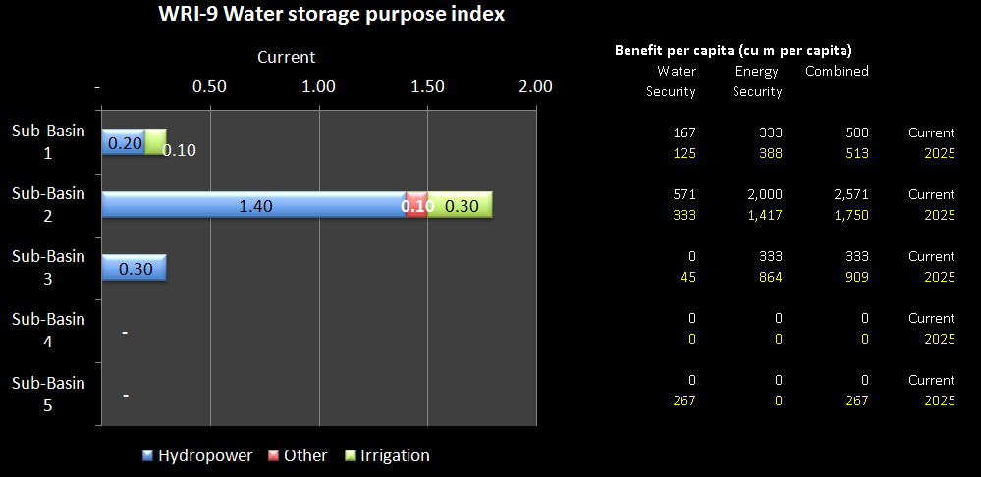**Figure 3‑9: Water storage purpose index**

WRI-10 is the infrastructure sub-basin inter-diversion index. This is the proportion of the water volume of a sub-basin that is diverted by physical water works from a sub-basin into another sub-basin. This is calculated on an annual basis and for the dry season. Typically these works are for hydropower generation. This indicator seeks to analyse physical sub-basin inter-diversions, and will show where the water is transferred from and the receiving sub-basin(s). A high percentage diverted out indicates a significant amount of water no longer available in this sub-basin with consequential impacts on river health and basin communities. These effects can be more severe in dry times.

To generate this indicator you will need to obtain the following information:

1. The total water volume of the sub-basin; and the dry season water volume.
2. The total water diverted by water-works from each sub-basin to another sub-basin using constructed infrastructure.
3. The dry season water diverted by water works from each sub-basin to another sub-basin using constructed infrastructure.

For the fictitious Example River Basin, Figure 3-10 shows that 2 Sub-basins (2 & 3) have water resources physically diverted to other sub-basins, i.e. they “lose” water. On an annual basis, about 5% of the total water volume in Sub-basin 2 is diverted to Sub-basin 1 and nearly 3% from sub-basin 3. Sub-basin 1 is the major beneficiary of the diversions, which increases the total water volume of that sub-basin by about 16%. Diversions to Sub-basin 5 increase the basins total water volume by 12%.

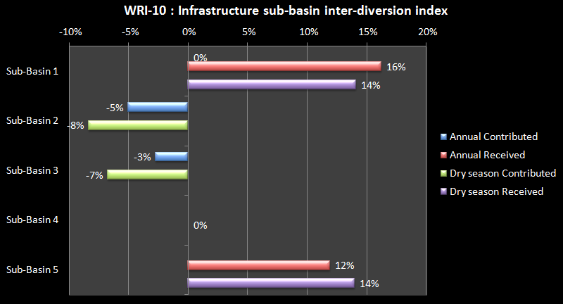Figure 3‑10: Infrastructure sub-basin inter-diversion index

In the dry season, the diversion of water from Sub-basin 2 to Sub-basin 1 increases to about 8% of the water volume available. Note that Sub-basin 2 only receives 33% of this total water volume during the dry season (see Figure 3-4), which puts increased pressure on the relatively low water available in the sub-basin. The diversion from Sub-basin 3 increases to about 7% - note that this basin only receives 29% of its total water volume in the dry season. Sub-basin 1 has an increased water volume of about 14% of the dry season total. Diversions to Sub-basin 5 increase the basin’s dry season water volume by 14%. These figures show the benefits gained by Sub-basins 1 and 5 (which have the greatest addition to total water volume available in the dry season), and the significance of the water volume losses from Sub-basins 2 & 3.

### Data sources and comments

Discharge data sources have been provided for other indicators and the comments provided in relation to those also apply here. Please note the following with respect to the data used:

1. Where water is being transferred from one sub-basin to another by water works infrastructure, the amount transferred during the dry season should be added to the receiving basin, and subtracted from the donor basin. An assumption is made that these infrastructure transfers occur uniformly across the months of the year.
2. ‘Active storage’ is defined as the full supply level of a reservoir minus the reservoir dead storage. It is the storage volume available for use through the normal operation of the dam. Active storage values should be calculated for existing reservoirs and those that are expected to be completed within 18 months.
3. Active storage volumes will likely need to be obtained from many sources. For example, the MARD Department of Hydraulic Works (covering for more than 400 reservoirs) is a good source.

## Water Availability Indicators

The following indicators relate the water resources volumes in the sub-basins to demands for water. Demand is expressed as the water volumes available to the community (cubic metres per person), the uses made of the water for different demands (irrigation, urban, industry, etc), and the impacts on the water resources of that use. Here, ‘demand’ is based on international standards and not actual quantities of water use and exploitation.

The international standard for adequate water per person is 4,000m3 a year[3], with the possibility remaining of having irregular or local water shortages with annual water availability of between 1,700m3 and 4,000m3. Below 1,700m³/capita/year, water stress appears regularly; below 1,000m³/capita/year water scarcity is a limitation to economic development; and below 500m³/capita/year water availability is a constraint to life.

These indicators also consider the dry season water availability, as this is one of the most critical issues for water management in much of Viet Nam. In order to assess the water available in the dry season in the sub-basins, the natural water volumes need to be augmented to take account of:

1. The inter basin diversions using the built infrastructure – dams and diversion works.
2. The storage volumes in the sub-basins. It is assumed that the storages will be full at the end of the wet season and the water will be available for use during the dry season. Therefore, active storage within each basin should be added to the dry season discharge, with the assumption that all active storage is used during the dry season. As almost all, if not all, reservoirs are managed on an annual basis (that is, they fill each year, and the full active storage is available for use at the end of the wet season), this assumption appears valid. In reality, the amount of active storage available for dry season use depends on the management of each reservoir. If reservoirs are managed conservatively to ensure late wet season floods are effectively mitigated, full supply level may not be achieved, if these floods do not occur. The ‘dry season’ discharge, then, may be slightly overstated.

For the fictitious Example River Basin, there are many water diversions and storages reservoirs that impact dry season water availability as seen in the following table.

Table 3‑1: Impact of diversions and reservoirs on dry season volumes

|  |  |  |  |  |  |  |
| --- | --- | --- | --- | --- | --- | --- |
| **Sub-basin** | **Natural Dry season volume** | **Infrastructure diversions** | | | **Reservoir Volumes** | **Adjusted Dry season Volume** |
|  |  | From sub-basin | Into sub-basin | |  |  |
| Sub-Basin 1 | 3.55 | 0 | | 0.50 | 0.3 | 4.35 |
| Sub-Basin 2 | 6.00 | -0.50 | | 0 | 1.8 | 7.3 |
| Sub-Basin 3 | 2.95 | -0.20 | | 0 | 0.3 | 3.05 |
| Sub-Basin 4 | 11.30 | 0 | | 0 | 0 | 11.3 |
| Sub-Basin 5 | 1.43 | - | | 0.20 | 0 | 1.63 |
| Basin | 25.23 | -0.70 | | 0.70 | 2.4 | 27.63 |

### Explanation of Water Availability Indicators

WRI-11 is the Water Availability index for sub-basins. Water availability is expressed on a per capita basis. This is the total annual water resources volume generated in the sub-basin divided by: (a) current population (VN only); (b) projected population at 2025 (VN only). For any sub-basins that depend substantially on natural through flows from other sub-basins (such as delta sub-basins), then include the through flows in a separate assessment. This indicator shows the relative abundance of surface water resources for the basin population.

The analysis should be based on the comparison of the sub-basin water availability figures against the international standards. Nationally, and based on the total surface water discharge in Viet Nam, the surface water resources equate to 9,856m3 per person per year, which provides adequate water according to the international standards (discussed later).

To generate this indicator you will need to have the following information:

1. The total water volume generated in the sub-basin.
2. Current populations per sub-basin, and projected population at 2025.
3. The active storage reservoir volumes in the sub-basin and the water transferred to/from sub-basins by way of water works infrastructure.
4. Identification of any sub-basin that depend substantially on natural through flows from other sub-basin and an assessment of the through flow volumes.

For the fictitious Example River Basin, Figure 3-11 shows that at current populations, all sub-basins have more than adequate water availability, and all but Sub-basin 5 are above the national average. However, by 2025, Sub-basin 5 would have a water availability getting close to dropping below the adequate level. Local water shortages may begin to occur in the future. Water availability in this sub-basin will need to be carefully monitored into the future.

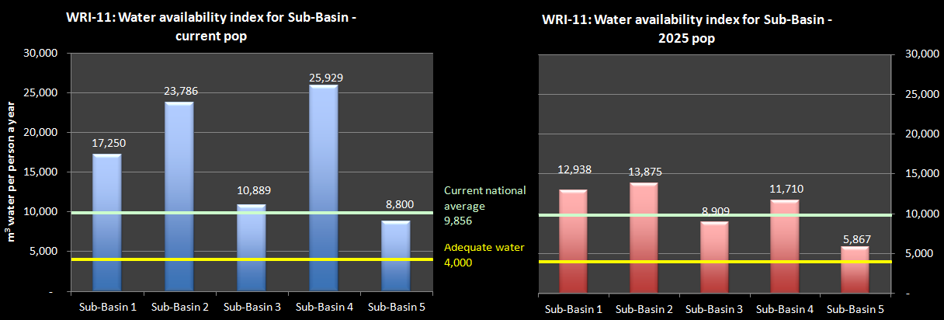**Figure 3‑11: Water availability index**

WRI-12, the dry season water availability index shows the dry season water volumes generated in a sub-basin divided by: (a) current population (VN only) and (b) projected population at 2025 (VN only). For any sub-basins that depend substantially on dry season through flows from other sub-basins (such as delta sub-basins) then adjust the dry season volumes by including the through flows, inter-basin diversions, and water volumes in reservoir storage in a separate adjusted assessment. The analysis is the same as for WRI-11, but using the dry season water availability figures, and comparing those results against the international standards.

To generate this indicator you will need to have the following information:

1. Number of months of the dry season for each sub-basin, and the specific months.
2. The total water volume generated in each dry season month in each sub-basin.
3. The total dry season sub-basin water volume.
4. Current populations per sub-basin, and projected population at 2025.
5. The dry season water contributions between sub-basins, the active storage reservoir volumes in the sub-basin and the water transferred to/from sub-basins by way of water works infrastructure in the dry season.

For the fictitious Example River Basin, **Figure 3‑12** shows that at current populations, and according to the international standard, in the dry season Sub-basins 3 & 5 are approaching the level of having adequate water. However, at 2025 population projections, the dry season water availability for sub-basin 5 would be below the water shortage level at which it runs the risk of regular local surface water shortages. By 2025, sub-basin 3 would be close to the level of only adequate water. These sub-basins will need careful monitoring into the future.

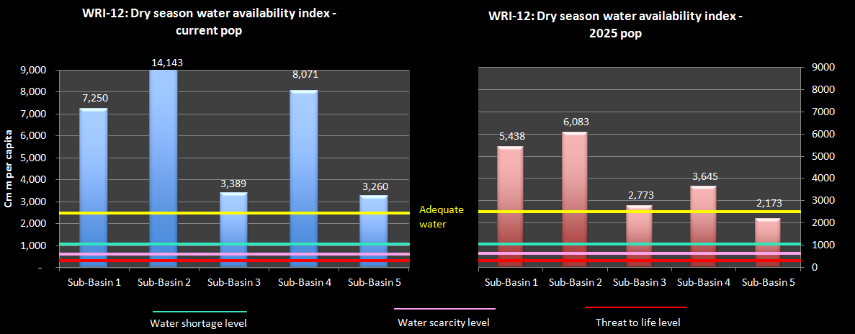

**Figure 3‑12: Dry season surface water availability indicator**

Note that in the Figure, the standards for water availability have been adjusted to reflect dry season values (see the discussion below on “data sources and comments”).

### Data sources and comments

* Discharge data sources are those provided for WRI-1 and those comments apply here. The following should also be noted with respect to the data used:

1. National population data can be sourced directly from the General Statistical Office of Viet Nam [website: [www.gso.gov.vn](http://www.gso.gov.vn)]. The sub-basin population data should be derived from GSO provincial and district population data, apportioning provinces and districts to sub-basins according to an agreed standard. Use the most recent data possible.
2. The Falkenmark Water Stress Indicator was developed by the Swedish water expert Falkenmark in 1989, and is one of the most commonly used indicators of water stress. Accordingly, the limits for water stress on an annual basis are:
   * Amounts more than 4,000m³/person/year indicate adequate supply of water;
   * Amounts between 1,700m³/person/year and 4,000m³/person/year indicate adequate supply of water; water shortage occurs only irregularly or locally;
   * Amounts between 1,000m³/person/year and 1,700m³/person/year water shortage appears regularly;
   * Amounts between 500m³/person/year and 1000m³/person/year water scarcity is a limitation to economic development, human health and well-being; and,
   * Amounts below 500m³/person/year water scarcity are a main constraint to life.
3. The Falkenmark indicator does not take account of temporal and spatial variations within the sub-basins, nor water quality data.
4. The Falkenmark indicator values must be adjusted for the dry season, based on the length of the dry season for the Basin as a whole. That is, the ‘annual’ standards at item (ii) are reduced to equal: (length of dry season for Basin/12) times the annual standards. This approach is likely to understate in the severity of dry season water shortage in sub-basins. It could be argued that as more than 80% of the demands occur in the dry season, a different distribution of the indicator across wet and dry seasons should be used. However, the purpose of this analysis is to show the relative situation between sub-basins, rather than absolute values.
5. The water available in the dry season must be adjusted for water inter sub-basin contributions, for inter-basin transfers to or from a basin via water works infrastructure, and for active storage of water in the reservoirs of each sub-basin.
6. Not all of the surface water shown in these indicators is available or accessible for use. The actual exploitable water resources (or water development potential) should consider factors such as: the economic and environmental feasibility of storing floodwater behind dams; the physical possibility of catching water which naturally flows out to the sea; and the minimum flow requirements for navigation, environmental services, aquatic life, etc. Therefore, care should be taken not to assume that the available water shown in these indicators is all fully exploitable.
7. Note that the water availability figures in these indicators should only include surface water availability. Groundwater availability should be excluded.

## Water Exploitation Indicators

### Explanation of water exploitation indicators

WRI-13 is the Water exploitation index (WEI) for Sub-Basins. It is the proportion of the total annual water volume that is exploited and used under: (a) current levels of water demand/use; (b) projected 2025 levels of water demand/use. The indicator combines information about water use/demands and water availability, and shows the intensity of use of surface water resources. High levels of water use leads to stress on the water source. The international standard for water exploitation stress is that moderate stress begins when more than 20% of average annual flow is extracted, and high water stress is felt for indicator values above 40% (see notes “Data Sources and Comments section below). According to this, frequent water crises will begin to occur when water stress moves above 40%. This indicator can identify whether water exploitation rates in the sub-basin are sustainable. Changes in the index show how changes in exploitation and use impact by adding pressure on the water resources or by making them unsustainable.

To generate this indicator you will need to have the following information:

1. Total water volume in sub-basins.
2. Current water use/demand in sub-basin by volume.
3. Projected 2025 water demand/use in sub-basin by volume.

For the fictitious Example River Basin, **Figure 3‑13** shows that at current demand/use levels, all of the sub-basins are in the low stress range. However with projected population growth, Sub-basin 5 will be in the moderate stress zone. This sub-basin will be increasingly under pressure to meet the projected demands for water as can be seen by the major change in stress level between current conditions and 2025.

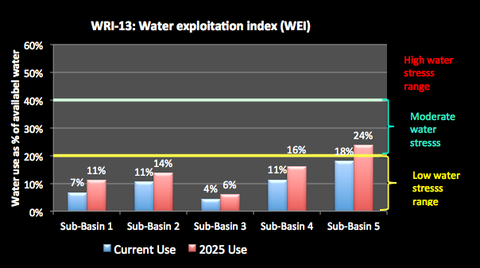

**Figure 3‑13: Annual water exploitation indicator**

WRI-14 is the dry season water exploitation index for Sub-Basins. This is the estimated dry season water use in the sub-basin for all sectors - irrigations, agriculture, industry, urban, aquaculture - divided by the average dry season surface water volume, including dry season inter sub-basin natural discharges, active storage in the basin and dry season inter-basin transfers using water works infrastructure. It can help identify if dry season exploitation and use rates are sustainable.

To generate this indicator you will need to have the following information:

1. Dry season water volume in sub-basins.
2. Current dry season water use in sub-basin by volume.
3. Projected 2025 dry season water use in sub-basin by volume.
4. Agreement on the international standard for water exploitation stress.

For the fictitious Example River Basin, **Figure 3‑14** shows problems with Sub-basins 4 & 5. Under current levels of water use/demand these two sub-basins are in the moderate stress level range, but with Sub-basin 5 almost at the high stress level. The other 3 sub-basins are in the low stress range.

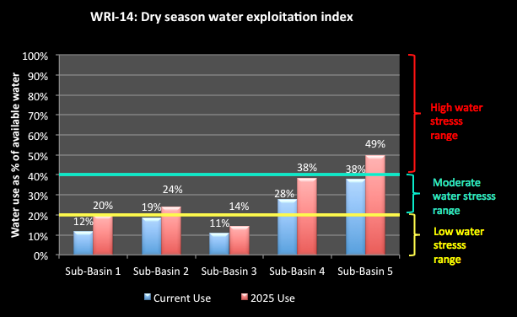

**Figure 3‑14: Dry season water exploitation index**

At 2025 projected water use/demands, Sub-basin 5 is in the high stress range, and Sub-basin 4 is almost there. This means that for Sub-basin 5, in the dry season, 49% of the water volume in this sub-basin is required to meet human demands for water at current conditions. It will be increasingly unsustainable for extraction levels to be at such a high level during the dry season. This Sub-basin and Sub-basin 4 needs attention in terms of sharing access to water and ensuring river health is actively managed. In contrast, the other sub-basins have an indicator value that shows that they remain at low stress in the dry season, suggesting room for additional exploitation without putting stress on river health.

WRI-15 is the water exploitation per capita index for the Sub-Basin. This is the (a) current total water use/demands of the sub-basin divided by the current population (VN only); and (b) the projected 2025 total water use/demands of the sub-basin divided by the projected population at 2025 (VN only). It indicates the average total water use per person in the basin, at present and projected at 2025. A high figure means that water use in this basin is for relatively higher water using activities, or it could mean inefficient water use.

To generate this indicator you will need to have the following information:

1. Current and projected 2025 water use in the sub-basin by volume.
2. Current and projected 2025 sub-basin population

On a national basis, water use in Viet Nam per person is 985m3 a year. For the fictitious Example River Basin, Figure 3‑15 shows that water use in sub-basins 1, 2, 4 & 5 are well above the national average, both currently and projected for 2025. Given that most of the water use is for irrigation this suggests that water use in these sub-basins may be inefficient. This can be further determined by examination the economic indicators for these sub-basins. Of further concern is that for Sub-basin 1, and to a lesser extent Sun-basin 3, the index for 2025 is greater than for current conditions, meaning greater inefficiency at present projections. This is clearly an area for more detailed consideration.

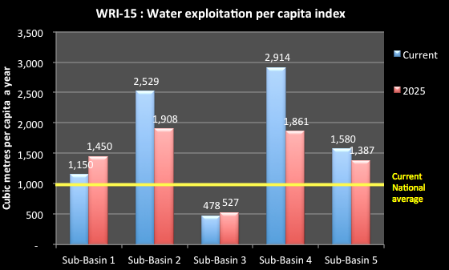

Figure 3‑15: Water exploitation per capita index

Sub-basin 3 is well under the national average. It may be worthwhile assessing water use to see if there are good techniques or technologies that may be applicable in other sub-basins.

### Composite graphs for integrated analysis

It is useful to combine several water indicators to show a composite picture which planners may find useful. One composite chart is to combine the Annual per capita water availability and water exploitation and use by sub-basin, combining the outputs of WRI-11 and WRI-13. Another is to do this for the dry season - the per capita dry season water availability and demand by sub-basin, combining the outputs of WRI-12 and WRI-14.

For the fictitious Example River Basin, Figure 3-16 shows that all of the sub-basins are in a “safe zone” – being below the diagonal yellow lines and to the right of the vertical red lines. This means that the water availability per capita is above the adequate water level (4,000 m3 per capita), and also in the low stress area as the water demands are below 20% of the available water. However, Sub-basin 5 is approaching the 20% line for water exploitation.

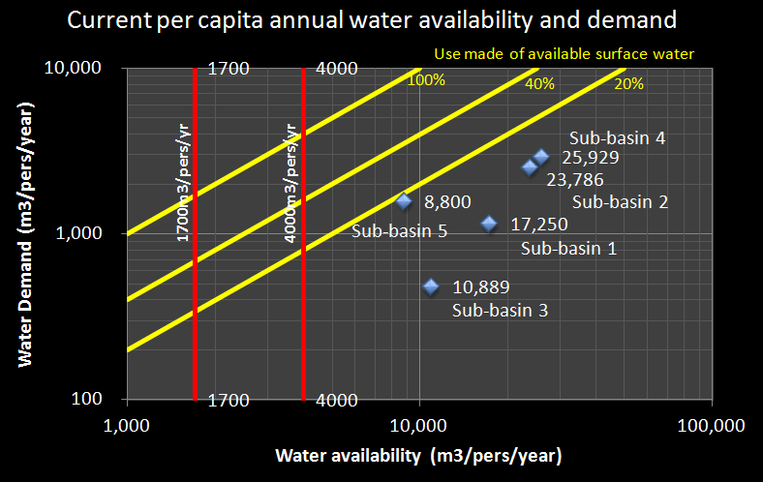

**Figure 3‑16.Annual availability and demand per capita**

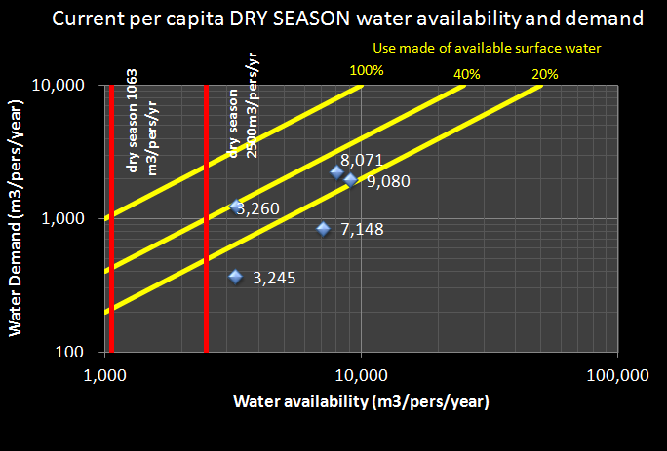

**Figure 3‑17** shows the situation for the dry season, based on current levels of populations and water demands. This shows that Sub-basins 4 & 5 are above the level of 20% of available water being used, with Sub-basin 5 near the 40% line. However, the figure also shows that Sub-basin 2 is now almost at the moderate stress zone.



**Figure 3‑17. Dry season availability and demand per capita**

However, this picture gets worse when future projections of population and water demands are taken into account as in Figure 3-18. BY 2025, Sub-basin 5 will have dry season water availability per capita below the water shortage level, and is at the same time in the high stress zone with nearly half of the available water being used. Sub-basin 3 would be almost at the adequate water level, although still in the low stress range. Sub-basin 2 & 4 would be in the medium stress range.

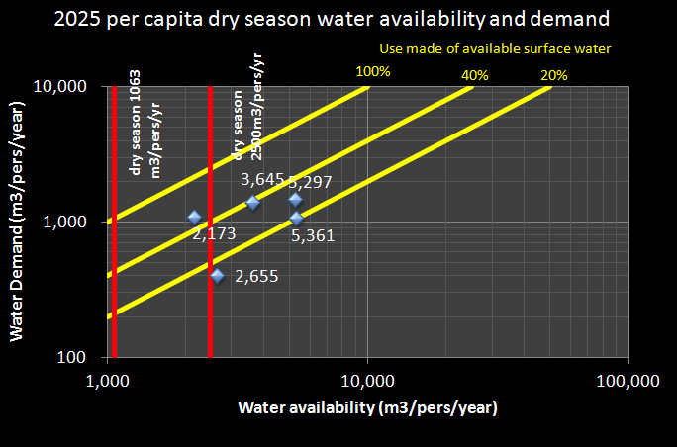

**Figure 3‑18. 2025 DRY season projected water availability and demands**

WRI-16 is the Sector Water use index for Sub-Basin. This shows the water use in each sub-basin by each main water-using sector. It is calculated as the proportion of the total water use in the sub-basin by the major sectors - irrigation, agriculture, industry, urban, aquaculture. Accurate data and information on water use in Viet Nam is generally not available, except for the urban water supply, where most use is measured. Quantities may have to be based on the best available estimates. Nationally, irrigation accounts for over 80% of total water use; aquaculture 11%; industry 5%; and cities, towns and villages 3%. Generally, water use for irrigation is not very efficient in Viet Nam. Therefore, a high proportion of water use for irrigation suggests a large potential for water efficiency gains.

To generate this indicator you will need to have the following information:

1. Total water use in the sub-basin by volume.
2. Total water use in the sub-basin by sub-sectors - irrigations, agriculture, industry, urban, aquaculture.

For the fictitious Example River Basin, **Figure 3‑19** shows that irrigation is by far the highest water using sector in the sub-basins, although the proportion of water use for irrigation is generally below the national average. This may mean that the potential for significant efficiency gains may not be as strong in this Basin as in others. In the sub-basins in the lower part of the Basin catchment, Sub-basins 4 & 5, urban water use is an increasingly large component. In Sub-basin 4, which comprises flatter lands and the delta and estuarine areas, water use for aquaculture is also a significant component.

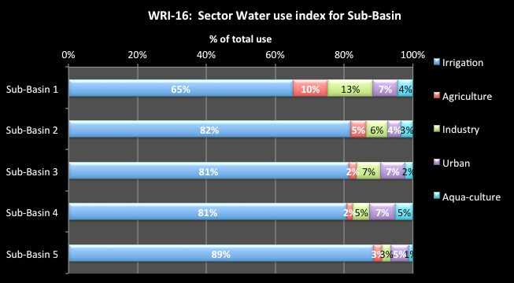

**Figure 3‑19: Water use by sector**

### Data sources and comments

Discharge data sources are those provided for earlier indicators, and those comments apply here. The following should also be noted with respect to the data used:

1. Water use is generally not directly measured in Viet Nam and will require estimates for water demand. A separate paper was developed for this project to discuss methods for estimating water demand in Viet Nam.
2. Water demand data may be found in a range of Ministry or project reports. For older reports, these figures may not be current, but can give an indication of the approximate demands in a river basin compared to average annual discharge in the basin.
3. Water demands of cities, towns, and villages include domestic/residential demands, as well as demands of commercial premises, and any (usually smaller water using) industries that are using the urban supply system. Industry water supplies are generally for larger industries that have their own supply source, rather than part of the municipal supply.
4. Water demands will mostly include groundwater use, as these cannot be fully separated from total water demands. Groundwater use across the country is quite small, about 5% of total water use. However, domestic use of groundwater is significant, as is use of groundwater in some basins for irrigation and industry.
5. Estimates of dry season water demands must be made. You will need to make assumptions about how the sector demands may vary through the year. For example, one assumption may be that all irrigation and aquaculture demands are in the dry season, and that the other demands are generally uniform per month. You need to make assumptions such as these for the sub-basins.
6. Dry season discharge figures should be adjusted for inter sub-basin contributions and inter-basin transfers via water works infrastructure, and should have the active water storage volumes added in (assuming that water is stored in the wet season and then released during the dry season, and can be used to satisfy demands).
7. The water exploitation indicators are defined as the average annual total exploitation of freshwater divided by the mean annual surface water discharge (inter sub-basin contributions and inter-basin transfers via water works infrastructure), and the average dry season exploitation of freshwater divided by the average dry season surface water discharge (adjusted for inter sub-basin contributions and inter-basin transfers via water works infrastructure, and active storage).

According to the literature, the warning threshold of water stress can be 20% of the flow being extracted, which distinguishes a non-stressed region from a stressed region (Raskin et al., 1997, Lane et al., 2000). Severe water stress can occur where the indicator exceeds 40%, indicating strong competition for water but creating frequent water crises. Some experts argue that 40% is too low a threshold, and that water resources can be used up to a 60% threshold. Others argue that freshwater ecosystems cannot remain healthy if the waters in a river basin are abstracted as intensely as indicated by an indicator in excess of 40% (Alcamo et al., 2000).

## Flood Indicator

### Explanation of flood indicators

WRI-17 is the flood mitigation storage index for Sub-Basin. This is total reservoir storage volume in the sub-basin used for flood mitigation as a percentage of wet season water volume in the sub-basin. It shows the relative size of flood mitigation reservoirs in the sub-basin, compared to wet season flows. A higher ratio means a greater proportion of wet season basin flows could potentially be caught in a reservoir.

To generate this indicator you will need to have the following information:

1. Storage volumes for flood mitigation reservoirs, currently and for 2025.
2. Total wet season water volume for sub-basin.

For the fictitious Example River Basin, Figure 3‑20 shows that the current flood mitigation storage volumes are a small proportion of the wet season flows. The maximum is for sub-basin 2, with a value of only about 1%. At projected storage volumes in 2025, a new flood mitigation reservoir would be constructed in sub-basin 3, making the indicator value 0.7%.

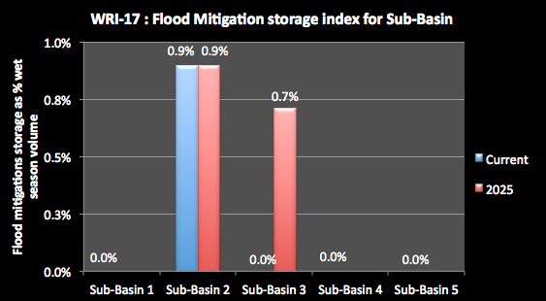

Figure 3‑20: Flood mitigation storage index

## Climate change Indicators

### Explanation of climate change indicators

The climate change indicator used will depend on the data available at the sub-basin scale. Planners should consider a range of aspects of climate change and determine if there is data available, such as:

* Salt water intrusion into lower river areas (may be sea level rise);
* Changes in rainfall intensity over time;
* Frequency sub-basins suffer severe drought; or,
* Trends in the recorded temperature record.

In the Example River Basin, temperature change was selected to illustrate the process.

WRI-18 is the climate change temperature indicator for Sub-Basin. This is the ratio of the average summer temperature over the recent history compared to that projected for the sub-basin under climate change. It shows the temperature increase and the relative increase in the average summer temperatures in the sub-basins.[4] A high % means a significant increase in summer heat, causing increased evaporation: reducing runoff and increasing the demands for water within the sub-basin

To generate this indicator you will need to have the following information:

(i) The Current average summer temperatures for the sub-basin.

(ii) Projected change in average summer temperatures for the sub-basin.

For the fictitious Example River Basin, Figure 3‑21 shows that sub-basins 3, 4 & 5 are naturally warmer that the other sub-basins, and that sub-basins 4 & 5 will experience a greater temperature rise compared to the others. They both are projected to experience a 2% change in temperature compared to about 1% for the other sub-basins.

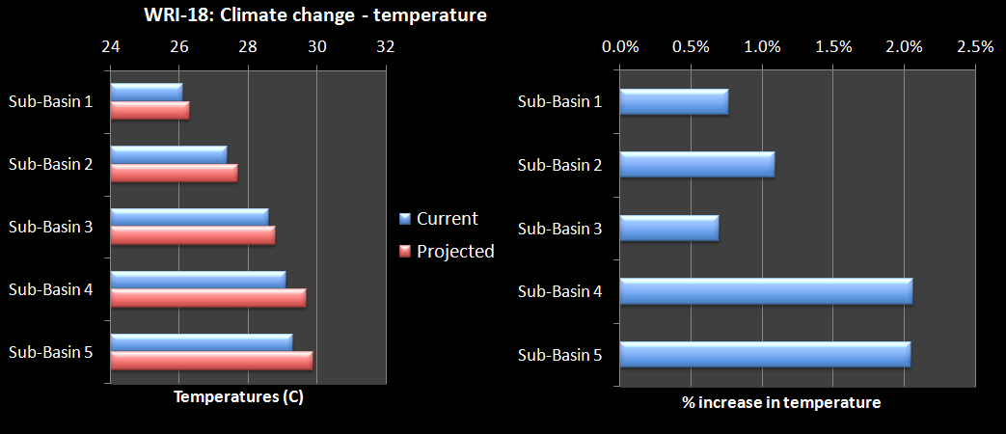

Figure 3‑21: Climate change temperature indicator

# Groundwater Indicators

For the sustainable management of groundwater in the Basin, ‘groundwater potential’ is the dynamic reserve (or recharge) to the Basin’s aquifers. It does not include any groundwater storage component which, if extracted, would result in the unsustainable mining of groundwater over time. In the indicators, the term “groundwater exploitation capacity” is the volume of groundwater that can be extracted on a sustainable basis, which will be less than the assessed annual recharge.

Groundwater aquifers do not always physically align themselves with sub-basins. Unless detailed delineations of the aquifers already exist, then it will not be possible to do this during the preparation of planning tasks. If this is a critical issue, then it should be proposed as a specific planning task for the full river basin planning. For the preparation of planning tasks, professional judgement will be required to prepare and analyse the data for the groundwater indicators.

### Explanation of groundwater indicators

GWI-1 is the groundwater area indicator. This is the proportion of the areas of each aquifer type in the Basin and each sub-basin. It indicates the proportion of the Basin's total area covered by each aquifer type; and also shows the area of each aquifer type in the sub-basins. A high % indicates that a substantial proportion of the Basin's groundwater area is provided by an aquifer type or a sub-basin. This could indicate a sub-basin’s groundwater potential. For example, a high % of fractured rocks may indicate that although there will be groundwater available the potential bore yields may be small.

To generate this indicator you will need to have the following information:

1. Basin groundwater total area and areas of aquifer type.
2. Area per aquifer type in each sub-basin.

For the fictitious Example River Basin, Figure 4‑1 shows that sub-basin 2 has the largest aquifer area – totalling 36% of the total aquifer area of the Basin. It is mostly made up of fractured rock aquifers with significant areas of the other aquifer types. Sub-basin 2 is similar but slightly smaller in area. Sub-basin 5 has mostly porous aquifers, which are generally the high yielding aquifers. Sub-basins 1 & 4 have small aquifer areas.

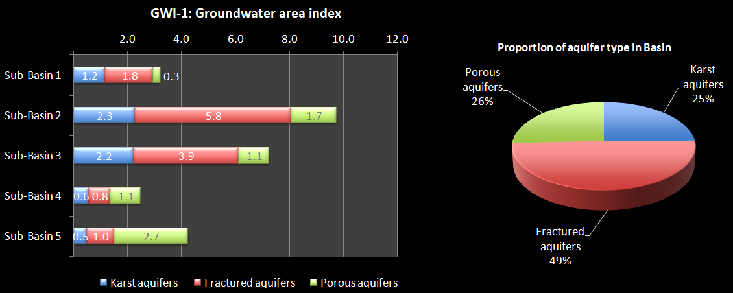

Figure 4‑1: Groundwater Area Index

GWI-2 is the Groundwater recharge index. This is the Proportion of the Basin groundwater recharge in the sub-basins; and the recharge in the aquifer types in the sub-basins. It indicates the proportion of the Basin's total recharge that is provided by the sub-basin; and also shows the recharge capacity of the aquifer types in the sub-basins. A high % indicates that a substantial proportion of the Basin's groundwater potential groundwater is provided by a sub-basin. A low % means that the sub-basin most likely contains little usable groundwater.

To generate this indicator you will need to have the following information:

1. Basin groundwater recharge
2. Groundwater recharge in each sub-basin.

For the fictitious Example River Basin, **Figure 4‑2** shows that sub-basins 2, 4 & 5 provide the most aquifer recharge in the Basin – together totalling nearly 70% of the total. Sub-basin 2 has the most recharge overall at 3.2 billion m3 a year. The porous aquifers in sub-basin 5 provide the most recharge at 2.5 billion m3 a year. The total overall recharge is 12.7 billion m3 a year, which is small in relation to the surface water (77.5 billion m3 a year).

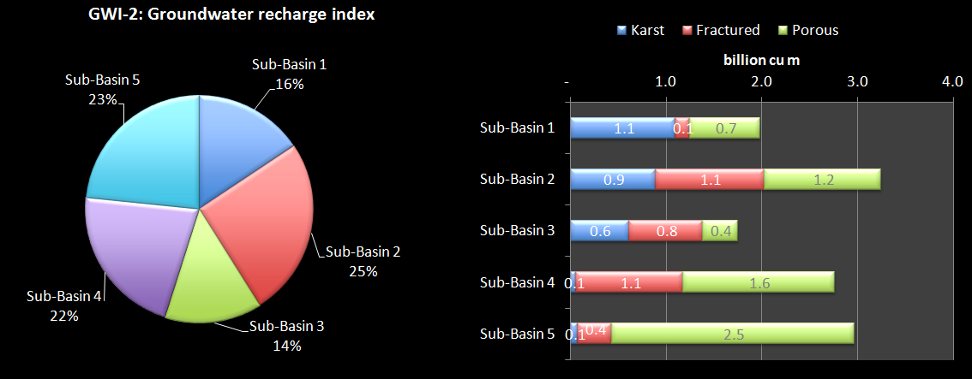

**Figure 4‑2: Groundwater recharge indicator**

GWI-3 is the Groundwater recharge potential index. This is the recharge of the aquifer types per land area. It indicates the types of aquifer that provided the most recharge and their location in the sub-basins. It can show the more important recharge areas that may need to be protected.

To generate this indicator you will need to have the following information:

1. Assessed area of each aquifer type in sub-basins.
2. The assessed recharge to each aquifer type in sub-basins.

For the fictitious Example River Basin, Figure 4‑3 shows that porous aquifers provide the highest recharge in all basins, except sub-basin 4. Sub-basin 1 has the highest rate of porous aquifer recharge at 2.5 million cubic meters per km2. Sub-basins 2 and 3 have low recharge rates for all types of aquifer possibly indicating limited potential for widespread use of groundwater as a source.

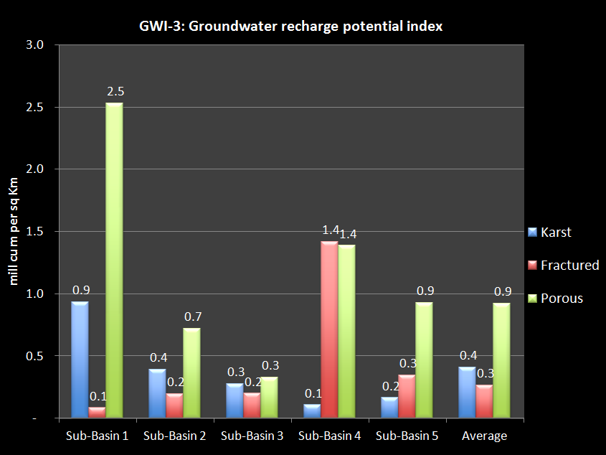

Figure 4‑3: Groundwater recharge potential index

GWI-4 is the groundwater exploitation index. This is the proportion of the Basin groundwater exploitation capacity in the sub-basins; and the exploitation capacity in the aquifer types in the sub-basins. It indicates the proportion of the Basin's total exploitation capacity that is provided by the sub-basin; and also shows the exploitation capacity of the aquifer types in the sub-basins. A high % indicates that a substantial proportion of the Basin's groundwater exploitation capacity is provided by a sub-basin. A low % means that the sub-basin most likely contains little usable groundwater.

To generate this indicator you will need to have the following information:

1. Basin groundwater exploitation capacity
2. Groundwater exploitation capacity in each sub-basin

For the fictitious Example River Basin, Figure 4‑4 shows that sub-basins 2 & 4 provide the most exploitation capacity at 25%, with the other sub-basins about equal. The most volume of exploitable water is in sub-basin 4 at 1.4 billion m3 a year in the porous aquifers. These aquifers generally provide more water that the other aquifer types.

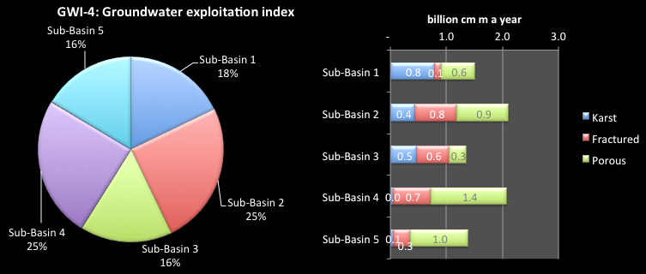

Figure 4‑4: Groundwater exploitation index

GWI-5 is the groundwater sustainability index. This is the Ratio of the exploitation capacity of the aquifer to the natural recharge. It shows the sustainability of the exploitation capacity of the aquifer. If the indicator is greater than 100%, then the groundwater is being extracted at greater than the recharge rate, so that water is being taken from the aquifer storage volume, which may not be replaced. For a sustainable aquifer system, the assessed exploitation capacity should be less that the natural recharge, recognising that some of the recharge is required to sustain aquifer processes and some surface environment, such as wetlands, and provide low flows to some rivers. In some countries a general level of 70% is taken as the default ratio. The only time when greater than 100% is sustainable is when there is induced recharge to the aquifer – when the extractions induce recharge that would not normally occur as the aquifer is full or near full.

To generate this indicator you will need to have the following information:

1. Assessed natural recharge of the aquifer.
2. Assessed exploitation capacity of the aquifer

For the fictitious Example River Basin, Figure 4‑5 shows that overall the basin is within sustainable limits – averaging extractions at around 70% of recharge. The highest level is for the fractured rock aquifer in sub-basin 1 at 90%. This may need careful watching into the future. It must also be remembered that his indicator is calculated as aquifer averages. There will be some areas of intense water exploitation where the current levels of extraction are not sustainable and are resulting in lowering water levels.

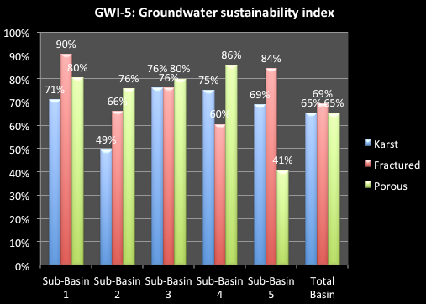

Figure 4‑5: Groundwater sustainability index

GWI-6 is the groundwater availability index. This is exploitation capacity of the sub-basin divided by: (a) current population (VN only); (b) projected population at 2025 (VN only). It relates the sustainable groundwater resources to the population (current and at 2025) and indicates the ability of the water resources to support the population and its economic activity now and into the future.

This indicator should be considered in conjunction with surface water availability, particularly in the dry season. While the two are not additive, together they do indicate the overall water availability per capita.

The international standards for water availability set out in Section 3.5 also apply here. However, they are indicative only as groundwater is seldom used on its own to meet water demands.

To generate this indicator you will need to have the following information:

(i) Populations for the sub-basin, and Basin overall.

(ii) Exploitation capacity in each sub-basin and for the Basin overall.

For the fictitious Example River Basin, **Figure 4‑6** shows that on its own groundwater would not be able to provide adequate water to the population. At current populations, sub-basins 3 &4 are already below the water shortage level (1,700 cu m per capita).

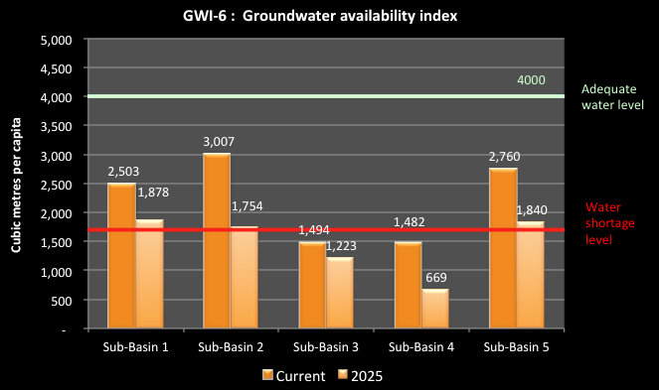

**Figure 4‑6. Groundwater availability indicator**

For projected 2025 populations, all sub-basins are near or below the water shortage level, with sub-basin 4 at less than half that requirement. Interestingly, this sub-basin also has serious dry season surface water shortages into the future, so that groundwater is unlikely to provide substantial additional supplies.

GWI-7 is the overall groundwater use indicator. This is the proportion of the total Basin groundwater use provided by each of the sub-basins. It indicates the proportion of the Basin's total groundwater use that is supported by the sub-basin. A high % indicates that a substantial proportion of the Basin's groundwater use occurs in a sub-basin. A low % means that there is relatively little groundwater use in the sub-basin.

To generate this indicator you will need to have the following information:

(i) Overall Basin groundwater use;

(ii) Groundwater use in each sub-basin.

For the fictitious Example River Basin, Figure 4‑7 shows that over half the groundwater use is in sub-basin 4, the areas of the main population and industrial development. Sun-basin 5 also has significant groundwater use making up 20% of the total.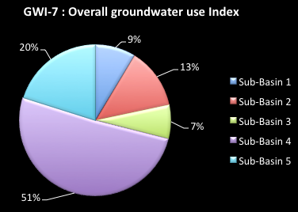

Figure 4‑7: Overall groundwater use index

GWI-8 is the groundwater use per sector indicator. This is the proportion of the sub-basin groundwater use by the main sectors (i.e. towns, industrial zones, rural water supply) and “other” uses not clearly identified. A high percentage for any of the sectors indicates the dependence of that sector on groundwater. A low percentage means that the sector has alternative supply sources. A high percentage for "other" means that water use monitoring is inadequate and use is poorly understood.

To generate this indicator you will need to have the following information:

(i) Basin overall groundwater use per sector.

(ii) Groundwater use per sector in each sub-basin.

For the fictitious Example River Basin, **Figure 4‑8** shows that groundwater use for towns is greatest in sub-basin 1 at 37% of total use in the sub-basin, and is lowest in sub-basin 5 (12%). Water use for industry is greatest in sub-basin 4, which contains the majority of industrial development. In this sub-basin, groundwater for rural water supply is proportionally less (8% of the sub-basin total) than in other sub-basins, reflecting the greater availability of surface water. Of concern is the high proportion of “other” uses in the sub-basins, particularly for sub-basin 5 at 50%. This means that water use monitoring is inadequate so that actual use and is poorly understood.

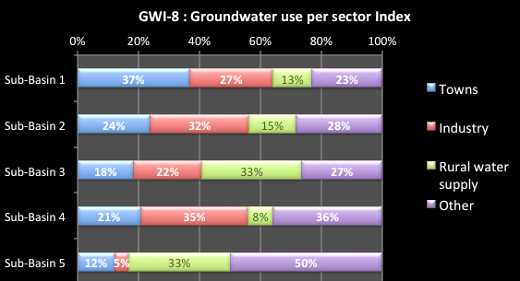

**Figure 4‑8. Groundwater use per sector indicator**

GWI-9 is the groundwater use per aquifer type indicator. This is the groundwater use by the sectors (towns, industrial zones, rural water supply) by aquifer type (karst, fractured rock and porous rock). It indicates the sub-basin's use of groundwater by both the sectors and aquifer type. A high use for any of the sectors indicates strong dependence of that sector on groundwater from a particular aquifer type. This may focus the groundwater management effort onto specific aquifer types in localities to protect water supply.

To generate this indicator you will need to have the following information:

1. Sub-basin groundwater use by the sectors (towns, industrial zones, rural water supply) by aquifer type
2. Basin overall groundwater use per sector and aquifer type

For the fictitious Example River Basin, Figure 4‑9 shows the strength of the water use in sub-basin 4 from the porous aquifers for urban and industrial supply. Use of the porous aquifers in sub-basin 5 is also high for rural water supply. The karst and fractured rock aquifers are particularly used for town and rural water supply in the upper sub-basins 1, 2 & 3.

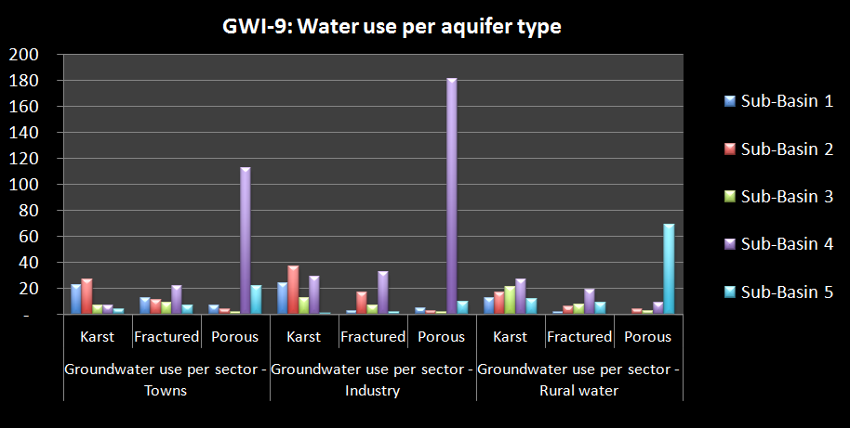

Figure 4‑9: Groundwater use by sectors and aquifer type

GWI-10 is the future groundwater use per sector indicator. This is the proportion of the sub-basin groundwater use, projected to 2025, by the main sectors (towns, industrial zones, rural water supply) and “other” uses not clearly identified. A high percentage for any of the sectors indicates the dependence of that sector on groundwater. A low percentage means that the sector has alternative supply sources. A high percentage for "other" means that water use monitoring is inadequate, and use is poorly understood.

To generate this indicator you will need to have the following information:

(i) Basin overall groundwater use per sector projected to 2025.

(ii) Groundwater use per sector in each sub-basin projected to 2025.

For the fictitious Example River Basin, **Figure 4‑10** shows that groundwater is projected to be meeting a far greater proportion of industrial water use at 2025 in all sub-basins, but particularly sub-basin 1 (47%). In sub-basin 5, water for rural water supply will be increasingly met from groundwater. In that sub-basin there is also projected to be less “other” uses.

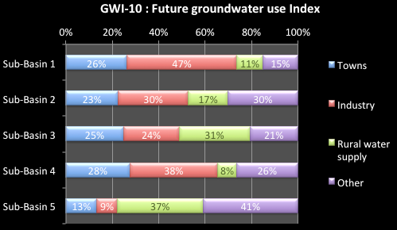**Figure 4‑10. Future groundwater use indicator**

GWI-11 is the groundwater use and exploitation capacity indicator. This is the ratio of groundwater use compared to the groundwater exploitation capacity, under current and 2025 conditions. It indicates the amount of the assessed exploitation capacity that is required to meet current and projected 2025 water uses. A figure greater than 100% means that current use is greater than the assessed exploitation capacity. This will require immediate management action to reduce groundwater use; otherwise the groundwater use will be unsustainable and the resource will be mined.

To generate this indicator you will need to have the following information:

(i) Total volume of groundwater exploitation capacity of the sub-basin.

(ii) Current groundwater total use from the aquifer of the sub-basin.

(iii) 2025 groundwater total use from the aquifers of the sub-basin

For the fictitious Example River Basin, Figure 4-11 shows that the largest growth in groundwater exploitation is in sub-basin 1, with use increasing from 8% of exploitation capacity to 15%. The other sub-basins experience smaller, although significant, increases.

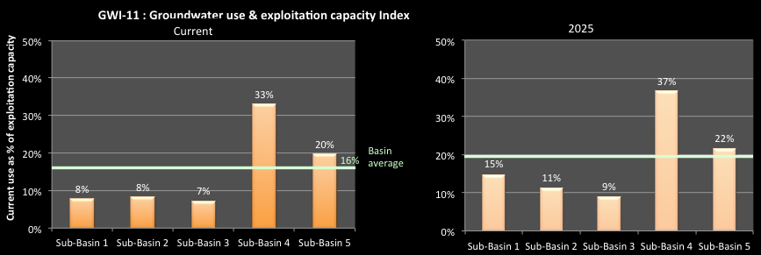**Figure 4‑11. Groundwater use and exploitation indicator**

GWI-12 is the water level drawdown indicator. This is the ratio of the drop in groundwater level of the aquifer at current conditions compared to conditions 10 years previously. A high number indicates a major lowering of water levels without recovery through natural process. This means that the aquifer is being mined and aquifer storage is being extracted. Extraction will progressively require higher pumping costs, increase the likelihood of drawing in poor quality water, and increase the potential for land use impacts, such as compaction and settlement.

To generate this indicator you will need to have the following information:

(i) Total volume of groundwater exploitation capacity of the sub-basin

(ii) Current groundwater total use from the aquifer of the sub-basin

(iii) 2025 groundwater total use from the aquifers of the sub-basin

For the fictitious Example River, Figure 4‑12 shows that only Sub-basin 4 has a significant area of the aquifer suffering water level drawdown – 30% of the aquifer area. This needs critical assessment to find the localities suffering the most drawdown and to put in place strategies to return the aquifer to a sustainable basis. An aquifer management plan appears essential.

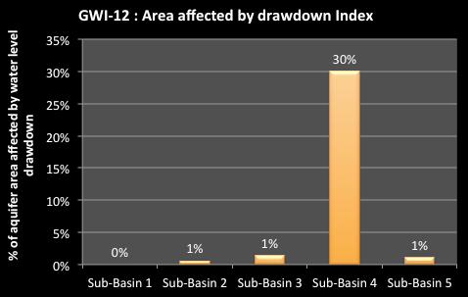Figure 4‑12: Area affected by drawdown index

GWI-12 is the groundwater quality indicator. This is the percentage of the aquifer area that is subject to saline water and arsenic contamination. Arsenic is a particular problem as it leads to chronic poisoning if ingested regularly in small doses. A high indicator value indicates that major parts of the aquifer are not suitable for exploitation and use without special treatment, and pose a health hazard. Careful management of these areas is required to ensure that contaminated water does not move into good quality aquifers.

To generate this indicator you will need to have the following information.

(i) The area of the aquifer that is subject to saline water.

(ii) The area of the aquifer that is subject to arsenic contamination.

(iii) The total areas of aquifer.

For the fictitious Example River Basin, **Figure 4‑13** shows that sub-basin 4 has problems with saline water and arsenic. 13% of the aquifer area is affected by saline water and 10% by arsenic in the groundwater. The area of arsenic contamination is a major concern as many communities rely on groundwater for their water supply. There are small areas of concern in the other sub-basin, and then will need investigation or monitoring, particularly the areas affected by arsenic.

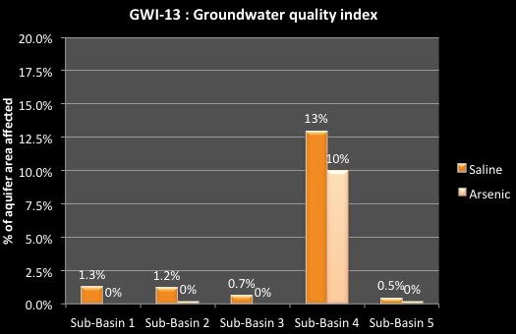**Figure 4‑13. Groundwater quality indicator**

### Data sources and comments

Groundwater potential (recharge) will generally need to be assessed for the main aquifers, but little existing information is currently available on this. Information for this may be sourced from various research reports such as from Research project 44-04-01-01, Research project of Mining-Geology University and Hydrology data, from program advance Science – Technology, State level, and some project level groundwater assessments. Calculations should be based on:

* The volume of groundwater discharge to rivers in mountainous areas, where the river discharge is the average of the month with the minimum discharge in each year of record, or
* The annual change in water level is estimated from field studies or data where available, or
* Recharge of rainfall to groundwater in delta areas, estimated as a proportion of average annual rainfall which infiltrates into the uppermost freshwater aquifer, using infiltration rates range from 5-10% of rainfall, depending on the aquifer type
* Currently, there is no national inventory on the use of groundwater. Data will have to be sourced from reports available at MoNRE Department of Water Resources Management and DoNREs. Assessments may also be derived from:
  + Statistical data on upland cropping in mountainous areas, and winter-spring rice plantings in other areas, and the volume of irrigation water use per ha in each area.
  + Estimates of use by large scale Water supply companies based on the results of investigation data of single wells and bore fields, and from company records where these exist. These are likely to be an underestimation of use.
  + Estimates of groundwater use per capita of rural populations, and estimates of the number of small bores and dug wells.

# 

# Social Development Indicators

The social development indicators seek to show the relationship between the social conditions in Viet Nam and river basins and the provision of basic water services to people. They also indicate the impacts of water related disasters on communities.

## Population Indicators

### Explanation of Population Indicators

SDI-1 is the Basin population indicator. This shows the proportion of the Basin population that lives in each sub-basin. The higher the percentage, the greater the significance to the Basin overall in terms of putting pressure on the water and related natural resources, and on the potential demands for water services

To generate this indicator you will need to have the following information:

(i) Basin population both current and in 2025.

(ii) Sub-basin populations both current and in 2025.

For the fictitious Example River Basin, Figure 5‑1 shows that under current conditions, sub-basin 4 has 40% of the Basin population. The next highest is sub-basin 2 with 20%. Sub-basin 3 & 5 are at about half that. By 2025, sub-basin 4 will have an even greater proportion of the Basin population at 44%. This sub-basin will clearly be the economic driver for the Basin and its growing population will put increasing pressure on the water resources of the sub-basin.

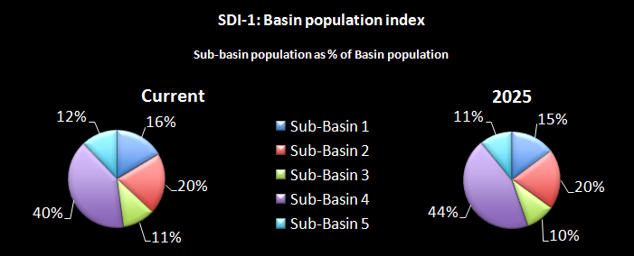

Figure 5‑1: Basin population index

SDI-2 is the population growth indicator. This is the average annual population growth in each sub-basin over the last 5 years. It indicates the potential growth of the population and the potential change in water demand over time. A high percentage indicates a faster growing population and a more rapid increase in impacts on the sub-basin.

To generate this indicator you will need to have the following information:

(i) Sub-basin populations in each of the last 5 years.

For the fictitious Example River Basin, **Figure 5‑2** shows that the greatest population growth is for sub-basin 4. Sub-basins 1 and 3 have SDI 1 the lowest growth rate reflecting the migration of workers to industrial areas and urban centres outside of the sub-basin. This sub-basin has an annual growth rate of over twice the Basin average (2.05% a year). Sub-basin 2 also has a high growth rate at 1.45% a year, well above the other 3 sub-basins.

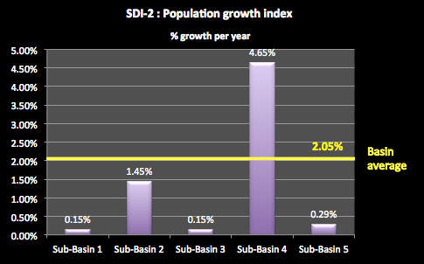

**Figure 5‑2. Population growth indicator**

SDI-3 is the population density indicator. This is the sub-basin population divided by its area. It indicates the pressures on the sub-basin from the density of its population. A high percentage suggests greater potential impacts on demands for water services, water supply, wastewater disposal, waste disposal, employment opportunities as well as the associated potential for degradation and pollution.

For the fictitious Example River Basin, Figure 5‑3 shows that the Basin average of 267 people per km2 is greater than the National average of 252. Sub-basin 4 had the highest population density, nearly 4 times the Basin average, and is projected to increase into the future. Of the other sub-basins, only sub-basin 1 is greater than the Basin and National average, but its density is not projected to increase much into the future.

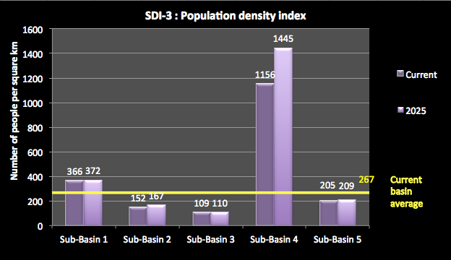

Figure 5‑3: Population density indicator

SDI-4 is the rural-urban indicator. This shows the proportion of the population of each sub-basin that live in the rural and urban areas. The proportion of the population living in urban and rural areas indicates the level of water services they require. A higher proportion of rural people may suggest the need special consideration for pro poor developments

To generate this indicator you will need to have the following information:

* + - 1. Sub-basin populations in rural areas.
      2. Sub-basin populations in urban areas.

For the fictitious Example River Basin, Figure 5‑4shows that the sub-basin populations are predominantly rural. In most sub-basins, the rural population is by far the greatest proportion of the population – up to 83% in sub-basins 1 & 5. Conversely, the urban population is dominated by sub-basin 4, with 32% of its people living in urban areas, and to a lesser extent sub-basin 2 at 25%.

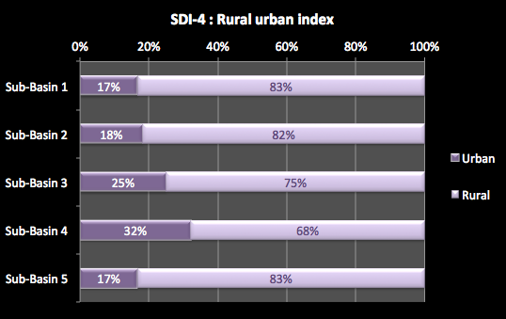

Figure 5‑4: Rural Urban Index

### Data sources and comments

The Basin population figures can be sourced from GSO website: [www.gso.gov.vn](http://www.gso.gov.vn). Sub-basin populations can be derived from provincial and district populations according to apportionment of provinces and districts to sub-basins as required. Projections of populations into the future can also be obtained from the GSO.

For SDI-2, a simplified approach to population growth may be taken. Using the data sources outlined for populations, the following formula may be applied to each river sub-basin:

$$Average annual sub-basin pop growth \left(\%\right)=\frac{1}{5}×\left(\frac{{Sub\text{-}basin pop}_{yr5}–{Sub\text{-}basin pop}_{yr1}}{{Sub-basin pop}_{yr1}}\right)$$

Where *Sub-basin popyr5* is the sub-basin population in year 5, the most recent year available, and *Sub-basin popyr1* is the sub-basin population in year 1, 5 years prior.

Try to exclude swamp and lagoon areas from the sub-basin areas, as these can be significant.

For the rural-urban population distributions assume that urban areas are defined as special urban centres, and class I to V urban centres, as defined by Decree 42/2009/NĐ-CP (signed 7th May 2009). Assume that communes and villages of less than 4,000 people are included in the rural population.

## Poverty and employment indicators

### Explanation of poverty, ethnicity and employment indicators

For the poor, including the unemployed and ethnic minorities, water and water services are among the most critical factors for their social and economic improvement. For example, water and sanitation availability, as per Millennium Development Goal (MDG) 7, influences health, gender issues, and the economy. A recent study[5] of 193 countries assessed the influence of water and sanitation against indicators associated with MDGs 1 to 6 as follows:

Table 5‑1. Influence of water and sanitation on MDGs

|  |  |  |
| --- | --- | --- |
| **Millennium Development Goal** | **Influence of water and sanitation on MDG** | |
| Water supply | Sanitation |
| **Poverty and hunger (MDG 1)** | ☑ | ☒ |
| **Primary education (MDG 2)** | ☒ | ☒ |
| **Gender equality (MDG 3)** | ☑ | ☒ |
| **Child mortality (MDG 4)** | ☑ | ☑ |
| **Maternal health (MDG 5)** | ☑ | ☑ |
| **Diseases (MDG 6)** | ☑ | ☒ |

*☑ statistically significant relationships between the provision of water or sanitation and the MDG*

*☒ not statistically significant relationships between the provision of water or sanitation and the MDG*

The analysis found statistically significant relationships between access to an improved water source and indicators for Goals 1, 3, 4, 5 and 6; and access to improved sanitation for Goals 4 & 5. Clearly, a good understanding of poverty, ethnicity and unemployment is an important part of setting out tasks for river basin planning.

SDI-5 is the poverty indicator. This shows the number of people and the percentage of households in the sub-basin living in poverty. These people are vitally interested in water availability, quality, and quantity. A high number suggests that a great many people in the sub-basin live in extremely poor conditions, which affects access to safe food and sanitation.

|  |  |  |
| --- | --- | --- |
| *Note: the Poverty threshold applied for the General census (1752/CT-TTg, September 2010, is as follows:* | | |
| *Rural area* | *< 400,000 VND/capita/month (4.8 million VND/year)* | |
| *Urban area* | *< 500,000 VND/capita/month (6.0 million VND/year)* | |
|  |  |  |

To generate this indicator you will need to have the following information:

1. Number of households assessed as in poverty for the sub-basin and the Basin.
2. Population assessed as living in poverty for the sub-basin and the Basin.
3. Populations of the sub-basin and Basin

For the fictitious Example River Basin, Figure 5-5 shows that sub-basin 1 has a poverty problem with 31% of households, comprising 527,000 people (44% of the sub-basin population), assessed as living in poverty. Sub-basin 3 has a higher household poverty rate, but less people (322,000). In sub-basin 4, only 12% of households are in poverty, but this represents 333,000 people.

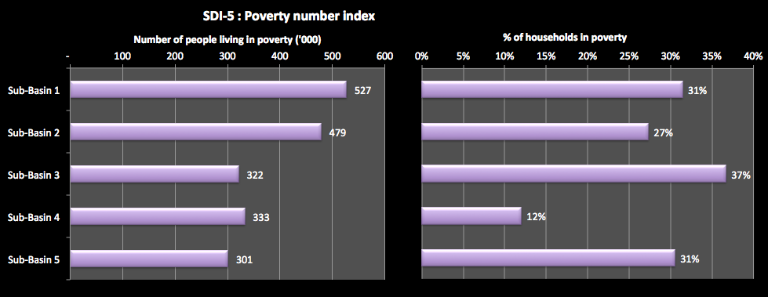

**Figure 5‑5. Poverty indicator**

SDI-6 is the ethnic minority indicator. This is the proportion of the total population in each sub-basin that are ethnic minority people. A high percentage can indicate both a need for provision of water services as these people are often the poor, and the potential difficulty in providing services.

To generate this indicator you will need to have the following information:

1. Number of people of ethnic origin for the sub-basin.
2. Total population of the sub-basin.

For the fictitious Example River Basin, Figure 5‑6 shows that sub-basin 1 has 64% of the population of ethnic origin, compared to a Bain average of 36%. The lowest indicator value is for sub-basin 4 at 17%.

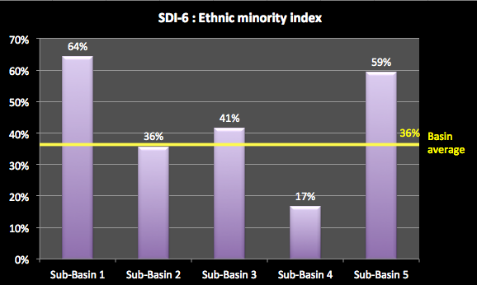

Figure 5‑6: Ethnic Minority Index

SDI-7 is the employment index. This is the percentage of people employed in the agriculture, industry, and service sectors. This indicator illustrates which sector is most important to a sub-basin in terms of employment, and which sector may need priority for water allocations These three indicators should be assessed along with GDP and water use by sector. These can then be used to assess tradeoffs between employment, economic productivity, and water use.

To generate this indicator you will need to have the following information:

1. Percentage of people employed in the agricultural, industry and services sectors.

For the fictitious Example River Basin, Figure 5‑7 shows that employment in the agricultural sector dominates the statistics – highest in sub-basin 1 at 80% of total employment. Only sub-basin 4 has agricultural employment at less than 70%, where it is 46%. That sub-basin has 27% of employment in each of the industrial and services sectors. For the other sub-basins, industrial employment is low at 11% or less.

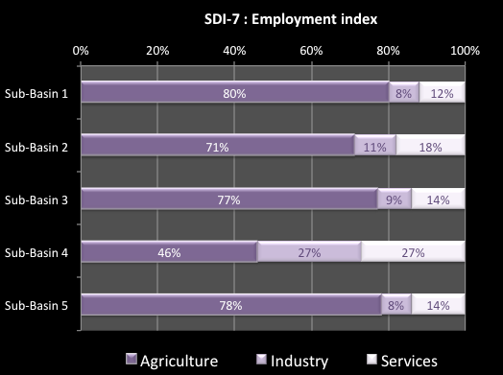

Figure 5‑7: Employment Index

SDI-8 is the unemployment indicator. This is the percentage of people unemployed in each sub-basin. It indicates the ratio of people without a job. A high percentage suggests that this sub-basin may need special consideration for pro-poor developments.

To generate this indicator you will need to have the following information:

1. Percentage of people un-employed in the sub-basin.

For the fictitious Example River Basin,

**Figure 5‑8** shows that the urban unemployment rate is much higher that the rural rate. Sub-basin 4 has the highest urban and rural rates, followed by sub-basin 2. The other sub-basins have fairly similar levels of un-employment.

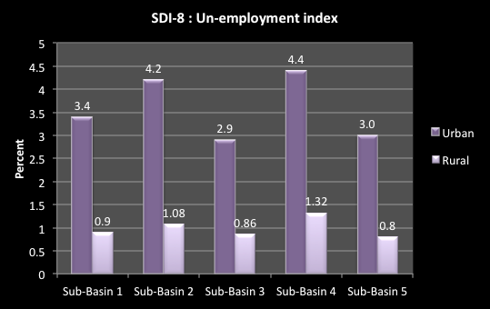

**Figure 5‑8. Unemployment indicator**

### Data sources and comments

For the poverty indicators, provincial data on the total number of households, and the number of households assessed as living in poverty may be obtained from GSO, or from any Poverty Assessment studies undertaken by the Ministry of Labour, Invalids Social Affairs (MOLISA). Data will need to be adjusted to account for provinces in more than one sub-basin. In making this adjustment, you can assess the number of poor people living in each sub-basin by assuming an average of five people per household.

For the ethnic minority population in a sub-basin, studies by the Committee for Nationalities ([www.cema.gov.vn](http://www.cema.gov.vn)) may assist. Old data may need to be converted to more up to date data by making assumptions about how the proportion of ethnic minority people in each sub-basin may have changed over time.

For the employment and unemployment indicators, data may be sourced from MOLISA provincial scale survey results, adjusted by the project to account for provinces in more than one basin. Employment age can be assumed as between 15 and 55 for females, and 15 and 60 for males. Data must be assessed carefully as they can vary considerably arising from the definition of ‘employment’, differences between national and provincial sources, and the likelihood of under-reporting from rural areas.

## Water related services indicators

### Explanation of water related services indicators

SDI-9 is the urban clean water indicator. This shows the percentage of people with access to clean water in urban areas under direct control of the central or provincial governments, and in district level urban areas. Clean water here is measured according to MoH standards QCVN 02:2009/BYT “National technical regulation on domestic water quality” which specifies 14 parameters to be measured. The WSR found that provision of services at District level was far less effective that at the larger cities and towns under Provincial control. A high percentage shows good access to essential services. A low percentage means that access to clean water is not generally available so the poorer people have to obtain access to raw or untreated water, or buy expensive clean water.

To generate this indicator you will need to have the following information:

1. The % of people with access to clean water for urban areas at Provincial capital level.
2. The % of people with access to clean water for urban areas at District level.

For the fictitious Example River Basin, Figure 5-9 shows that the provision of clean water at District level is far less than at Provincial capital level. Sub-basin 1 has only 12% of people at District level having access to clean water, compared to nearly half the population at the Provincial capital level. Sub-basin 4 has the highest percentage of people in urban areas having access to clean water – 66.7% for the Provincial capital. However, even in this sub-basin less than a quarter of the people in the District urban areas have access to clean water.

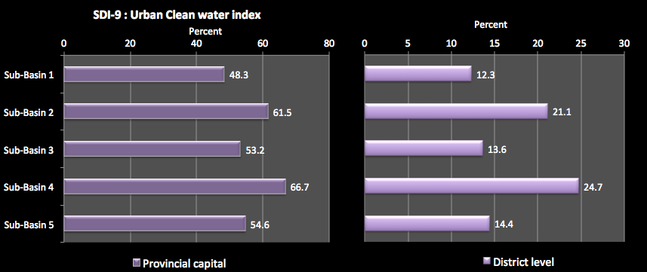**Figure 5‑9. Urban clean water indicator**

SDI-10 is the rural hygienic water indicator. This shows the proportion of people in rural areas of the sub-basin with access to hygienic water in their home or at a public facility. It indicates the access people have to hygienic water in rural areas and the nature of that access. Here, hygienic water is a judgment based on 5 informal parameters used by MARD. The general condition is that water is safe for drinking after boiling.

In 2008, MARD issued Decision No.51/2008/QĐ-BNN on Rural Water Supply and Sanitation Monitoring & Evaluation Indicator Set. This Decision set forth that rural hygienic water would have no color; no smell; no strange odor; no harmful components that can negatively affect the human health, and it can be used for drinking after boiling. The Decision specified that these were qualitative measures for judging water quality.

Ideally, this indicator would be based on MoH standards for Domestic Water which would allow this indicator to be compared directly with SDI-9. The MoH has issued QCVN 02:2009/BYT “National technical regulation on domestic water quality” which specifies 14 parameters to be measured. Unfortunately, that data does not exist for rural water supply in Vietnam. Moreover, the current government priority is to ensure delivery of enough water, rather than clean water. If, the government priority changes to delivery of rural water supply at MoH Domestic Water standards and data are collected to monitor this coverage, then this indicator should be modified from “hygienic” water to “clean” water, and based on the appropriate data. A current rough estimate is that rural water supply at MoH standards is 40-50% of delivery at MARD’s rating.

A high percentage shows good access to essential services. A low percentage means that access to clean water is limited so poorer people must use raw water in rivers, untreated water, or buy expensive clean water.

To generate this indicator you will need to have the following information:

1. For rural areas, % of people with water piped to home, according to MARD conditions.
2. For rural areas, % of people with access to a public supply according to MARD conditions.

For the fictitious Example River Basin, Figure 5‑10 shows that rural people have less access to clean water that urban people (shown in SDI-9), with typically only 25% to 30% of people having access to clean water in the home. A small percentage of additional people have access to a public facility. This means that nearly three quarters of the people in the Basin, often the poorer people, have to use raw water in rivers or untreated water. For most of these people, buying clean water is not an option.

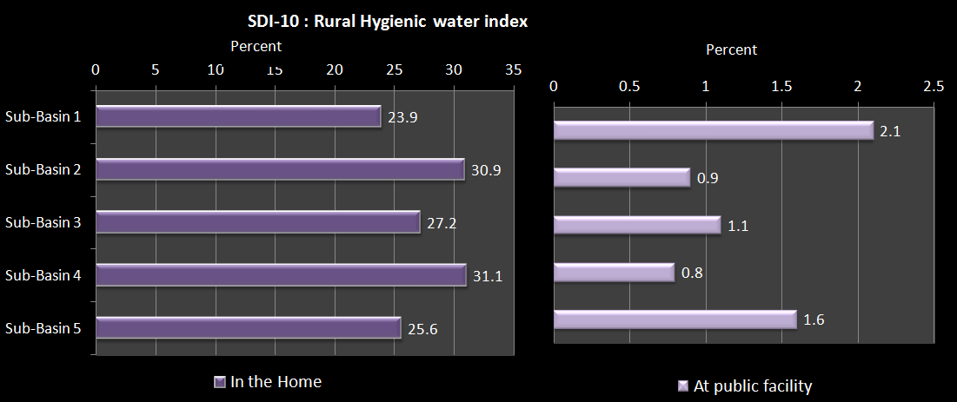

Figure 5‑10. Rural clean water indicator

SDI-11 is the urban sanitation indicator. This is the proportion of households in urban areas of the sub-basin with access to sanitation (connection to centralized sewerage system or a hygienic latrine) assessed at Provincial capital level and District level. A high percentage shows good access to adequate sanitation services. Note this does not indicate wastewater treatment – see Environmental indicator EVI-9. A low percentage means that people have to use makeshift facilities, often directly into the natural environment.

To generate this indicator you will need to have the following information:

1. For Provincial levels, the % of people with access to sanitation services, according to Ministry of Health standards.
2. For District level urban areas, the % of people with access to sanitation services, according to Ministry of Health standards.

For the fictitious Example River Basin, Figure 5‑11 shows that, as with clean water access (SDI 10), provision of sanitation services at District level is far less than at Provincial level. At provincial level, virtually all of the people have access to sanitation services, but in District level towns this is only at around 70 to 80%. The District level is also far greater than for clean water supply. This implies that at District level people have to make their own arrangements for water supply but are able to avail themselves of sanitation facilities. However, the sanitation service may be a septic tank, the effectiveness of which depends on regular maintenance. This indicator does not assess how effective the operation of the septic tank is, which could have a major impact on the nature of the sanitation service. These results need to be compared to EVI-9 on domestic wastewater disposal.

At Provincial and District levels, people in sub-basins 1 & 3 have significantly less access to sanitation that in other sub-basins.

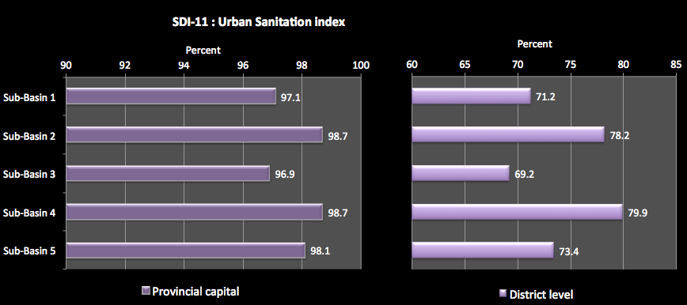

Figure 5‑11: Urban Sanitation Index

SDI-12 is the rural sanitation indicator. This is the proportion of people with access to sanitation in rural areas in the sub-basin, both in the home and with public access. A high percentage shows good access to essential services. A low percentage means that people have to use makeshift facilities, often directly into the natural environment.

To generate this indicator you will need to have the following information:

1. For rural areas, % of people with sanitation services at home, according to Ministry of Health standards.
2. For rural areas, % of people with access to a public sanitation facility according to Ministry of Health standards.

For the fictitious Example River Basin, Figure 5‑12 shows that sub-basin 1 has less than 30% of its people with access to sanitation services at home, and a very small percentage of public facilities. This means that nearly 70% of the people use makeshift facilities or the natural environment to meet their sanitation needs. The highest level of rural sanitation is for sub-basin 4 at 43.6%.

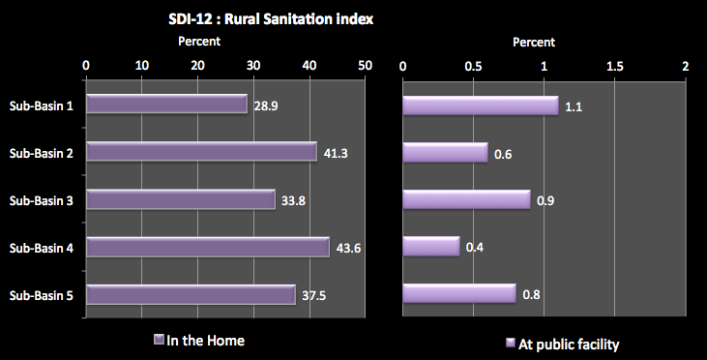Figure 5‑12. Rural sanitation indicator

### Data sources and comments

Data for the urban clean water indicator may be sourced from Viet Nam water supply and sewerage association annual reports (VWSA), from the regular benchmarking survey of companies carried out by VWSA, and from Provincial water supply companies. Clean water is defined by MOH drinking water standards. Note that the urban areas serviced by a company do not necessarily represent the entire defined urban areas. Urban areas include special urban centres, and class I to V urban centres where class IV and V are district level urban areas.

For the rural clean water indicator, note that the ‘rural’ areas include all communes, towns, villages and other smaller units. Data may be sourced from VWSA annual reports. Other reports that may prove useful include reports under NTP II on rural water supply and sanitation. Clean water is preferably defined by MOH drinking water standards (but data may only be available according to MARD’s hygienic water ‘standard’).

For the urban sanitation indicator, a hygienic latrine is defined as being a flush toilet connected to public sewerage system, or a pour flush toilet with septic tank and leach pit. Data may be sourced from VWSA annual reports and from provincial sewerage companies.

The rural sanitation indicator, a hygienic latrine is one meeting MoH standards, and is a pour flush toilet with septic tank and leach pit, or a double vault composting latrine. Data may be sourced from VWSA annual reports, Provinces, and reports under NTP II on rural water supply and sanitation.

The Viet Nam Household Living Standards Survey will also be relevant and useful.

## Water related disaster indicators

### Explanation of water related disaster indicators

SDI-13 is the flood damage indicator. This is the average yearly cost of flood damage and natural disaster in each sub-basin for a 10-year period, expressed as a percentage of GDP. It indicates the susceptibility of the basin community to severe flooding and natural disasters. A high percentage indicates that the sub-basin has been exposed to severe flooding and natural disasters. Typically, poorer people are most susceptible to flooding. Although the value of damage may be less for poor people, the resources to recover and vulnerability for going deeper into poverty are much higher.

To generate this indicator you will need to have the following information:

1. Flood and natural disaster damage (in VND) caused by floods in each of last 10 years for the sub-basin.
2. Sub-basin GDP at current values.

For the fictitious Example River Basin, Figure 5‑13 shows that Sub-basin 4, having a significant coastal area, has the greatest losses from flood and natural disaster damage, at 2.3% of GDP. This amount is one fifth of the GDP growth rate of the sub-basin providing a significant slowing to the sub-basin economy. The other sub-basins have an indicator value equal to or less than the Basin average of 2%. For sub-basin 1 the flood and natural disaster damage at 1.2% of GDP is almost equivalent to the annual growth rate of the sub-basin economy (2%). This means that on average the economic growth of the economy is lost in flood and natural disaster damage. For the other sub-basins, the flood and natural disaster damage is about a quarter to one fifth of the annual GDP growth rate, representing a significant retarding effect on the economic growth.

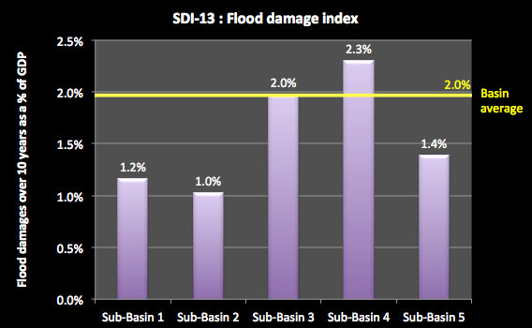

Figure 5‑13. Flood damage indicator

### Data sources and comments

Data sources include the Centre Committee for flood and storm control disaster data base at:

<http://www.ccfsc.gov.vn/KW6F2B34/Co-so-du-lieu-thien-tai.aspx>

It should be noted that while the damage figures are primarily due to flood disasters, they can include damage from flood, drought, bank erosion, ice rain, storm, cyclone, etc.

# 

# Economic Indicators

This section presents the economic indicators and discusses the major implications. The indicators focus on economic growth and development, economic structure, and productivity from water and its uses.

## GDP Indicators

### Explanation of GDP indicators

EDI-1 is the sub-basin GDP indicator. This is the sub-basin GDP divided by the Basin GDP, at current prices. This shows the significance of the current levels of economic activities of the sub-basin to the Basin economy. A high indicator value means that the sub-basin is contributing significantly to the Basin economy compared to other sub-basins.

To prepare this indicator you will need to have the following information:

1. Total GDP for the Basin at current prices.
2. Total GDP for each sub-basin at current prices.

In the fictitious Example River Basin, the total GDP for the Basins is 155,940 billion VND at 2010. Figure 6‑1 shows that sub-basin 4 generates the bulk of the Basin GDP – 69%. The other sub-basins generate relatively little Basin GDP as a whole.

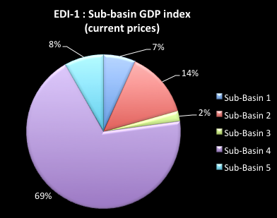

Figure 6‑1: Sub-basin GDP Indicator

EDI-2 is the GDP per capita indicator. This is the sub-basin GDP at current prices divided by sub-basin populations. It shows the current level of per capita income in the basin and sub-basins. A high indicator value shows that sub-basin economic activity is more adequate for meeting the income needs of the population compared to other sub-basins.

To prepare this indicator you will need to have the following information:

1. Total GDP (current values) and population for the Basin.
2. Total GDP (current values) and population for the sub-basins.

The National average for this indicator is VND 28.9 million per person at current values.

In the fictitious Example River Basin,

Figure 6‑2 shows that sub-basin 4 has the highest indicator value, about twice the Basin average and nearly four times the national average. Production value per person is very high. All of the other sub-basins are under the Basin average. Sub-basins 1 &3 have an indicator value below the National average, indicating a low-value economy.

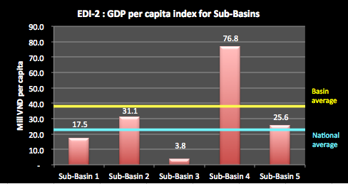

Figure 6‑2. GDP per capita indicator

EDI-3 is the GDP growth indicator. This is the average annual GDP growth rate over the last 5 years. It indicates the strength of growth of economic activities of the sub-basin and is assessed at constant 1994 prices to remove the effects of inflation and show actual growth. A high percentage suggests strong growth.

To prepare this indicator you will need to have the following information:

1. Total GDP for the sub-basins for the most recent 5 years, at constant 1994 prices.

In the fictitious Example River Basin, Figure 6‑3 shows that sub-basin 4 has the highest indicator value, well above the Basin average and the national average. It is nearly twice the rate of any other sub-basin. Sub-basins 2, 3 & 5 are all at about the National average. Only sub-basin 1 has an indicator value below the National average, indicating low growth of that economy.

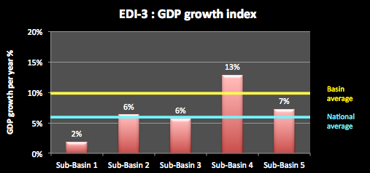Figure 6‑3. GDP growth indicator

EDI-4 is the economic structure indicator. This shows the percentage contribution of the agriculture (A), industry (I) and services (S) sectors to the GDP of each basin, assessed at current GDP values and indicates the nature of economic activity in the basin. This helps identify the economic drivers for the sub-basin and also the potential impacts of overall economic activities on water resources.

To prepare this indicator you will need to have the following information:

1. Total GDP for the sub-basins at current values.
2. Value of economic production per sector for the sub-basins.

In the fictitious Example River Basin, Figure 6‑4 shows sub-basin 4 dominated all economic activity. Over half of its GDP was produced by the industrial sector, and relatively little from the agricultural sector. Sub-basin 2 also has a high proportion of industrial GDP (28%). These sub-basins may be the economic drivers for the Basin as a whole, but the high levels of industrial activity may have consequences for water pollution or other degradation.

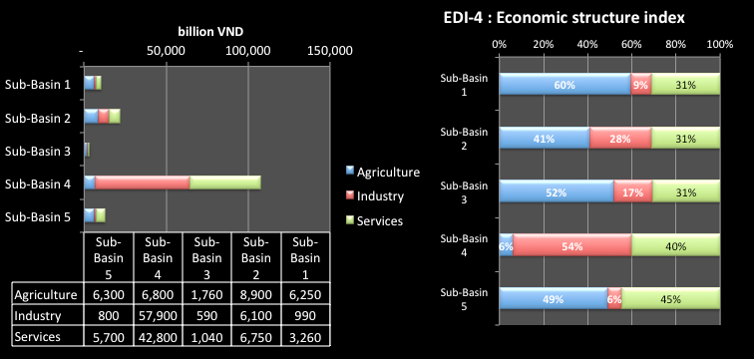Figure 6‑4. Economic structure indicator

Sub-basins 1, 3 & 5 are dominated by the agricultural sectors, with relatively little industrial economic activity. The services sector contribution to GDP is fairly constant across the sub-basins at about 25% to 35%.

### Data sources and comments

Gross Domestic Product (GDP) is the measure of an area’s total economic output for a given period; usually for a nation for a year. However, GDP can also be applied to any area, such as a river basin, and defined for any period of time. GDP is measured in both current and constant prices.

GDP at current price is calculated based on the price found in a given year. It includes affects of inflation. Current prices are useful for assessing the structure of the economy and for reflecting the current status of the economy.

GDP at constant price is calculated by removing the effect of inflation on prices by adjusting all output to a single year’s price. GDP at constant price is useful for assessing the growth of the economy over time and changes in quantities of output for different economic sectors.

For the GDP statistics, use figures from the General Statistics Office of Viet Nam. For the analysis of current GDP and GDP per capita, use current value GDP figures. For an analysis of GDP growth, use GDP based on constant 1994 prices, so as to remove the effects of inflation.

For assessing GDP growth assume that this is the average growth rate over the most recent 5 years, expressed as a percentage. The sub-basin GDP growth is the average of GDP growth rates of all provinces in the sub-basin, adjusted for provinces that span more than one sub-basin.

The sub-basin GDP may have to be calculated from the GDPs of provinces included in basins, plus or minus districts that are inside or outside of the sub-basin.

Sector GDPs for basins can be estimated based on sector GDPs for provinces derived from MPI data, and adjusted for provinces spanning more than one basin. The agricultural sub-sectors include irrigation, farming, livestock, and aquaculture.

Use caution as there can be wide discrepancies between national and provincial GDP methods and data

## Subsector economic indicators

### Explanation of subsector economic indicators

EDI-5 is the industry sector production indicator. This indicates the economic value of industrial production per unit of water used for industrial activities (in thousands of VND per m3 of water used). It may be difficult to obtain accurate data on industrial water use for this indicator. Information that is available is not likely to separate surface water and groundwater. A high indicator value shows a sub-basin with significantly greater economic returns from industrial production per unit of water input compared with the other sub-basins, but does not necessarily, reflect more efficient use of water, which it is highly dependent on the industry type, the value of outputs, and it water use. NOTE: This indicator ascribes 100% of industrial output value to water, which will over estimate the marginal value of water as all other inputs to industry are excluded.

To prepare this indicator you will need to have the following information:

1. Total economic value of industrial production for the sub-basins, and for the Basin.
2. Total water used for industrial production within the sub-basins, and for the Basin.

In the fictitious Example River Basin, Figure 6‑5 shows sub-basin 4 has a very high value of economic production per unit of water used for industrial activities – well in excess of any other sub-basin and nearly twice the Basin average. Sub-basins 1 & 3 have relatively small economic returns for water use in industry.

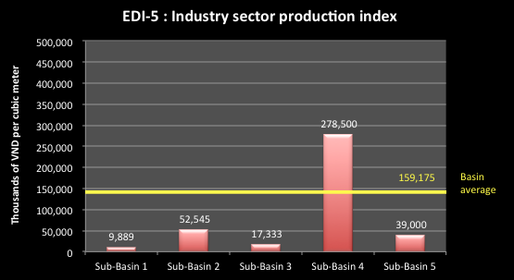

Figure 6‑5. Industry sector production indicator

If there is sufficient data, it would be very useful to prepare an additional indicator specifically for craft village production, so that water use in that sector can be compared to other uses of water. Unfortunately, a current lack of data may make it impossible to compile this indicator.

EDI-6 is the irrigation production indicator. This shows the value of irrigation production per unit of water used for irrigation activities (in thousands of VND per m3 of water used). Note that the water used will generally include both surface water and groundwater, as it is difficult to separate these. A high production value per unit of water use may, but does not necessarily, indicate more efficient use of water, as the indicator value is highly dependent on the crop type, the nature of the irrigation system, the value of products, and its water requirements. NOTE: This indicator ascribes 100% of irrigated agricultural output value to water, which will over estimate the marginal value of water as all other inputs are excluded.

To prepare this indicator you will need to have the following information:

1. Total economic value of irrigation production for the sub-basins, and for the Basin.
2. Total water used for irrigation production within the sub-basins, and for the Basin.

In the fictitious Example River Basin, shows sub-basin 5 has a high value of economic production per unit of water used for irrigation activities – well in excess of any other sub-basin and nearly than twice the Basin average. This may suggest irrigation of a high value crop in the sub-basin. Sub-basins 1 & 2 have relatively high economic returns for irrigation water use. Note that all of the economic returns from irrigation water user are well below those generated by industry water use, however, this is due to the much higher value of marginal product for industry’s non-water inputs.

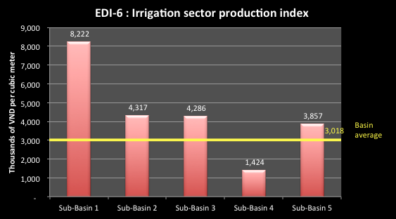

Figure 6‑6. Irrigation sector production indicator

EDI-7 is the irrigation development indicator. This shows the proportion of the design area of irrigation schemes in a basin that is currently irrigated. A high number indicates that the irrigation schemes are highly developed. A low number might suggest that there is a constraint to effective operation, e.g. too little water, inefficient operation, poor system management, or poor design.

To prepare this indicator you will need to have the following information:

1. Total design area for irrigation production for the sub-basins, and for the Basin.
2. Total actual are irrigated within the sub-basins, and for the Basin.

In the fictitious Example River Basin, Figure 6‑7 shows sub-basin 1 has the highest level of development of the design irrigation area at 84% – well in excess of any other sub-basin and greater than the Basin average. The other sub-basins have about 30% of their design area not being irrigated. The reasons for this under use include: funding shortfalls; water availability shortfalls; under-capacity of systems; planning or design changes or deficiencies; incomplete construction of works, including lack of secondary or tertiary canal systems; system damage or degradation; and poor system operations.

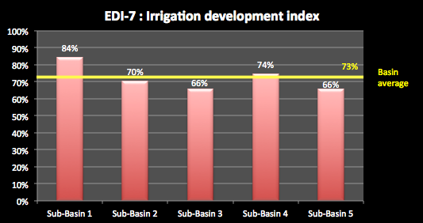

Figure 6‑7: Irrigation development indicator

EDI-8 is the hydropower indicator. This shows the current hydropower generating capacity of the sub-basin (in megawatts at 2010 levels, including small hydropower capacity) as a proportion of the total Basin hydropower generating capacity. A high percentage indicates that this sub-basin is providing a significant contribution to the Basin hydropower generating capacity and is therefore important regionally.

To prepare this indicator you will need to have the following information:

1. Total current Basin hydropower generating capacity for the Basin.
2. Total current sub-basin HP generating capacity.

In the fictitious Example River Basin, Figure 6‑8 shows sub-basin 2 clearly provides the majority of the generating capacity – 85%. Sub-basins 1 & 3 have a small generating capacity and the other sub-basins no current hydropower dams.

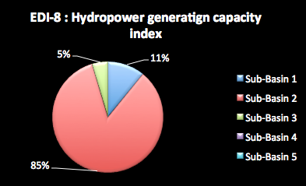

Figure 6‑8: Hydropower Generating Capacity Index

EDI-9 is the future hydropower indicator. This shows the projected hydropower capacity of the sub-basin (in megawatts at 2025 levels) as a proportion of the projected hydropower capacity of the Basin in 2025.

To prepare this indicator you will need to have the following information:

1. Total 2025 Basin hydropower generating capacity for the Basin.
2. Total 2025 sub-basin HP generating capacity.

In the fictitious Example River Basin, Figure 6‑9 shows that sub-basin 2 would still provide the majority of the hydropower at 2025 projection levels, but that the significance of the other sub-basins would increase.

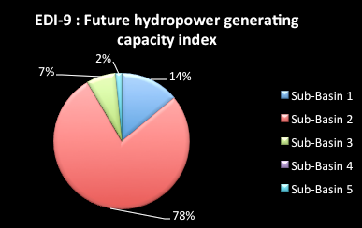

Figure 6‑9: Future hydropower generation capacity indicator

EDI-10 is the hydropower development index indicator. This shows the proportion of the full technical and economic potential for hydropower development of the sub-basin that is currently developed, and that which developed at 2025 projections. The WSR found that Viet Nam has relatively small hydropower potential overall – a maximum of about 85,000 GWh a year, compared to 130,000 GWh a year for Japan, 320,000 GWh a year for India and 1,300,000 GWh a year for China. By 2025, this is expected to increase to 83%, a very high proportion of its full hydropower potential. The levels of development for the sub-basins are important to assess the pressure that such development is putting on the river basin.

To prepare this indicator you will need to have the following information:

1. Total full potential hydropower of the sub-basin.
2. Total current sub-basin HP generating capacity of the sub-basin.
3. Total 2025 sub-basin HP generating capacity of the sub-basin.

In the fictitious Example River Basin, Figure 6-10 shows that sub-basin 2 has 76% of its full hydropower potential developed. This is a very high level. By 2025, sub-basin 1 will have risen from 41% to 57%. Overall, the Basin figure is that, at 2025, 68% of the hydropower potential of the basin will have been developed. This means that to develop the remaining potential will involve the less feasible structural options – each additional MW will come at increasing cost and will be putting greater stress on the river Basin.

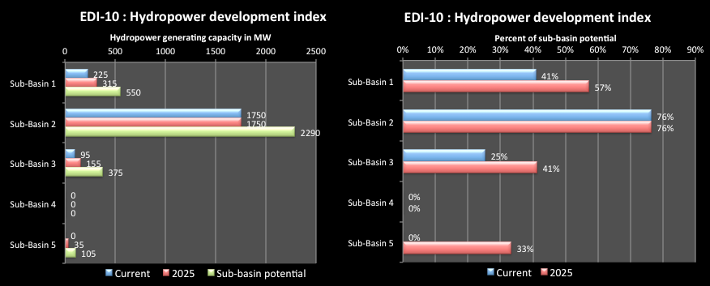Figure 6‑10. Hydropower development indicator

EDI-11 is the navigation value indicator. This is economic value of inland cargo for the sub-basin as a proportion of total for Basin. This illustrates the value of cargo and passenger navigation of the sub-basin to the overall Basin.

To prepare this indicator you will need to have the following information:

1. The economic value of inland navigation in sub-basins.
2. The economic value of inland navigation in Basin.

In the fictitious Example River Basin, Figure 6‑11 shows that sub-basin 5 is by far the most important to the Basin for waterway transport, with 87% of total freight. This simply shows its position in the Basin as the link from the upland area to the coast.

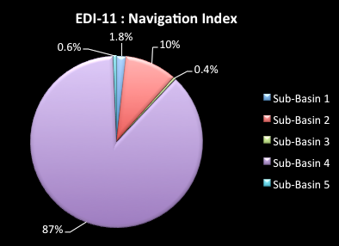

Figure 6‑11: Navigation Indicator

EDI-12 is the aquaculture production indicator. This shows the economic value of aquaculture (fresh and brackish water) divided by the water used in production (surface water and groundwater). It may be difficult to obtain accurate data on aquaculture water use for this indicator. A high indicator value shows a sub-basin with significantly greater economic returns from aquaculture production per unit of water input compared with other sub-basins. This may, but does not necessarily, reflect more efficient use of water, which it is highly dependent on the farm type, the value of outputs, and its water use.

To prepare this indicator you will need to have the following information:

1. Total economic value of aquaculture production for the sub-basins and Basin.
2. Total water used for aquaculture production within the sub-basins and Basin.

In the fictitious Example River Basin, Figure 6‑12 shows sub-basins 2, 3 & 5 have the greatest economic returns for each unit of water used, suggesting the production of high value aquatic species. Sub-basin 4 has a relatively low value of economic production per unit of water used suggesting either production of a low value species or inefficient production techniques.

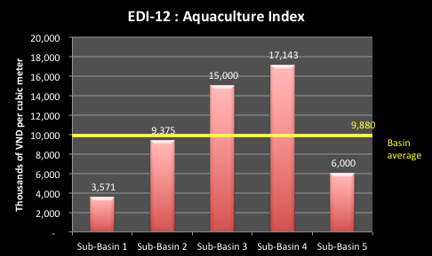

Figure 6‑12. Aquaculture production indicator

### Data sources and comments

The statistics for the economic production indicators for industry, irrigation, and agriculture production may be difficult to obtain. Estimates may have to be prepared based on best available data, including demand estimates and professional interpretation. Water use in Viet Nam is not directly measured. Note that the data obtained is most likely to include both surface water and groundwater use. Sub-basin values will be derived from provincial data and adjusted for provinces spanning more than one basin.

The data for the irrigation development indicator may be obtained from a *Study on Nationwide Water* Resources *Development and Management in the Socialist Republic of Vietnam*, (JICA 2002). For other Vietnamese river basins, data may be obtained for MARD's investigation of irrigation projects.

# Environmental indicators

The Environmental Indicators seek to show the use of natural and environmental resources of river basins, the condition of important resources, and the impacts of human activities on the natural environment of river basins.

## Conservation and land use indicators

### Explanation of conservation and land use indicators

EVI-1 is the land use indicator. This shows the percentage of land area of each sub-basin used for forests, agriculture, residential, specific purposes, and ‘other’ uses. It indicates the way the basin land is being used, which can indicate the health of the catchments of the sub-basins and potential pressures on water resources. A high percentage of forests suggests that this sub-basin has good water retention capability, can sustain natural processes, and has a less modified environment.

To prepare this indicator you will need to have the following information:

1. Total land area for the sub-basins, and for the Basin.
2. Total land area for the sub-basins, and for the Basin used for forestry, agriculture, residential, special purposes and “other” land uses.

In the fictitious Example River Basin, Figure 7‑1 shows sub-basins 1, 2, 3 & 5 all have the majority of the catchment area under forest cover – up to 67% in sub-basin 3. Sub-basin 4 has a low proportion of forest cover – this is the industrial area of the Basin, and it is also dominated by agriculture. Special purpose land and residential areas make up only a small part of the sub-basins. “Other” land uses makes up a significant proportion of land use in all sub-basins.

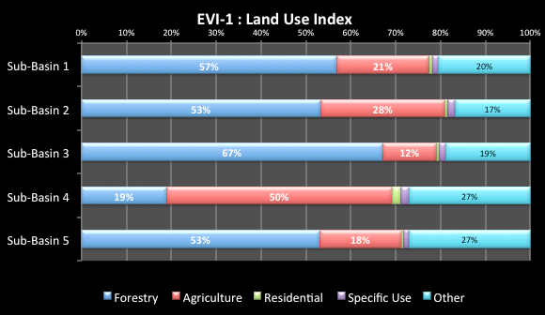

Figure 7‑1. Land use indicator

EVI-2 is the native forest indicator. This shows the proportion of sub-basin area that is native forest and the percentage of native forest in the Basin that is within each sub-basin. A high value indicates good quality natural forests and possibly good catchment processes for water runoff and water quality. A low value may mean that there are substantial plantation forests in the sub-basin, which could be drawing on the water stored in the soil profile as the young trees grow.

To prepare this indicator you will need to have the following information:

1. Total forest area for the sub-basins.
2. Total native forest area for the sub-basins, and for the Basin.

In the fictitious Example River Basin, Figure 7‑2 shows that sub-basin 3 has the highest proportion of its forests remaining as native forests at 61%. Sub-basins 1, 2 & 5 have less than half their forests as native forests, around the Basin average. However, sub-basin 4 has only 22% of its forest cover as native forest. Sub-basin 4 also has only 1% of the total native forest area of the Basin, meaning that its land area has been extensively modified. Sub-basins 2 & 3 have most the native forest area of the Basin - amounting to nearly three quarters of the total. These are areas where greater land protection measures may be required to sustain the nature water processes for the Basin.

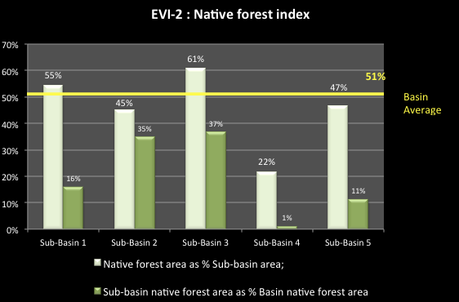

Figure 7‑2. Native forest indicator

EVI-3 is the species indicator. This shows the number of flora and fauna species in the Red Book that have been identified in each basin. Red Book species are endangered, threatened, vulnerable, near threatened, or rare. A high number suggests that a basin, or parts of it, require special care and protection as it makes a significant contribution to national bio-diversity.

To prepare this indicator you will need to have the following information:

1. Total number of Red Book flora species listed for the sub-basins and the Basin.
2. Total number of Red Book fauna species listed for the sub-basins and the Basin.

In the fictitious Example River Basin, Figure 7-3 shows that sub-basins 1 & 5 have the greatest number of fauna listed in the Red Book – 66% of the total in the Basin. Sub-basin 1 also has the greatest number of listed flora, amounting to 33% of the Basin total. This reflects the fact that these sub-basins have considerable forest cover and native forest areas. Sub-basin 4 is extensively modified, and only has a small number of Red Book species.

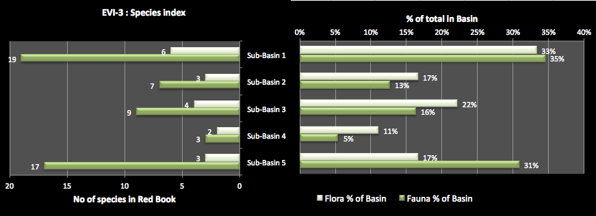Figure 7‑3. Species indicator

EVI-4 is the conservation area indicators. This shows the area of national parks, significant wetlands, other conservation areas or water related heritage area in each sub-basin firstly as a percentage of the total in the Basin as a whole, and also as a percentage of the sub-basin area. It indicates the conservation values provided by the basin. A high % suggests that there are large areas of special conservation value and environmental assets in the sub-basin.

To prepare this indicator you will need to have the following information:

1. National parks, significant wetlands, other conservation areas or water related heritage area in each sub-basin.
2. National parks, significant wetlands, other conservation areas or water related heritage area in the Basin.

In the fictitious Example River Basin, Figure 7‑4 shows that sub-basin 2 is most significant in terms of conservation features – making up half of those identified for the Basin. Sub-basin 1 has about a quarter of the identified conservation features.

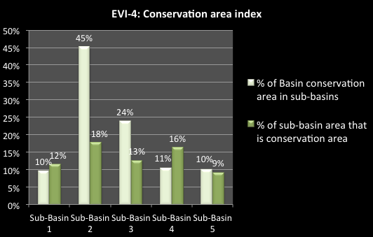

Figure 7‑4: Conservation Area Index

### Data sources and comments

Data for the land use indicator statistics can be obtained from provincial level land use data, or sourced from the Statistical Yearbook of Viet Nam. Data will need to be adjusted where provinces spanned more than one sub-basin. Note that both the sub-basin areas and the land use areas include areas of lagoons and swamps in each sub-basin.

“Forest” includes old growth native forest, regenerated native forest and plantations. No indication of the quality of the forest is given.

“Agriculture” includes seasonal and annual crops, as well as permanent plantings, livestock raising, and aquaculture.

“Residential” includes all village and land within defined urban areas.

“Specific purposes” includes non-agricultural industrial and manufacturing land, mining, military (defence and security) land, and other ‘public’ purposes.

“Other” includes all other land, which may include lagoons and swamps, and unused land.

Data for the native forest indicator statistics can be obtained from the Statistical Yearbook of Viet Nam. This includes lakes and lagoons. Provincial data native forest area can be estimated from GSO Statistical Yearbook and adjusted for provinces spanning more than one sub-basin.

Data for the species indicator statistic is the number of flora and fauna species in Vietnam Red Book found in each sub-basin. Red Book species have been surveyed in protected areas and national parks, nature reserves, habitat or species conservation areas, and wetlands. Data will need to be sought from many and varied sources, such as from the Bird of Life prepared by IUCN. Provincial State of the Environment (SoE) reports may be another source. Data may not be available for some provinces. To a large extent, the number of species found is a function of where studies or surveys have been undertaken. Mostly these are undertaken in conservation areas, so there is a high correlation between conservation areas and Red Book species. This does not necessarily mean, however, that these species are absent elsewhere, rather that few or no surveys have been undertaken.

The conservation area indicator statistics (EVI-4) are the conservation areas of each sub-basin as a percentage of the total for the Basin. Conservation areas are defined as national parks, conservation areas, significant wetlands, nature reserves and significant water-related heritage sites. The list of national parks and nature reserves can be taken from the Government decree. Area data may be sourced from Bird of Life (IUCN), and official provincial SoE reports. The list of heritage, cultural, and historic sites can be sourced from the Government decree. “Water related” sites include forested areas, and other sites of biodiversity or conservation value, as well as those water–related sites of historic value.

## Water flow indicators

### Explanation of water flow indicators

EVI-5 is the natural flow indicator. This shows the proportion of the sub basin area within Viet Nam that is located above major dams. It indicates the degree to which surface flows in the catchments and sub-catchments of the basin are not impacted by major reservoirs. In the areas upstream of the major dams, flows are unregulated, and are likely to be relatively “natural” in terms of their timing and variability. A high % means a high proportion of surface runoff can be captured by dams and regulated - suggesting a low degree of natural river flows in the basin.

To prepare this indicator you will need to have the following information:

1. The catchment areas above major dams in each sub-basin.
2. The area of the sub-basin.

In the fictitious Example River Basin, Figure 7‑5 shows that sub-basin 1 has 61% of its catchment area above the major reservoirs, meaning that a high proportion of surface runoff can be captured by dams and regulated. This suggests a low degree of natural river flows in the sub-basin. Sub-basin 2 is also a relatively high percentage. Sub-basin 3 is 26% meaning most of the catchment in that sub-basin is not controlled by reservoirs, and is likely to be still essentially natural.

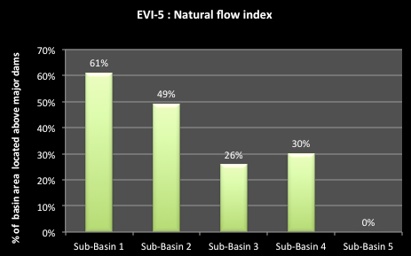

Figure 7‑5. Natural flows indicator

EVI-6 is the river obstruction indicator. This shows the length of river above the most downstream fixed structure on the main rivers in a basin, compared to the total length of the main rivers in the basin, expressed as a percentage. Fixed structures include significant barrages, weirs or dams. A high number indicates long lengths of river above a fixed blockage. This will restrict movement of aquatic fish/animals and also reduce navigation passage. A low figure means a river much better able to fulfil natural functions.

To prepare this indicator you will need to have the following information:

1. The length of the river above fixed structures.
2. The total length of rivers in the sub-basin.

In the fictitious Example River Basin, Figure 7-6 shows that sub-basin 2, with a dam in the lower end of the catchment, has the highest index at 70%. This means that access to 70% of the rivers of the sub-basin is blocked by the dam. For sub-basin 1, access to about half the rivers is blocked by the dam. Sub-basin 5 has no dams yet so all of its rivers are fully accessible without obstruction.

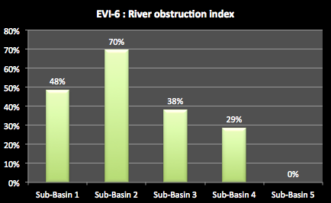

Figure 7‑6. River obstruction index

EVI-7 is the River level index. This shows the current annual minimum river height level at key sub-basin locations compared to the past levels (preferably 10 years ago). A low index value means that the current water level is much lower than it used to be, resulting in less water for water allocations, reduced navigation passage, possible non supply to some users if the current flow levels are below the off-take levels of the supply channel, and significantly reduced river health. The causes can be dam construction with no agreed low flow releases or inter-sub-basins diversions, or increased water diversions up river.

To prepare this indicator you will need to have the following information:

1. The current annual minimum river height level at key sub-basin locations.
2. The average water level 10 years ago.

In the fictitious Example River Basin, Figure 7-7 shows that sub-basins2 and 4 have suffered significant loss of river height in the dry seasons compared to previous times – a loss of 30 to 35%. This can have significant effects on water supply, navigations, river health and on local communities who depend on the river. These are often the poor and most vulnerable. Other sub-basins also have suffered a loss of river height.

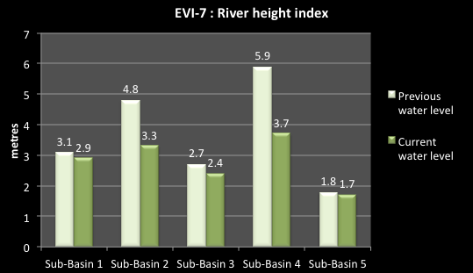

Figure 7‑7. River level indicator

### Data sources and comments

The natural flow indicator statistic requires data on the sub-basin area above major dams. This area includes catchment areas of all tributaries without major dams that flow into the main river upstream and downstream of the uppermost major reservoir on the main river, as well as the catchment area of the main river upstream of the uppermost major reservoir on the main river. The sub-basin area above major reservoirs excludes the catchment area of all tributaries that themselves have major dam reservoirs, and flow into the main river upstream and downstream of any major reservoir on the main river. Major reservoirs have been defined as having storage of greater than 1 million m3. Data on the location and size of reservoirs may be sourced from Master Plan Study on Hydropower Development in Vietnam – Period 200-2010 and perspective up to 2020 (Ministry of Industry), and from various project documents on water resources development (from MARD).

River obstruction indicator statistic data on the total length of rivers in each basin can be sourced from Characteristics of River Morphology in Viet Nam (General Office of Hydrometeorology, 1985). Length of river above fixed structures data can be calculated from various sources, including the Inland Waterway Administration (Ministry of Transportation), and Master Plan Study on Hydropower Development in Vietnam – Period 2001-2010 and perspective up to 2020 (Ministry of Industry). A fixed structure is defined as ungated dams, weirs and barrages.

River height data may be sourced from the National Centre for Hydro-Meteorological Services (<http://www.nchmf.gov.vn/web/en-US/67/96/Default.aspx>).

General information on rivers from: Department of Water Resources Management - Decision 1989/QD-TTg dated 1 November 2011.

The General Statistics Office records the deepest levels and the shallowest levels at key locations for some rivers.

## Water quality indicators

EVI-8 is the biological water quality indicator. This shows the ambient water quality for BOD5 in a representative river in the mid to lower part of each sub-basin, compared to the corresponding QCVN 08: 2008/BTNMT standard value. It is a factor calculated by dividing the monitored result by the numerical limit defined in the standard. The BOD5 concentrations used to calculate the indicator values must be from a section of the river that is not near a known problem area or discharge point. BOD indicates the amount of organic pollutants found in surface water. Natural sources of organic matter include plant decay and leaf fall. However, natural levels are increased when there are excessive nutrients and sunlight due to human influence. Runoff from agricultural land and from urban areas can add significantly to natural processes. The Standards are as follows: B2 class ≤ 25 mg/l and A1 class ≤ 4 mg/l. A high indicator value means waters low in dissolved oxygen, which can lead to increased release of phosphorus from sediments that can fuel algal blooms. High levels indicated untreated runoff to the river and lack of riparian vegetation to shade the river.

To prepare this indicator you will need to have the following information:

1. BOD5 readings in mid to lower river for each sub-basin.
2. VN standard (Class B2).

In the fictitious Example River Basin, Figure 7‑8 shows that the water quality in sub-basin 4 is over 6 times the standard, clearly caused by the considerable amount of urban settlement in the sub-basin and the agricultural and industrial activities. Nutrient runoff to the river is a clear cause of concern. The degraded nature of the river system also limits the ability of the river to cope with the nutrients levels. All of the other sub-basins have readings above the standard, with sub-basin 5 being the closest to the standard.

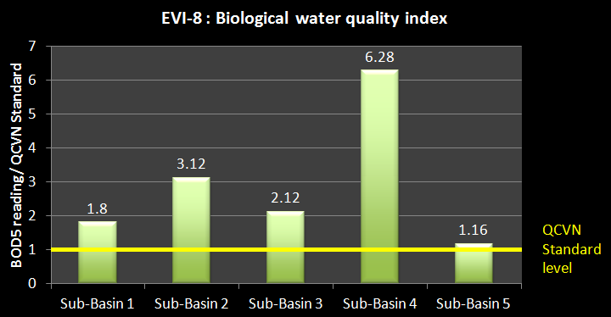

Figure 7‑8: Biological Water Quality Index

EVI-9 is the domestic wastewater treatment indicator. This shows the percentage of domestic wastewater that is treated before discharge to water sources, and the level of domestic wastewater treatment - primary, secondary, and tertiary. A low indicator value for domestic wastewater treatment, and a low secondary or tertiary score, indicates a high potential for pollution and the addition of organic or other pollutants to the water source.

To prepare this indicator you will need to have the following information:

1. Identification of towns with wastewater treatment facilities for each sub-basin.
2. Volumes of domestic wastewater treated.
3. Level of treatment before discharge to water source.

In the fictitious Example River Basin, Figure 7‑9 shows that of the wastewater generated in the Basin, only 15% is treated overall. Of this, the vast majority is in sub-basin 4, where the major city is located. But even there, of the total wastewater, only 17% is treated before discharge to the river, which represents 66% of the total for the Basin. The level of treatment in sub-basin 4 includes some secondary treatment, but only 5% of the total (on right hand side of figure). In the other sub-basins, only a small proportion of the domestic wastewater is treated, with the maximum being for sub-basin 2 at 18%, representing 24% of the Basin total. There is no treatment at all in sub-basins 3 & 5.

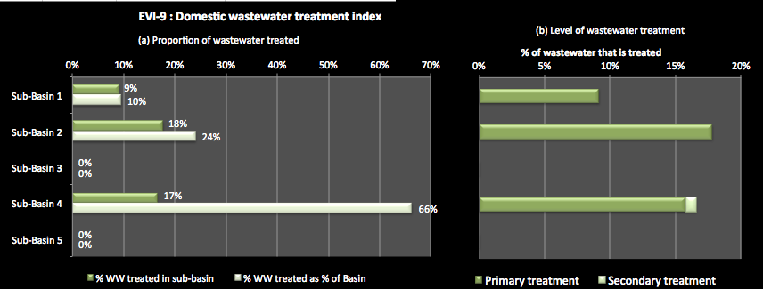

Figure 7‑9: Domestic wastewater treatment index

EVI-10 is the hospital wastewater treatment indicator. This shows the percentage of the hospital wastewater that is treated before discharge to a water source. The indicator also shows the level of hospital wastewater treatment - primary or secondary. A low indicator value for hospital wastewater treatment, and a low secondary indicator value, indicates a high potential for pollution and the addition of organic or other pollutants to the water source. Untreated hospital waste can lead to serious health consequences in the local community. *Note: planners could decide to have the indicator look at the volume of wastewater generated and treated rather than the percentage figures as is done for EVI-9*.

To prepare this indicator you will need to have the following information:

1. Identification of hospitals with wastewater treatment facilities for each sub-basin.
2. Volumes of hospital wastewater treated.
3. Level of wastewater treatment before discharge to water source.

In the fictitious Example River Basin, Figure 7‑10 shows that across the Basin, just over 30% of hospital wastewater is treated. The bulk of this is in sub-basin 4 where 54% of that wastewater is treated accounting for 64% of the total. Relatively little of the hospital wastewater in the other sub-basins is treated before discharge – mostly less than a quarter of the sub-basin wastewater volume, but down to zero in sub-basin 3. All of the treatment is for primary treatment only – there is no secondary treatment.

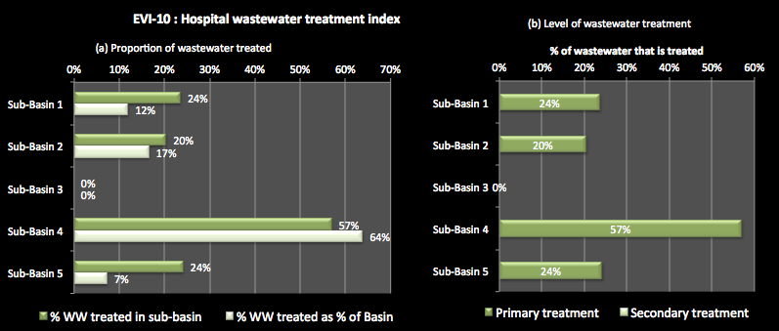

Figure 7‑10: Hospital wastewater treatment

EVI-11 is the industrial wastewater treatment indicator. This is the percentage of industrial wastewater in each basin that is treated before discharge to a water source, and the level of treatment. The indicator also shows the level of industrial wastewater treatment - primary or secondary. A low indicator value for industrial wastewater treatment, and a low secondary indicator value, indicates a high potential for pollution and the addition of organic, heavy metals or other pollutants to the water source. Untreated industrial waste can lead to serious health consequences in the local community. *Note that the planners could decide to have the indicator look at the volume of wastewater generated and treated rather than the proportion or percentage figures –as we done for EVI-9*.

To prepare this indicator you will need to have the following information:

1. Identification of industrial zones and area with wastewater treatment facilities for each sub-basin.
2. Volumes of industrial wastewater treated.
3. Level of wastewater treatment before discharge to water source.

In the fictitious Example River Basin, Figure 7-11 shows that across the Basin only 20% of all industrial wastewater is treated before discharge to a water source. Most of this is in sub-basin 4 where 34% of wastewater is treated, comprising 82% of the total volume treated in the Basin. In sub-basins 3 & 5, none of the industrial wastewater is treated. Most of the treatment is at primary level only. Only in sub-basin 4 is there some secondary treatment – 6% of the total.

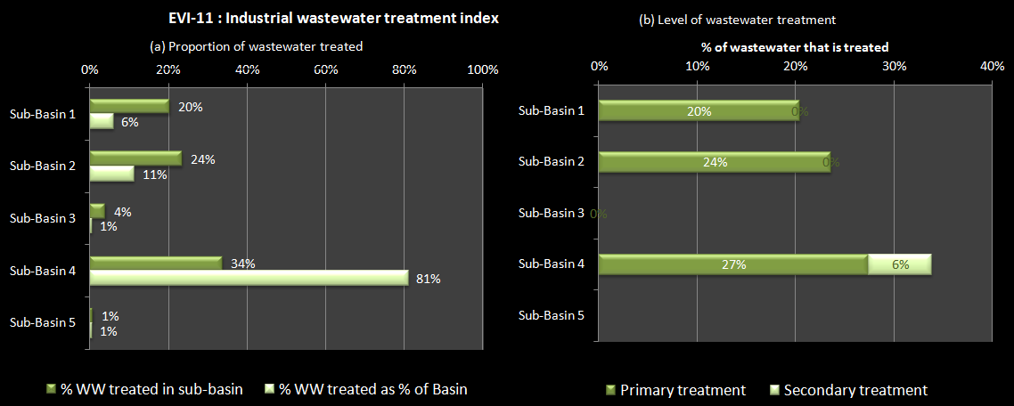Figure 7‑11. Industrial wastewater indicator

EVI-12 is the solid waste index. This shows the proportion of solid waste that is collected and disposed of in a designated disposal site. A low % indicates a high potential for pollution as most solid waste is dumped near water sources and/or can find its way to a river, lake or groundwater.

To prepare this indicator you will need to have the following information:

1. The % of solid waste collected and disposed of ineffectively in Central & provincial cities/towns.
2. The % of solid waste collected and disposed of ineffectively in District towns.
3. The % of solid waste collected and disposed of ineffectively in Rural areas and settlements.

In the fictitious Example River Basin, Figure 7‑12 shows that In the cities and towns, there are quite high rates of effective solid waste disposal, from 55% (sub-basin 3) to 85% (sub-basin 4). However, in District towns, these are estimated at only 25% or less. In rural areas and settlements these are extremely low, just a few % in some cases. Although volumes are small, poor disposal of solid waste is a continuing threat to local water sources and the health of local communities.

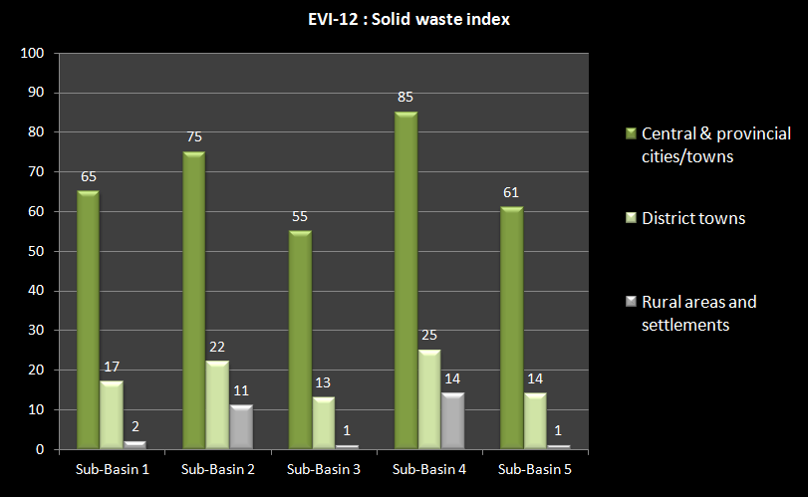

Figure 7‑12: Solid Waste Index

### Data sources and comments

For BOD5, data may be sourced from:

* Center for Environment Quality, MONRE
* Reports on monitoring results of “Terrestrial Monitoring Stations” (National monitoring programme MONRE, 2006, 2005).
* Vietnam State of the Environment (SoE) reports.
* Provincial SoE reports as additional sources where necessary, and
* Related project reports for the Basin.

Standards for BOD5 must be obtained from the appropriate Viet Nam Standard.

BOD5 concentration results should be from monitoring stations in main rivers of the sub-basins (not in lakes or reservoirs) to represent the general ambient water of the sub-basin rivers. Results from monitoring stations should be excluded if they are impacted by a known point source pollution discharge (stations in the sewage discharge channels and stations located immediately after a known discharge point, where the water is not yet fully mixed).

In some cases, there may be significant differences between data from the national and local monitoring systems. Data from the national monitoring programme should be used as the first preference, as they are considered more reliable given that the monitoring activities have been carried out for more than 10 years by competent agencies.

The domestic wastewater treatment statistic is the percentage of domestic wastewater treated in basin relative to domestic wastewater generated in sub-basin. The domestic wastewater treated equals the total capacity of domestic wastewater treatment plants of provinces in the sub-basin. Data for domestic wastewater treatment plant capacity can be sourced from provincial Water Supply and Sewerage Companies (WASECOs). The domestic wastewater generated may have to be computed from domestic water use figures, assuming that 80% of water used becomes wastewater.

The hospital wastewater treatment statistic is the percentage of hospital wastewater treated in the basin relative to the hospital wastewater generated in a sub-basin. The hospital wastewater treated equals the total capacity of hospital wastewater treatment plants of provinces in the sub-basin. Data for hospital wastewater treatment plant capacity may be sourced from the Viet Nam Water Supply and Sewerage Association or the Ministry of Health. The hospital wastewater generated may be computed assuming that each patient bed generates 500-600 litres of wastewater per day (600 litres in major cities and 500 litres elsewhere), as based on the methodology used by VWSA. Provincial data for hospital bed numbers can be sourced from GSO and adjusted for provinces in more than one sub-basin.

Data on industrial effluent may be difficult to source. Sources may include the Ministry of Industry and Trade or Provincial governments.

The solid waste collection statistics are the percentage of solid waste collected and disposed of in cities and towns, District towns and rural areas in each sub-basin. The solid waste collected equals the total solid waste as measured at disposal sites in the sub-basin. Data for solid waste measured at disposal sites may be sourced from URENCOs (urban environmental companies). The solid waste generated may be computed assuming an average amount of waste generated of 0.7kg/person/day for cities and towns and 0.3kg/person/day for rural areas. It should be noted that collection and disposal at a designated site does not necessarily mean that the waste is being disposed of in a socially or environmentally benign manner, just that it is centrally disposed of. Of waste that is disposed of in designated disposal sites, the bulk is taken to the thousands of above-ground, non-sanitary dumpsites around the country, which themselves pose a risk to human health, both directly and indirectly via pollution of soils, surface water, and groundwater resources.

# Water Management Indicators

The Water Management Indicators seek to show the effectiveness of water resources management across some of the key sectors. In this context management includes the collection of data and information for effective decision making, implementing key government initiatives such as Decision 64 on pollution control, using environmental instruments such as EIAs, licensing, efficient provision of services and human capacity.

## Basic survey indicators

### Explanation of basic survey indicators

WMI-1 is the recorded streamflow indicator. This is the number of Level 1 gauging stations (National) in the sub-basin, and the number of years of record at the station with the most years. The higher the number, the greater the confidence in the assessment of river flows.

To prepare this indicator you will need to have the following information:

1. Number of Level 1 gauging stations with more than 1 year continuous record.
2. Number of years of record of the station with the most years of recording. Note that if there is more than one station; use the one that measures the majority of flow in the river system.

In the fictitious Example River Basin, Figure 8‑1 shows that all the sub-basins except sub-basins 3 &5 have Level 1 streamflow gauging stations. The lack of a station in sub-basin 3 could be an issue as this sub-basin extends into a neighbouring country. Monitoring of flows from that country could be important. Sub-basins 1 & 2 are also international sub-basins and they have gauging stations, although the length of record for sub-basin 1 is not long (6 years).

Sub-basin 4 has 4 gauging stations, and one of these has been in operation for 36 years, providing a relatively long historical record. As this is on the main river, this provides a strong level of confidence of the available surface water and how it is changing over time.

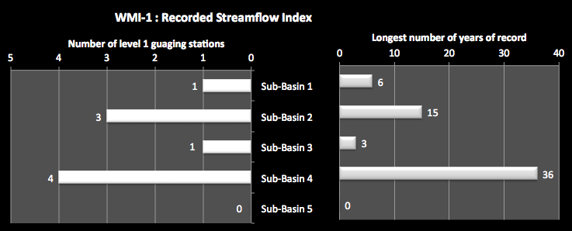

Figure 8‑1. Recorded streamflow indicator

WMI-2 is the groundwater assessment indicator. This is the percentage of the total area of aquifer in the sub-basin for which groundwater assessment has been undertaken in each class (A, B, C). It shows the proportion of the estimated groundwater potential of a sub-basin for which more detailed assessments have been undertaken. Class A is the most detailed and fully surveyed aquifers in terms of quantity and quality and has the highest accuracy. It is generally based on detailed mapping, observation wells and pumping tests. It can be used for technical design for construction and exploitation of groundwater. Class B is derived from detailed survey and mapping, and pumping tests. This assessment level allows preliminary design of groundwater exploitation. Class C is sometimes based on large scale mapping and short pumping tests only, but more generally is estimated from large scale mapping, contributions to surface water and rainfall. It can be used as the basis for planning groundwater use, but more typically provides a basis for further detailed determination of groundwater resources.

To prepare this indicator you will need to have the following information:

1. Total area of aquifers within the sub-basin.
2. The area in the sub-basin for each class A, B, or C.

In the fictitious Example River Basin, Figure 8‑2 shows that there is relatively little Class A assessment and mostly Class C assessment, which is as high as 97% in sub-basin 5. This indicates the high lack of understanding of the Basin’s groundwater resources. Even in sub-basin 4 where most assessment has been undertaken, only 7% is in Class A and 12% in Class B.

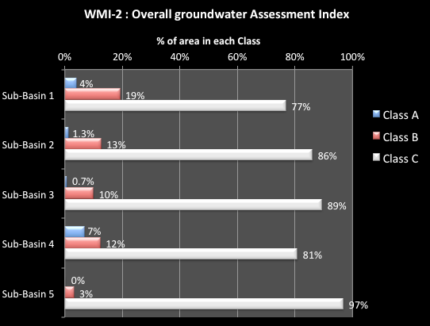

Figure 8‑2. Overall groundwater assessment indicator

WMI-3 is the monitoring bore indicator. This is number of National level monitoring bores per sub-basin and the number of years of record at the bore with the most years. It indicates the extent of recorded groundwater information in the sub-basin. It also indicates where the monitoring bores are located, which can be compared to the groundwater resource situation. A higher the number implies greater confidence in the assessment of groundwater resources. A high number in an area not suffering from over-exploitation of pollution may be a poor investment. Alternatively, a low number in areas where water tables are dropping or where there is a growing area of saline water will reflect poor management decisions

To prepare this indicator you will need to have the following information:

1. Number of National level monitoring bores in the sub-basin with more than 1 year’s continuous record.
2. Number of years of record of the bore with the most years of recording.

In the fictitious Example River Basin, Figure 8-3 shows that sub-basins 1, 3 & 5 have no National level monitoring bores. In sub-basin 4, where there is considerable pressure on groundwater and water levels are dropping (see GWI 8), there are only 3 National level bores and they have a relatively small historical record (8 years). This indicator shows a lack of basic monitoring for the effective management of the resource.

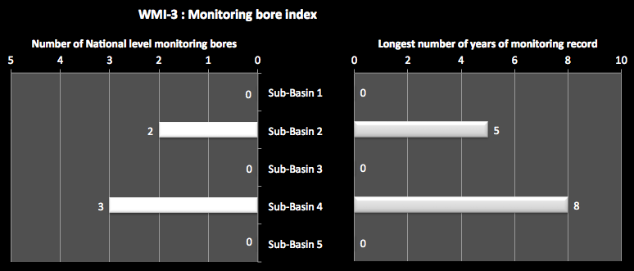

Figure 8‑3. Monitoring bore indicator

WMI-4 is the environmental monitoring indicator. This is number of environmental monitoring sites per sub-basin, and the number of years of record at the station with the most years. It indicates the extent of recorded environmental information (mostly for water quality assessment) in the sub-basin. It also indicates the where the monitoring stations are located, which can be compared to the river health situation. A higher number indicates greater the confidence in the assessment of groundwater resources. A high number in an area not suffering from pollution may be a poor investment. On the other hand, a low number in areas where there is a growing industrial concentration will show poor management decisions

To prepare this indicator you will need to have the following information:

1. Number of environmental monitoring stations in sub-basin.
2. Number of years of record of the environmental monitoring station with the most years of recording.

In the fictitious Example River Basin,

Figure 8‑4 shows that very little environmental monitoring is undertaken for the Basin, despite the high levels of industrial concentration and poor water quality in many parts – see the environmental indicators EVI-8 to EVI-11. Sub-basin 4 has only 2 monitoring station and there is only 3 years of historical record.

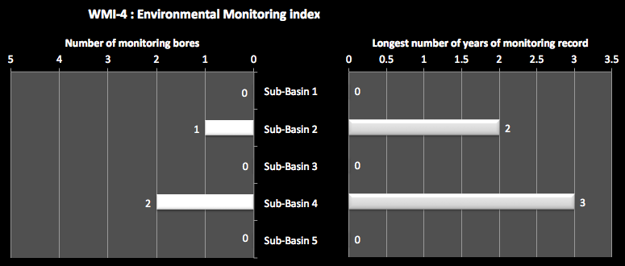

Figure 8‑4. Environmental monitoring indicator

### Sources of data

Decision 16/2007/QĐ-TTg dated January 29, 2007 on approval of the master plan for a national monitoring network for natural resources and the environment by 2020. Decision 16 specifies several principles for the network including that it make best use of existing infrastructure. Annex I-1: List of hydrological stations by 2020.

Decision 526/2011 On approval of General Monitoring Program on Red-Thai Binh river basin and Da river water environment for period of 2012-2016.

Center of Meteorology and Hydrological Forecasting for Red–Thai Binh River

Data from DoNREs.

## Licensing indicators

### Explanation of licensing indicators

WMI-5 is the Central licensing indicator. This the number of licences for the sub-basin issued by MoNRE for surface water extraction, groundwater extraction, and wastewater discharge. It indicates the extent of licensing activity for the Basin undertaken at the central level for major licences. The higher the number the greater the likelihood that major impacting activities are coming under regulatory control. Note that under Decree 149/2004 Licensing of Water Resources, MoNRE is to issue licences for major activities and the Provinces for all other activities.

To prepare this indicator you will need to have the following information:

1. Number of licences for the sub-basin issued by MoNRE, and types of licences (surface water, groundwater and wastewater).

In the fictitious Example River Basin,

Figure 8‑5 shows that MoNRE has issued a total of 76 licences at Central level – for major activities. The figure shows that licensing activities has concentrated on sub-basin 4, where 31 surface water and 22 groundwater licences have been issued. However, only 5 wastewater licences are issued. It is not surprising that the Central level activities concentrate on sub-basin 4 as there is where there is conflict over access to water, groundwater levels are locally dropping and pollution is increasing. There is also a focus on sub-basin 2, where economic growth is increasing.

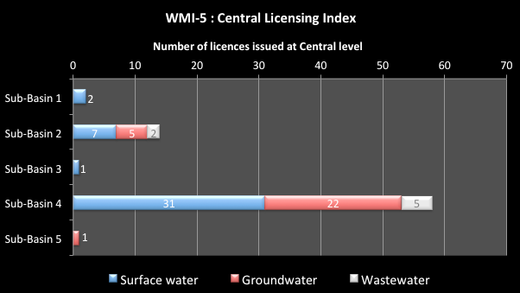

Figure 8‑5. Central licensing indicator

WMI-6 is the Provincial licensing indicator. This the number of licences for the sub-basin issued by Provinces for surface water extraction, groundwater extraction and wastewater discharge. It indicates the extent of licensing activity for the Basin undertaken at the Provincial level. The higher the number the greater the likelihood that major impacting activities are coming under regulatory control. Note that under Decree 149/2004Licensing of Water Resources, MoNRE is to issue licences for major activities and the Provinces for all other activities.

To prepare this indicator you will need to have the following information:

1. Number of licences for the sub-basin issued by Provinces, and types of licences (surface water, groundwater and wastewater).

In the fictitious Example River Basin, Figure 8‑6 shows that Provinces have issued a total of 205 licences, considerably more than MoNRE. The figure shows that licensing activities has concentrated on sub-basin 4, where 27 surface water, 49 groundwater licences and 67 wastewater licences are issued. It is not surprising that the Provincial level activities concentrate on sub-basin 4 as there is where there is conflict over access to water, groundwater levels are locally dropping and pollution is increasing. There is also a focus on sub-basin 2, where economic growth is increasing. Also, there are licences issued in the other sub-basins for all three purposes.

|  |
| --- |
| Description: Macintosh HD:Users:Des:Work:Post 2011:AECOM - ADB - Red R:Figures:WMI 6.pngFigure 8‑6. Provincial licensing indicator |

### Data sources and comments

Date for this section must be obtained from MoNRE and the Provinces in the Basin and the categorized into the various sub-basins.

## Environmental instrument indicators

### Explanation of Environmental instrument indicators

WMI-7 is the Decision 64 Index. It is the number of pollution establishments in the sub-basin, listed in Decision 64, that have been completed (effectively dealt with), are in the process of treatment, or have not yet been dealt with. Decision 64 represents the Government’s commitment to thoroughly deal with major polluting establishments. These establishments are listed in the Decision, which is periodically updated, and it is the responsibility of the Provinces to deal with the pollution. A high completed or processing number means that Provinces in the sub-basin have moved quickly to deal with the most polluting establishments. A high ‘not dealt with’ number means that provinces will need to work hard to meet the requirements of the Decree.

To prepare this indicator you will need to have the following information:

1. Number of polluting establishments in the sub-basin listed in Decision 64.
2. Number of listed establishments completed, under process or “not deal with” in the sub-basin.

In the fictitious Example River Basin, Figure 8‑7 shows of the 30 listed pollution establishments in the Basin overall, 10 are completed, 11 are in the process of resolution and 9 are not dealt with. The figure shows that all sub-basins contain Decision 64 establishments not deal with, meaning that the Provinces have not effectively responded to the requirements of Government. Most of the establishments are in sub-basin 4 where half the listed establishments are completed, but 3 are not dealt with.

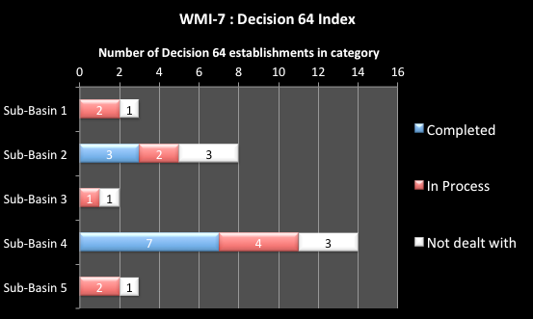

Figure 8‑7. Decision 64 Indicator

WMI-8 is the pollution fees Indicator. This is the total value of pollution fees collected under Decree 67/2003 and the proportion of this from urban and industrial polluters. It indicates the use of economic tools for pollution control, particularly for the industrial component. A high value generally means that pollution fees are being levied by the Provinces. However, a low industrial value means that most of the fees are being set on urban water users and not many industries are exposed to economic tools.

To prepare this indicator you will need to have the following information:

1. Revenue collected under the provisions of Decree 67/2003 for the sub-basin.
2. Proportion of the revenue collected from industrial polluters and urban polluters.

In the fictitious Example River Basin,

Figure 8‑8 shows that a total of 5.03 billion VND were collected in pollution fees for the Basin overall. Of this, over half is from sub-basin 4 and 70% of that was raised from the urban centres. In all of the sub-basins, it is clear that Provinces are obtaining most of their pollution revenue from urban centres rather than industry. This means that the major polluters are not being effectively subjected to economic instruments.

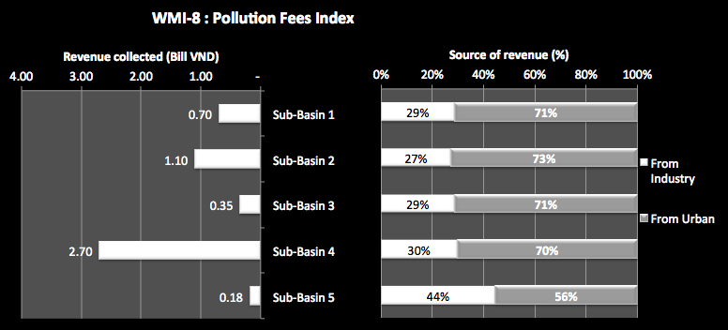

Figure 8‑8. Pollution fees indicator

WMI-9 is the urban pollution fee rate indicator. This is the total value of pollution fees collected under Decree 67/2003 from urban centres divided by the urban population. It indicates the scale of the financial impact of the pollution fees per person, and can be used to compare the fees in one sub-basin to another. A high level of revenue per person means that fees are most likely being levied effectively by the Provinces. However, a low value per person means that Provinces are not using the economic instruments effectively.

To prepare this indicator you will need to have the following information:

1. Revenue collected for the sub-basin under the provisions of Decree 67/2003 from urban centres.
2. Urban population for the sub-basin.

In the fictitious Example River Basin, Figure 8‑9 shows that the revenue per head of urban population varies a good deal – from a high of 2,977 VND in sub-basin 2 to a low of 687 VND in sub-basin 5. The Basin average is 2,024 VND. This indicates that Provinces are not applying the pollution charges effectively to urban centres - the rates per person should have been a lot closer if the Provinces were applying the Decree in a uniform manner.

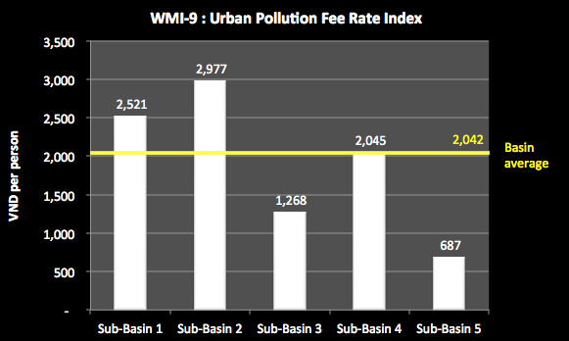

Figure 8‑9: Urban pollution fee rate index

WMI-10 is the EIA indicator. This is the total number of EIA reports assessed and approved and the number of registration forms issued to establishments that achieve environment standards. It indicates the number of establishments that have been subject to assessment by the regulatory authorities. A high value means that enterprises that may have a significant effect on the environment have been assessed by specialists and approved, subject to conditions.

To prepare this indicator you will need to have the following information:

1. Number of EIA reports issued in the sub-basin.
2. Number of registration forms issued to establishments that achieve environment standards in the sub-basin.

In the fictitious Example River Basin, Figure 8‑10 shows that most of the EIA reports are in sub-basins 2 and 4, where most of the economic activities are being undertaken. In sub-basins 1, 3 & 5, the EIA reports are relatively few in number. The registration forms for achieving environmental standards are very few across all sub-basins.

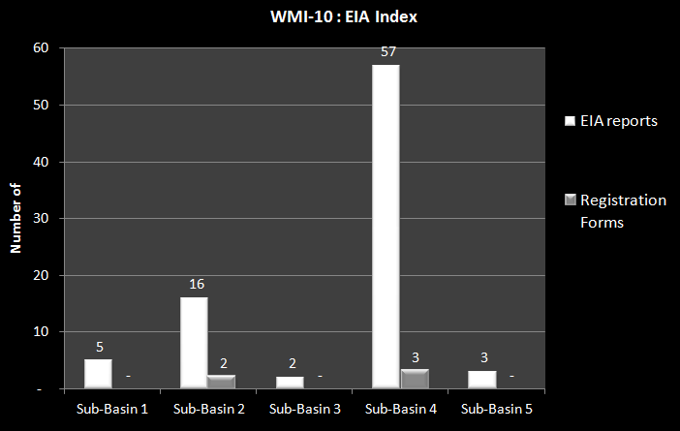

Figure 8‑10: EIA Index

WMI-11 is the industrial zone EIA indicator. This is the percent of Industrial Zones with EIA reports (Re)assessed and approved. Industrial zones can have major effects on surface water and groundwater resources and on human health if not planned and implemented effectively. The indicator shows the proportion of Industrial Zones that have been subject to assessment by the regulatory authorities. A high % means that most Industrial Zones have been assessed by specialists and approved, subject to conditions.

To prepare this indicator you will need to have the following information:

1. Number of industrial zones in the sub-basin.
2. Number of EIA reports issued for industrial in the sub-basin.

In the fictitious Example River Basin, Figure 8‑11 shows that only about a third or less of industrial zones have approved EIA reports. In sub-basins 3 and 5 there are no approved EIA reports for industrial zones. This means that most of these major potential pollution areas have not been subject to assessment by the regulatory authorities, and may be a major local source of pollution.

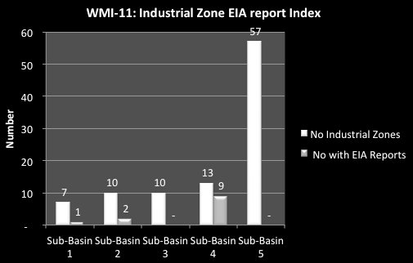

Figure 8‑11. Industrial zone EIA indicator

WMI-12 is the inspection indicator. This is number of inspections a year of businesses to ensure compliance with EIA conditions or licensing conditions, compared to the number of EIA reports and licences issued in the sub-basin. It indicates the extent to which the regulatory authorities inspect businesses to ensure compliance with approval conditions. A high number of inspections compared to SIA reports and licences issued means that there are regular inspections for compliance with conditions. A low number means that compliance is rarely inspected.

To prepare this indicator you will need to have the following information:

1. Average number of inspections in sub-basins for each of the last 3 to 5 years.
2. The number of EIA reports and licences issued in the sub-basin.

In the fictitious Example River Basin, Figure 8‑12 shows that there are relatively few inspections across the Basin, 173 in total, compared to the number of EIA reports (83) and number of licences issued (281). For the sub-basins, 1, 3 & 5 appear to be in proportion – the inspections are about the same number as the reports and licences issued meaning that they are inspected about once a year. However, for sub-basins 2 and 4, the inspections are fewer than the number of licences and reports issued meaning inspections occur at a frequency of greater than once a year.

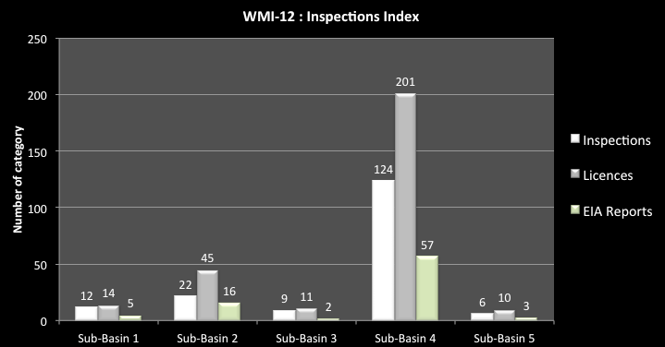

Figure 8‑12: Inspections Indicator

### Data sources and comments

Date for this section must be obtained from MoNRE and the Provinces in the Basin and categorized into the various sub-basins.

## Efficient service provision indicators

### Explanation of efficient service provision indicators

WMI-13 is the urban cost recovery indicator. It is the percentage of the average yearly costs of urban water services that are recovered through revenue. It indicates the cost recovery level for urban water services and the potential for financial sustainability. A high percentage means that subsidisation is minimal, consumers are receiving proper price signals, and service provision is increasingly sustainable. A low percentage means that the service providers are being heavily subsidised by government, there are likely insufficient funds for maintenance or to expand services as populations grow, and water users have no price signals to use water efficiently.

To prepare this indicator you will need to have the following information:

1. Costs of the water supply companies in providing services in the sub-basin.
2. The revenue received by the water service provided in the sub-basin.

In the fictitious Example River Basin, Figure 8‑13 shows that the urban water supply companies are only recovering a third or a quarter of the costs, except for sub-basin 4 where almost half of the costs are covered by revenue. This means that urban water supply is a heavily subsidised service, with insufficient funds for maintenance or to expand services.

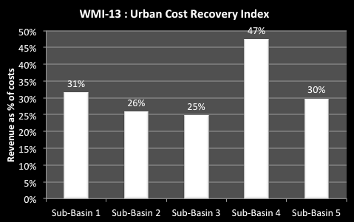

Figure 8‑13: Urban Cost Recovery Indicator

WMI-14 is the urban water efficiency indicator. It is the % of water losses in the supply system, or the “unaccounted for water” or “non-revenue water”. It indicates the efficiency of service delivery. A high % means that significant proportions of high cost treated water are lost in the system and a significant revenue loss.

To prepare this indicator you will need to have the following information:

1. For the main urban centres, the percentage of unaccounted for water.

In the fictitious Example River Basin, Figure 8‑14 shows that most of the services are inefficient, some of them losing about half the water in system losses. This means that half of the water that is treated at high cost is lost. Sub-basin 4 is the exception with unaccounted for water at only 27% of supply. The lowest national rate is 14% so there is still considerable room for efficiency improvements.

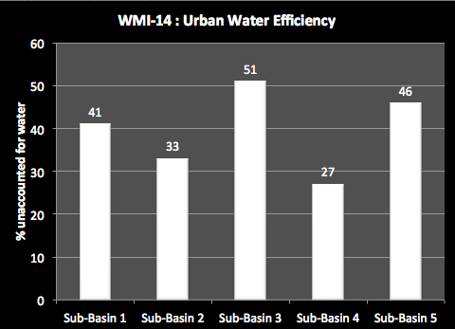

Figure 8‑14: Urban Water Efficiency Indicator

### Data sources and comments

Data for the urban efficiency indicators may be sourced from Viet Nam water supply and sewerage association annual reports (VWSA), from the regular benchmarking survey of companies carried out by VWSA, and from Provincial water supply companies.

## Capacity indicators

### Explanation of capacity indicators

WMI-15 is the water resources human capacity Indicator. This is the number of people working on water resources management per 1 million people in the sub-basin. The number of people working on water resources management is assumed as the total number of people working on any aspect of water resources, less those working on irrigation, on urban water, and on rural water supply and sanitation. This indicator shows the extent of human resource capacity in the basin engaged in water resources management. A high number indicates good capacity to manage water resources on a sustainable basis and to respond to any major issues as required. A low number means that there is little chance that IWRM principles are being applied and water management decisions may prove unsustainable.

To prepare this indicator you will need to have the following information:

1. For the sub-basins the number of Provincial and lower level staff working on water resources management (excluding those working on irrigation, on urban water and on rural water supply and sanitation).
2. The sub-basin population.

In the fictitious Example River Basin, Figure 8‑15 shows that there are relatively few water resources staff available for management activities at the local level – less that 4 staff per million people in the sub-basin for all sub-basins. Of greatest concern is sub-basin 4. There are many water resources issues in this sub-basin – water shortages, dropping groundwater levels, pollution, etc., but relatively few staff to deal with them. The indicator values of 3.8 are not much greater than for other sub-basin that have not nearly the same issues.

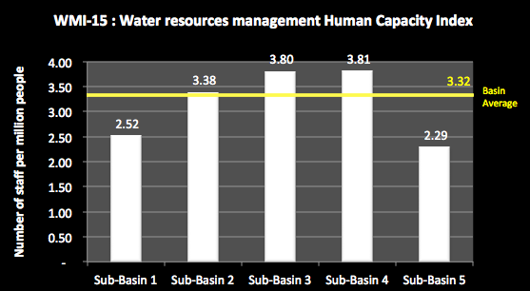

Figure 8‑15. Water resources human capacity indicator

WMI-16 is the water resources management investment capacity Indicator. This is the value of the state/provincial budget applied to water resources management per square kilometer of sub-basin area. The value of the state/provincial budget applied to water resources management is assumed as the total budget for any aspect of water resources, less that for irrigation, for urban water and for rural water supply and sanitation. This indicator shows the extent of financial capacity in the sub-basin engaged in water resources management. A high number indicates good capacity to manage water resources on a sustainable basis and to respond to major issues as required. A low number means that there is little chance that IWRM principles are being applied and water management decisions may prove not sustainable.

To prepare this indicator you will need to have the following information:

1. For the sub-basins, the State and Provincial budget for water resources management (excluding that for irrigation, for urban water, and for rural water supply and sanitation).
2. The sub-basin area.

In the fictitious Example River Basin, Figure 8-16 shows that sub-basin 4 has an investment capacity far greater than the other sub-basins at 47,400 VND/km2 compared to the Basin average of 13,481 VND/km2. Given that there are only relatively small staff numbers actually working on water resources management in the sub-basin (as shown by WRI-15), this suggests that the Provinces are seeking the use of external resources for their water management work. This may have longer term capability issues for those provinces if there is not an information transfer plan in place. Sub-basin 1 also has a relatively high investment capacity but a low human resources capacity, so its Provinces could be in the same position.

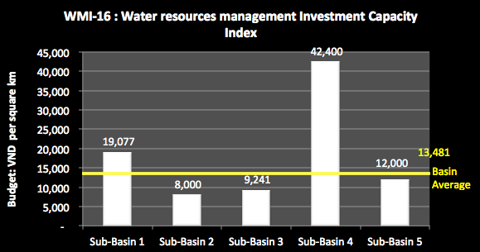

Figure 8‑16. Water resources management investment capacity indicator

### Data sources and comments

Date for this section must be obtained from MoNRE and the Provinces in the Basin, split into the various sub-basins.

# Appendix: Summary Explanation of indicators

**Surface Water Resources Indicators**

| *Index #* | **WRI-1** | **WRI-2** | **WRI-3** | **WRI-4** | **WRI-5** | **WRI-6** |
| --- | --- | --- | --- | --- | --- | --- |
| *Index Name* | Sub-Basin water index | International water index | Inter-basin discharge index | Dry season water index | Dry season international water index | Water productivity index |
| *Definition of index* | The total water volume generated in the sub-basins as a proportion of the total Basin water volume, including water from any other country - include: (a) Total incl international component (b) Within VN only | Proportion of the total water resources volume generated in the sub-basin that under current conditions and water use patterns (a) comes from another country or (b) flows to another country | Proportion of the total water resources volume naturally generated in the sub-basin (including international inflows and outflows) that under current conditions and water use patterns (a) flows to another sub-basin or (b) comes from another sub-basin | Proportion of the total annual water generated in the sub-basin that is generated in the dry season (incl water in VN and international inflows) basin | Proportion of the dry season water volume of the sub-basin that (a) comes from another country or (b) discharges to another country | Total natural water volume generated in the sub-basin divided by the sub-basin area - for: (a) the full year and (b) the dry season |
| *Information required for index* | Total water volume in the Basin, and water volume generated within the sub-basin: (a) originating in Viet Nam, and (b) originating in another country | Total water volume in the sub-basin, the volume provided from another country, the volume that flows form the sub-basin to another country | Total naturally generated water volume in sub-basin; volume naturally flowing from this sub-basin to other sub-basins; and volume flowing into this sub-basin from others | The dry season months, the natural dry season water volume generated in the sub-basin, dry season volumes generated in the sub-basin | Dry season water volume in sub-basin, Dry season water volume generated in other country, Dry season water volume generated in Viet Nam and passing to another country | Total natural water volume generated within, and catchment areas for, sub-basins, including inflows / outflows from/to other country; total water volume generated within and catchment areas for sub-basins, solely in VN; natural dry season water volume generated in the sub-basin |
| *Example* | 1a: 7% 1b: 22% | (a) 21% (b) 5% | (a) 38% (b) 22% | 27%, 5 | (a) 15% (b) 7.5% | (a) 2 million cubic metres of water per square kilometre of catchment (b) 0.5 million cubic metres of water per square kilometre of catchment |
| *Use of indicator* | It indicates the proportion of the Basin's total water that is generated within this sub-basin | It shows (a) the dependence of this sub-basin on water inflows from another country; (b) the dependence of other countries on the water from this sub-basin | It shows (a) the dependence of this sub-basin on water inflows from another sub-basin; (b) the dependence of other sub-basins on the water from this sub-basin | It indicates the proportion of the total water volume that is available in the dry season under natural conditions, and the length of the dry season. It provides an indication of the stress on the sub-basin during the dry season | It shows (a) the dependence of the sub-basin on water inflows from another country, and (b) the dependence of other countries on the water outflow or discharge from the sub-basin | It indicates the most productive water generating areas of the Basin (in Mill cu metres of water per sq km) |
|  | A high % indicates a high contribution of surface water to total water in the RR Basin | A high ratio indicates a high level of dependency on river flows from outside VN, or a high dependence of other countries on the water from the sub-basin | A high ratio indicates a high level of dependency on river flows from other sub-basins; or a high dependence of other sub-basins on the water from the sub-basin | A small ratio and a large number of months means that there is very little water available in the sub-basin for a long period | A high ratio indicates a high level of dependency on river flows from outside VN, or a high dependence of other countries on the water from the sub-basin | A high number indicates high significance of the sub-basin in terms of water productivity. |
|  |  | This shows (a) a need for good international agreements on water sharing and water quality to protect VN water security; (b) an expectation from other country(s) on the need for good international agreements on water sharing and water quality | This shows a need for good water sharing and water quality arrangements between sub-basins | This shows that water shortages will be acute and conflicts over access to water may be significant | This shows a need for good international agreements on water sharing and water quality | These areas are those that need to be protected by catchment management activities to ensure they can continue to generate water into the future |

| **WRI-7** | **WRI-8** | **WRI-9** | **WRI-10** | **WRI-11** | **WRI-12** |
| --- | --- | --- | --- | --- | --- |
| Water storage share index | Reservoir storage control index | Water storage benefit index | Infrastructure sub-basin inter-diversion index | Water availability index | Dry season water availability index |
| Total active reservoir volume in sub-basin as proportion of total active reservoir volume in the RR Basin, both (a) currently and (b) for 2025. | Total active reservoir volume in sub-basin divided by total natural water volume for sub-basin | (a) Total active reservoir volumes in the sub-basin used for hydropower, irrigation and "other" purposes - current and at 2025. (b) Water storage per capita for water security (irrigation, flood mitigation, water supply, etc) and for energy security (HP) for current and at 2025 | The water volume diverted between this sub-basin and other sub-basins using infrastructure as a % of the total natural water volume in this sub-basin: (a) for the total annual situation and (b) for the dry season | Total annual water resources volume generated in the sub-basin divided by: (a) current population (VN only); (b) projected population at 2025 (VN only); As well, for any sub-basins that depend substantially on through flows from other sub-basins (such as delta sub-basins) then include the through flows and the inter-basin diversions in a separate adjusted assessment | Dry season water resource volume generated in the sub-basin divided by: (a) current population (VN only); (b) projected population at 2025 (VN only). As well, for any sub-basins the depend substantially on dry season through flows from other sub-basins (such as delta sub-basins) then adjust the dry season volumes by including the through flows, inter-basin diversions and water volumes in reservoir storage, in a separate adjusted assessment |
| Total reservoir active volume in RR Basin, Total reservoir active volume in sub-basin | Total reservoir active volume in sub-basin, Total natural water volume for sub-basin | For each reservoir, its active storage volume and its purpose - current and projected to 2025; and populations current and at 2025 | Water volume diverted out of this basin to another using infrastructure (Total and dry season), Water volume diverted into this basin from another (Total and dry season), total natural water volume in the sub-basin and for the dry season | Total natural water volume generated in the sub-basin, current population, projected population at 2025; Identification of any sub-basin that depend substantially on natural through flows from other sub-basins and an assessment of the through flow volumes | Dry season water volume generated in sub-basin, current population, and projected population at 2025. Identification of any sub-basin that depend substantially on natural through flows from other sub-basins and an assessment of the adjusted dry season volumes (including water volumes in the active storage in the sub-basin, natural dry season through flows and water volumes transferred to/from sub-basin) |
| Current - 27% 2025 - 32% | 22% | HP - 2 bill cu m, Other - 0 bill cu m, Irrigation - 0.3 bill cu m Water security = 567 cm/c Energy security = 2180 cu m/c | Out: 6.7% In: 2.4% | (a) 3,500 cu m per capita (current) (b) 3,150 cm m par capita (2025) | 1,800 cu m per capita (current) 1,570 cu m per capita (2025) |
| It shows the significance of the storage volume of this sub-basin compared to the total Basin storage volume | It relates the total reservoir storage volume to the total water volume of a sub-basin - indicating the amount of the water flows in the sub-basin that may be captured in reservoirs and thereby controlled by infrastructure | It shows the predominant use of reservoirs in the sub-basin - current and at 2025, and the water storage per capita in sub-basins which can be compared to international levels. | It shows the proportion of sub-basin natural water volume that is diverted from a sub-basin (contributing) or is diverted into another sub-basin (receiving) | It relates the total natural water volume to the population (cu m per capita, current and at 2025) and indicates the ability of the natural water resources to support the population now and into the future (based on current natural water which may decline under climate change) | It relates the dry season water resources with the population (cu m per capita, current and at 2025) and indicates the ability of the water resources to support the population in the dry season |
| A high percentage means this sub-basin has a significant proportion of RR Basin storage | A high ratio means that the storages can exert significant control over river flows | A high ratio of single purpose storages means that generally single objectives are being met. Water storages for hydro are providing energy security, not water security (unless other benefit are explicitly incorporated such as flood mitigation). Other reservoirs provide water security (water supply, flood mitigations, etc) | A high diversion out % indicates a significant amount of water no longer available in this sub-basin with consequential impacts on river health and basin communities. These effects can be accentuated in dry times | 4,000m³/year/ person indicates adequate water supply | [4,000*F] m³/year/ person indicates adequate water supply over dry season |
| It indicates the significance of the sub-basin storage to the basin as a whole. A high percentage means this sub-basin has a significant proportion of Basin storage | This may mean good flood control potential on one hand; but on the other hand, that river health or the needs of lower river communities may not be met |  |  | more than 1,700m³/capita/year is defined as the threshold above which water shortage occurs irregularly or locally | more than [1,700*F] m³/capita/year is defined as the threshold above which water shortage occurs irregularly or locally |
|  |  |  |  | Below 1,700m³/ capita/ year water stress appears regularly | Below [1,700*F] m³/ capita/ year water stress appears regularly |
|  |  |  |  | below 1,000m³/capita/year water scarcity is a limitation to economic development and human health and well-being, | below [1,000*F] m³/capita/year water scarcity is a limitation to economic development and human health and well-being, |
|  |  |  |  | below 500m³/capita/year water availability is a main constraint to life | below [500*F] m³/capita/year water availability is a main constraint to life |
|  |  |  |  |  | where F = length of dry season in months divided by 12 |
|  |  |  |  |  | For example, if the dry season is 7 months, then F=7/12 = 0.5833 |

|  |  |  |  |  |  |
| --- | --- | --- | --- | --- | --- |
| **WRI-13** | **WRI-14** | **WRI-15** | **WRI-16** | **WRI-17** | **WRI-18** |
| Water exploitation index (WEI) | Dry season water exploitation index | Water exploitation per capita index | Sector Water use index | Flood Mitigation storage index | Climate change - temperature index |
| Proportion of the natural total annual water volume that is exploited and used under: (a) current levels of water demand/use; (b) projected 2025 levels of water demand/use | Proportion of the natural dry season water volume that is exploited and used under: (a) current dry season levels of water demand/use; (b) projected 2015 dry season levels of water demand/use | (a) Current total water use/demands in the sub-basin divided by current population (VN only); (b) Projected 2025 total water use/demands in the sub-basin divided by projected population at 2025 (VN only) | Proportion of total water use by the major sectors - irrigation (Ir), agriculture (A), industry (I), urban (U), aquaculture (Aq) | Total reservoir storage volume in the sub-basin used for flood mitigation compared to wet season water volume in sub-basin | Temperatures change and % increase in the average summer temperature over the recent history compared to that projected for the sub-basin under CC |
| Current water demand/use in the basin by volume, projected 2025 water demand/use in the basin by volume, total natural water volume for basin | Current water use/demand in sub-basin in dry season, projected 2025 water use/demand in sub-basin in dry season, dry season natural water volume. Also inlcude water volume with active storage + water transferred to/from sub-basin | Current and projected 2025 water use/demands in the sub-basin by volume, current and projected 2025 sub-basin population | Water use in the sub-basin by volume, water use volume per sector | Storage volumes for flood mitigation reservoirs, Total wet season water volume for sub-basin | Current average summer temperatures for the sub-basin; projected average summer temperatures for the sub-basin |
| Current - 19% 2025 - 22% | Current - 39% 2025 - 43% | Current - 970 cu m per capita 2025 - 1,075 cu m per capita | Ir 83%, A 2%, I 6%, U 8%, A 1% | 12% | 1.70C 2.1% |
| It relates water exploitation and use to the natural available water in the dry season, and can identify if abstractions rates are sustainable. A high % leads to pressure on the water resources | It relates exploitation and use to the available natural water and can identify if abstractions rates are sustainable. A high % leads to pressure on the water resources | It indicates the average total water use per person in the basin (cu m per capita), at present and projected at 2025 | It identifies the major uses of water in the basin | It shows the relative size of flood mitigation reservoirs in the sub-basin, compared to wet weather water volume in sub-basin | It shows the projected and relative increase in the average summer temperatures in the sub-basins |
| WEI < 0.1 no stress | WEI < 0.1 no stress | A high figure means that water use in this basin is for high water using activities or it could be inefficient. This is useful to compare across the sub-basins | A high proportion of water use for irrigation generally means potential for water efficiency gains | A high ratio means a significant proportion of wet season basin flows could potentially be caught in a reservoir | A high % means a significant increase in summer heat, causing increased evaporation: reducing runoff and increasing the demands for water within the sub-basin |
| 0.1 <WEI< 0.2 low water stress | 0.1 <WEI< 0.2 low water stress | This shows the pressure that water exploitation and use puts on the resource |  |  |  |
| 0.2 < WEI < 0.4 - moderate water stress; | 0.2 < WEI < 0.4 - moderate water stress; |  |  |  |  |
| WEI> 0.4 - high water stress | WEI> 0.4 - high water stress |  |  |  |  |

**Groundwater Resources Indicators**

| *Index #* | **GWI-1** | **GWI-2** | **GWI-3** | **GWI-4** | **GWI-5** | **GWI-6** |
| --- | --- | --- | --- | --- | --- | --- |
| *Index Name* | Groundwater area index | Groundwater recharge index | Groundwater recharge potential index | Groundwater exploitation index | Groundwater sustainability index | Groundwater availability index |
| *Definition of index* | Proportion of aquifer type areas in the Basin overall, and area of aquifer type in each sub-basin | Proportion of the Basin groundwater recharge in the sub-basins; and the recharge in the aquifer types in the sub-basins | This is the recharge of the aquifer types per land area | Proportion of the Basin groundwater exploitation capacity in the sub-basins; and the exploitation capacity in the aquifer types in the sub-basins | Ratio of the exploitation capacity of the aquifer to the natural recharge | Exploitation capacity of the sub-basin divided by divided by: (a) current population (VN only); (b) projected population at 2025 (VN only) |
| *Information required for index* | Basin groundwater total area and areas of aquifer type; area per aquifer type in each sub-basin | Basin groundwater recharge; groundwater recharge in each sub-basin | Assessed area of each aquifer type in sub-basins; assessed recharge to each aquifer type in sub-basins | Basin groundwater exploitation capacity; groundwater exploitation capacity in each sub-basin | Assessed natural recharge of the aquifer; assessed exploitation capacity of the aquifer | Exploitation capacity of sub-basin; current sub-basin population; 2025 sub-basin population |
| *Example* | Porous = 33% 4.2 '000 sq km | 27% Porous = 3.2 bill cu m | 0.75 cu m per sq km of aquifer area | 18% Porous = 0.7 bill cu m | 65% | Current = 3,450 cu m per capita 2025 = 2,750 cu m per capita |
| *Use of indicator* | It indicates the proportion of the Basin's total area provided by each aquifer type; and also shows area of each aquifer type in the sub-basins. | It indicates the proportion of the Basin's total recharge that is provided by the sub-basin; and also shows the recharge capacity of the aquifer types in the sub-basins | It indicates the types of aquifer that provided the most recharge and their location in the sub-basins. | It indicates the proportion of the Basin's total exploitation capacity that is provided by the sub-basin; and also shows the exploitation capacity of the aquifer types in the sub-basins | It indicates the proportion of the natural recharge of the aquifer that is exploited and used | It relates the sustainable groundwater to the population (current and at 2025) (cu m per capita) |
|  | A high % indicates that a substantial proportion of the Basin's groundwater area is provided by an aquifer type or a sub-basin. Depending on the aquifer type this could indicate the groundwater potential. For example a high % of fractured rocks may indicate that although there will be groundwater available the potential bore yields may be small | A high % indicates that a substantial proportion of the Basin's groundwater potential groundwater is provided by a sub-basin. A low % means that the sub-basin most likely contains little usable groundwater | It can show the more important recharge areas which may need to be protected. | A high % indicates that a substantial proportion of the Basin's groundwater exploitation capacity is provided by a sub-basin. A low % means that the sub-basin most likely contains little usable groundwater | it shows the sustainability of the exploitation capacity of the aquifer. A % greater than 100% means that the groundwater of the aquifer is being mined - water is being extracted at greater than the recharge rate, which means that water is being taken from the aquifer storage volume, which many not be replaced | It indicates the ability of the water resources to support the population now and into the future. 4,000m³/year/ person indicate adequate water supply  More than 1,700m³/capita/year is defined as the threshold above which water shortage occurs irregularly or locally Below 1,700m³/ capita/ year water stress appears regularly Below 1,000m³/capita/year water scarcity is a limitation to economic development and human health and well-being |
|  |  |  |  |  | For a sustainable aquifer system, the assessed exploitation capacity should be less that the natural recharge, recognising that some of the recharge is required to sustain aquifer processes and some surface environment such as wetlands, and provide low flows to some rivers. In some countries a general level of 70% is taken as the default ratio | below 500m³/capita/year water availability is a main constraint to life |

| **GWI-7** | **GWI-8** | **GWI-9** | **GWI-10** | **GWI-11** | **GWI-12** | **GWI-13** |
| --- | --- | --- | --- | --- | --- | --- |
| Overall groundwater use Index | Groundwater use per sector Index | Groundwater use per aquifer type | Future groundwater use Index | Groundwater use & exploitation capacity Index | Area affected by drawdown Index | Groundwater quality index |
| Proportion of the total Basin groundwater used within each of the sub-basins | Proportion of the sub-basin groundwater use by the sectors (towns, industrial zones, rural water supply) | Groundwater use by the sectors (towns, industrial zones, rural water supply) and by aquifer type | 2025 proportion of the sub-basin groundwater use by the sectors (towns, industrial zones, rural water supply) | The ratio of groundwater use compared to the groundwater exploitation capacity, under current and 2025 conditions | The ratio of the area of the aquifer suffering groundwater level drawdown to the total aquifer area | The % of the aquifer areas that are subject to saline water and arsenic contamination |
| Basin groundwater use; groundwater use in each sub-basin | Sub-basin groundwater use the sectors (towns, industrial zones, rural water supply) | Sub-basin groundwater use the sectors (towns, industrial zones, rural water supply) - overall, in the sub-basins and by aquifer type | 2025 sub-basin groundwater use the sectors (towns, industrial zones, rural water supply) | Total volume of groundwater exploitation capacity; current groundwater total use from the aquifer; 2025 groundwater total use from the aquifer | The current area of the aquifer suffering water level drawdown; total area | The area of the aquifer that is subject to saline water; area of the aquifer that is subject to arsenic contamination; total areas of aquifer |
| 27% | Towns 22%, industrial zones 17%, rural water supply 7%, other/unknown 54% | Towns: use of 1.1 mill cu m from porous aquifers in sub-basin A | Towns 32%, industrial zones 27%, rural water supply 17%, other/unknown 24% | Current = 65% 2025 = 72% | 12% | Saline water = 23% Arsenic = 8% |
| It indicates the proportion of the Basin's total groundwater use that is supported by the sub-basin | It indicates the proportion of the sub-basin's groundwater use by the sectors - towns, industrial zones, rural water supply, other/unknown | It indicates the sub-basin's use of groundwater by both the sectors and by aquifer type | It indicates the 2025 proportion of the sub-basin's groundwater use by the sectors - towns, industrial zones, rural water supply, other/unknown | It indicates the amount of the assessed exploitation capacity that is required to meet current and projected 2025 water uses | It indicates the extent of the aquifer suffering from dropping water levels due to local over-exploitation. This will allow priorities for actions to be established | It indicates the significance of saline water and arsenic contamination to the aquifer |
| A high % indicates that a substantial proportion of the Basin's groundwater use occurs in a sub-basin. A low % means that there is relatively little groundwater use in the sub-basin | A high % for any of the sectors indicates the dependence of that sector on groundwater. A low % means that the sector has alternative supplies of groundwater. A high percentage for "other/unknown" means that water use monitoring is inadequate, and is generally poorly understood | A high use for any of the sectors indicates strong dependence of that sector on groundwater from a particular aquifer type. This may focus the groundwater management effort onto specific aquifer types in localities to protect water supply | A high % for any of the sectors indicates the dependence of that sector on groundwater in 2025. A low % means that the sector has alternative supplies to groundwater. A high percentage for "other/unknown" means that water use monitoring is inadequate, and id generally poorly understood | A figure greater that 100% means that current use is greater than the assessed exploitation capacity. This will require immediate management action to reduce groundwater use and to use water more efficiently. Otherwise the groundwater use will be unsustainable and the resource will be mined | A high number indicates a major lowering of water levels without recovery through natural process. This means that the aquifer is being mined in some localities, and aquifer storage is being extracted. Extraction will progressively cost more (higher pumping cost), the likelihood of drawing in poor quality water increases, and land use impacts can result, such as compaction and settlement | A high number indicates that major parts of the aquifer are not suitable for exploitation and use. As well, careful management of these areas is required to ensure that contaminated water does not move into good quality aquifers |

**Economic Indicators**

| ***Index #*** | **EDI-1** | **EDI-2** | **EDI-3** | **EDI-4** | **EDI-5** | **EDI-6** |
| --- | --- | --- | --- | --- | --- | --- |
| *Index Name* | Sub-Basin GDP index | GDP per capita index | GDP growth index | Economic structure index | Industry sector production index | Irrigation sector production index |
| *Definition of index* | Sub-Basin GDP divided by Basin GDP | Sub-basin GDP divided by sub-basin populations | GDP average growth rate over the last 5 years | Percentage of GDP provided by agriculture (A), industry (I) and services (S) sectors | Value of industrial production divided by the water used for industrial activities | Value of irrigation production divided by the water used for irrigation activities |
| *Information required for index* | Total Basin GDP, GDP for river sub-basins | GDP for river sub-basins, population for sub-basins | GDP for river basin for last 5 years | Value of economic production per sector, GDP for basin | Water use for industry, value of industrial production | Vol of water use for irrigation, value of irrigation production |
| *Example* | 9.50% | 2.2 million VND per person% | 7.20% | A 57%, I 22%, S 21% | 12,000 thousand VND per cm m | 2,500 thousand VND per cm m |
| *Use of indicator* | It indicates the significance of the economic activities of the sub-basin to the Basin economy | It indicates the economic activities of the sub-basin based on the population | It indicates the strength of growth of economic activities of the basin | it indicates the nature of the economic activity in the basin - contributions from the different sectors | It indicates the economic returns ('000 VND) in industry activities for each unit of water used as input | It indicates the economic returns ('000 VND) in irrigation activities for each unit of water used as input |
|  | A high indicator value means that the sub-basin is significantly contributing to the Basin economy compared to other sub-basins | A high indicator value shows that the sub-basin population is contributing significantly to the Basin economy compared to other sub-basins | A high percentage suggests strong growth, most likely based on the industrial sector. This may have implications for river health | This helps identify the economic drivers for the sub-basin and also the potential impacts of overall economic activities on water resources | A high number indicates a good return for investments in industrial development. A high indicator value also shows a sub-basin with significantly greater economic returns from industrial production per unit of water input compared with the other sub-basins and may, but does not necessarily reflect more efficient use of water, which it is highly dependent on the industry type, the value of outputs, and its water use. | A high number indicates a good return for investments in irrigation development. A high indicator value also shows a sub-basin with significantly greater economic returns from irrigation production per unit of water input compared with the other sub-basins and may, but does not necessarily reflect more efficient use of water, which it is highly dependent on the irrigation crops, type, the value of outputs, and the water use. |

|  |  |  |  |  |  |
| --- | --- | --- | --- | --- | --- |
| **EDI-7** | **EDI-8** | **EDI-9** | **EDI-10** | **EDI-11** | **EDI-12** |
| Irrigation development index | Current hydropower generating capacity index | Future hydropower index | Hydropower development index | Navigation Index | Aquaculture Index |
| Proportion of the design area of irrigation schemes that is currently irrigated | Current hydropower generating capacity as a proportion of the total hydropower generating capacity of the Basin | Projected hydropower capacity of the sub-basin at 2025 as a proportion of the projected total Basin hydropower at 2025 | Proportion of the full potential for hydropower development of the sub-basin currently developed, and developed at 2025 projections | Economic value of inland cargo for the sub-basin as a proportion of total for Basin | Economic value of aquaculture divided by the water used for aquaculture production |
| For all irrigation schemes, design area and current irrigated area | Total current Basin generating capacity, current sub-basin HP generating capacity | Total 2025 Basin generating capacity, 2025 sub-basin HP generating capacity | Total full potential hydropower of the sub-basin; current sub-basin generating capacity; 2025 sub-basin HP generating capacity | Economic value of inland navigation in sub-basins and for Basin | Economic value of aquaculture production for sub-basin and Basin, water used for aquaculture for sub-basin and Basin, |
| 67% | 17% | 22% | Current = 45% 2025 = 67% | 32% | 6,000 thousand VND per cm m |
| It indicates the current development of irrigation schemes compared to their design potential | it indicates the % of the current generating capacity of the sub-basin to the Basin's total hydropower production | it indicates the % of the 2025 generating capacity of the sub-basin to the Basin's total hydropower production | it indicates the how much of the sub-basin full potential is currently developed and is projected to be developed in 2025 | it indicates the economic values of the current sub-basin waterway transportation as % of total for Basin | it indicates the economic returns ('000 VND) from the current use of water devoted to aquaculture |
| A high number indicates that the irrigation schemes are highly developed. A low number suggests that there is a constraint to effective operation, eg too little water, inefficient operation, poor system management or design | A high percentage indicates that this sub-basin is providing a significant contribution to the Basin hydropower generating capacity and is therefore important regionally | A high percentage indicates that this sub-basin would be providing a significant contribution to the Basin hydropower generating capacity and would therefore be important regionally | A high percentage indicates that the hydropower development of this sub-basin would be approaching the maximum full development potential - that is maximising most of the development opportunities of the sub-basin. This may have environmental consequences for the river system. | A high number indicates that waterway transportation in the sub-basin is significant to the Basin overall | A high number indicates a good return for investment in aquaculture production. This could be checked with other basins and internationally |

**Social Indicators**

| ***Index #*** | **SDI-1** | **SDI-2** | **SDI-3** | **SDI-4** | **SDI-5** | **SDI-6** |
| --- | --- | --- | --- | --- | --- | --- |
| *Index Name* | Basin population index | Population growth index | Population density index | Rural urban index | Poverty number index | Ethnic minority index |
| *Definition of index* | The sub-basin population as percentage of the Basin population, both current and in 2025 | Percentage of population growth experienced in the basin | Basin population divided by the basin area | Ratio of the population in rural and urban areas | The number of people in the sub-basin community assessed as living in poverty, and the percentage of households | The % of ethnic minority people in the total population |
| *Information required for index* | Basin population both current and in 2025; sub-basin population both current and in 2025 | Basin population for each of the last 5 years | Basin population, basin area | Basin population in urban and rural areas | Number of people assessed as living in poverty; % of households | Number of ethnic minority people, total population |
| *Use of indicator* | It indicates the proportion of the Basin population that lives in the sub-basin, both current and in 2025 | It indicates the growth of the population (% per year) | It indicates the pressure on the river basin from the density of people (No. people per sq km) | It indicates the proportion of the population that live in urban and rural areas and therefore the level of water services they may require | It indicates the number of people and households in poverty in the sub-basin, and thus indicates the number of people vitally interested in water availability, quality and quantity. | It can broadly indicate a need for provision of water services and also the degree of difficulty in providing services |
|  | This indicates how many people live in and depend on this sub-basin in a Basin context. The higher the percentage, the greater the significance to the Basin overall in terms of putting pressure on the water and related natural resources, and in the potential demands for water services | It shows the changes in impacts of people on water sources. A high percentage suggests a faster growing population and therefore greater potential impacts on the basin | A high percentage suggests greater potential impacts on the basin. The national average is about 250 people per sq km | A higher proportion of rural people may suggest that this basin may need special consideration for pro poor developments | A high number suggests that a great many people in the basin live in extremely poor conditions. Water management is critically important to these people in ensuring adequate access to safe food. Moreover, health problems associated with poor water quality and sanitation can often lead to malnutrition | A high percentage suggests that this basin may need special consideration for provision of water services |

|  |  |  |  |  |  |  |
| --- | --- | --- | --- | --- | --- | --- |
| **SDI-7** | **SDI-8** | **SDI-9** | **SDI-10** | **SDI-11** | **SDI-12** | **SDI-13** |
| Employment index | Un-employment index | Urban Clean water index | Rural Hygienic water index | Urban Sanitation index | Rural Sanitation index | Flood damage index |
| Percentage of peopled employed in agriculture (A), industry (I) and services (S) sectors | Percentage of people unemployed | The proportion of people with access to clean water in urban areas at Central/Provincial level and at District level | The proportion of people with access to clean water in rural areas | The proportion of people with access to sanitation in urban areas | The proportion of people with access to sanitation in rural areas | Total cumulative flood damages in the sub-basin over the previous 10 years as a % of sub-basin GDP |
| Number of employed people, number employed in A, I, S sectors | Number of unemployed people living in urban areas; number of unemployed people living in rural areas, total basin population | For urban areas, % people with access to clean water - at Provincial capital level and at District level | For rural areas, % people with water piped to home, or with access to a public supply to MARD standards | For urban areas, % people with sanitation services - at Provincial capital level and at District level | For rural areas in the sub-basin the % people with sanitation at home, or with access to public sanitation facilities, to Ministry of Health standards | Flood damage (in VND) caused by floods in each of last 10 yrs for the sub-basin; sub-basin GDP |
| It indicates the ratio of people working in the 3 sectors - this can be related to water used and GDP generated | It indicates the ratio of people without a job and therefore who live in difficult circumstances | It indicates the % people having access to clean water in urban areas, at different levels | It indicates the % people having access to clean water (according to MARD standards) in rural areas and the nature of that access | It indicates the access people have to sanitation services in urban areas in the sub-basin, at different levels | It indicates the % people having access to sanitation services (to Health standards) in rural areas, and the nature of that access | It indicates the damages to the sub-basin community from severe flooding ( % of sub-basin GDP) |
| An example: industry accounts for 50% of water use, 60% of basin GDP, but only 10% of employment; agriculture uses 30% of the water, produce 15% of GDP, but account for 80% of employment | A high percentage suggests that this basin may need special consideration for pro poor developments | A high percentage shows good access to essential services | A high percentage shows good access to essential services | A high percentage shows good access to essential services | A high percentage shows good access to essential services | A high percentage indicates that a large proportion of the community are regularly exposed to severe flooding. Typically these will be the poorer people |

**Environmental Indicators**

|  |  |  |  |  |  |  |
| --- | --- | --- | --- | --- | --- | --- |
| ***Index #*** | **EVI-1** | **EVI-2** | **EVI-3** | **EVI-4** | **EVI-5** | **EVI-6** |
| *Index Name* | Land Use Index | Native forest index | Species index | Conservation area index | Natural flow index | River obstruction index |
| *Definition of index* | Proportion of land area in basin used for forests (F), agriculture (A), residential (R), special purposes (S) and other (O) | Native forest area as % Sub-basin area; Sub-basin native forest area as % total native forest area | Number of species in red book found in basin | Area of national parks, significant wetlands or other conservation areas as % of sub-basin area, and of the Basin total | The proportion of the basin area that is located above major dams | Ratio of the lengths of river upstream of river structures to the total length of the main rivers in basin |
| *Information required for index* | Total areas of sub-basin, forest area, agriculture land area, residential land area, special purposes land area, other land area | Sub-basin area; total native forest area in sub-basin, total native forest area for Basin | Red book species, number in basin | Areas of natural parks, significant wetlands or other conservation areas, Sub-basin areas | Catchment areas above major dams, Basin area | Length of river above fixed structures, total length of rivers in basin |
| *Example* | F 45%, A 37%, R 6%, S 7%, 5% | 22% 13% | Flors = 6 Fauna = 22 17% | 4% | 54% | 53% |
| *Use of indicator* | It indicates the way the basin land is being used (%) | It indicates the % of remaining native forest and therefore the quality of forest cover | It indicates the significance of the basin for overall bio-diversity. | It indicates the conservation values provided by the basin | It indicates the % of sub-basin area above storages and thus the extent to which surface runoff in the sub-basin is intercepted by dams | It indicates the % of the length of river affected by a fixed blockage across the river (eg weir or barrage) |
|  | A high percentage of forest suggests that a sub-basin has good water retention capability and can sustain natural processes. High forest cover also suggests a less modified environment | A high % indicates good quality natural forests and therefore good catchment processes for water runoff and water quality | A high number suggests that this basin or parts of it need special care and protection as it makes a significant contribution ot national bio-diversity | A high % suggests that there are large areas of special conservation value and environmental assets in the basin | A high % means that a high proportion of surface runoff can be captured by dams and regulated - this suggests a low degree of natural river flows in the basin | A natural river with few structures will have a low number. A high number indicates long lengths of river above a fixed blockage (barrage, weir or dam). This will restrict movement of aquatic fish/animals. It will also reduce navigation passage |

|  |  |  |  |  |  |
| --- | --- | --- | --- | --- | --- |
| EVI 7 | EVI-8 | EVI 9 | EVI 10 | EVI 11 | EVI 12 |
| River level index | Biological water quality index | Domestic wastewater treatment index | Hospital wastewater treatment index | Industrial wastewater treatment index | Solid waste index |
| The current annual minimum river height level at key sub-basin locations compared to the past level (preferably 10 years ago) | Ambient water quality for BOD5 divided by the corresponding values (Class B) - QCVN 08: 2008/BTNMT National technical regulation on surface water quality | For domestic wastewater, the proportion treated and the level of treatment (P=primary, S=secondary) | For hospital wastewater, the proportion treated and the level of treatment (P=primary, S=secondary) | For industrial wastewater, the proportion treated and the level of treatment (P=primary, S=secondary, T=tertiary) | The % of solid waste that is collected and disposed of in urban (U) and rural (R) areas |
| The current annual minimum river height level at key sub-basin locations; the average water level 10 years ago | BOD5 readings in mid to lower river, VN standard (Class B) | identification of towns with wastewater treatment; volumes of wastewater treated; level of treatment before discharge | Vol of hospital wastewater in sub-basin and Basin; vol of hospital wastewater treated; of this volume, the level of treatment - primary (P), secondary (S) | % industrial wastewater treated (I); of this volume, the average level of treatment - primary (P), secondary (S), tertiary (T) | Urban and rural % solid waste collected |
| 4.7m 4.1m | 3.6 | D 26%; P 55%, S 15% | H 17%; 65%, S 35%, | I 33%; P 55%, S 35%, T 10% | U 33%, R 15% |
| It indicates the drop in river height over 10 years and therefore the amount of reduced dry season flows in the rivers of the sub-basin | It is the recorded BOD level divided by the Standard - BOD indicates the amount of organic pollutants found in surface water | It indicates the proportion of domestic wastewater treated before discharge, and the level of treatment (primary, secondary) | It indicates the proportion of wastewater treated before discharge and the level of treatment | It indicates the proportion of wastewater treated before discharge and the level of treatment | It indicates the proportion of solid waste that is collected and not simply dumped at random |
| A low index value means that the current water level is very much lower that it used to be, resulting in far less water for water allocations, reduced navigation passage, possible non supply to some users if the current flow levels are below the off-take levels of the supply channel, and significantly reduced river health. The causes can be dam construction with no agreed low flow releases or inter-sub-basins diversions, or increased water diversions up river | Standard: B2 class ≤ 25 mg/l, A class ≤ 4 mg/l. A high score indicates waters low in dissolved oxygen, which can lead to increased release of phosphorus from sediments that can fuel algal blooms | A low score for domestic wastewater, and a low S score, indicates a high potential for pollution and the addition of organic or other pollutants to the water source  It is assumed that there is no tertiary treatment | A low score for hospital wastewater, and a low S score, indicates a high potential for pollution and the addition of organic or other pollutants to the water source. Untreated hospital waste can lead to serious health consequences in the local community | A low score for industrial wastewater, and a low T score, indicates a high potential for pollution | A low % indicates a high potential for pollution as most solid waste is dumped near water sources, and/or can find its way to a river, lake or groundwater |

**Water Resources Management Indicators**

| ***Index #*** | **WMI-1** | **WMI-2** | **WMI-3** | **WMI-4** | **WMI-5** | **WMI-6** |
| --- | --- | --- | --- | --- | --- | --- |
| *Index Name* | Recorded Streamflow Index | Overall groundwater Assessment Index | Monitoring bore index | Environmental Monitoring Index | Central Licensing Index | Provincial Licensing Index |
| *Definition of index* | The number of Level 1 gauging stations (National) in the sub-basin, and the number of years of record at the station with the most years | The % per total exploitation reserves of the aquifer in sub-basin assessed in each class (A, B, C) | Number of National level monitoring bores per sub-basin, and the number of years of record at the bore with the most years | The number of installed sites for monitoring water quality (WQ) and ecological health (EH) | The number of licences for the basin issued by MoNRE for surface water extraction (SW), groundwater extraction (GW) and wastewater discharge (WW) | The number of licences for the basin issued by Provinces for surface water extraction (SW), groundwater extraction (GW) and wastewater discharge (WW) |
| *Information required for index* | Number of Level 1 stations with more than 1 yrs continuous record, number of years of record | Total exploitation reserves of the aquifer within the sub-basin; the exploitation reserves for each class A, B, C | Number of monitoring bores per sub-basin; length of record in yrs | The number of installed sites for WQ and EH | Number of licences issued by MoNRE for SW, GW and WW | Number of licences issued by Provinces for SW, GW and WW |
| *Example* | Number = 4 Length = 7 yrs | Total 8% (A 2%, B 21%, C 67%) | Number = 4 Length = 7 yrs | WQ 5, EH 1 | SW 7, GW 15, WW 15 | SW 22, GW 32, WW 26 |
| *Use of indicator* | It indicates the extent of recorded river flow information in the sub-basin | It indicates the level of assessment of the aquifer, based on the 3 classes of assessment, thus providing an understanding of the reliability of the information provided from the aquifer. | It indicates the extent of recorded groundwater information in the sub-basin | It indicates the potential for assessing the overall health of water sources in the basin and to assess the impacts of human activities | It indicates the extent of licensing activity for the Basin undertaken at the central level - for major licences | It indicates the extent of licensing activity for the Basin undertaken at the provincial level |
|  | The higher the number, the greater the confidence in the assessment of river flows | A high % for Class A indicates a high level of assessment providing confidence in the results. Assessment at this level can be used for detailed project planning. Conversely, a high % at Class C indicates only a very general understanding of the aquifer. The information is not reliable and should be used for general planning only. | The higher the number, the greater the confidence in the assessment of groundwater resources. A high # in an area not suffering form over- exploitation of pollution may be a poor investment. On the other hand, a low # in areas where water tables are dropping, or where there is a growing area of saline water, will show poor management decisions. | The higher the number the greater the potential to properly assess water source health. High EH values are particularly important to provide an assessment of a healthy and productive river system | The higher the number the greater the likelihood that major impacting activities are coming under regulatory control | The higher the number the greater the likelihood that major impacting activities are coming under regulatory control |
|  | Note: If there is more than one station use the one that measures the majority of flow in the river system |  | It also broadly suggests where the monitoring bores are located - the sub-basin - which can be compared to the groundwater resource situation. |  |  |  |

|  |  |  |  |  |  |
| --- | --- | --- | --- | --- | --- |
| WMI-7 | WMI-8 | WMI-9 | WMI-10 | WMI-11 | WMI-12 |
| Decision 64 Index | Pollution Fees Index | Urban Pollution Fee Rate Index | EIA Index | Industrial Zone EIA Index | Inspections Index |
| The number of pollution establishments listed in Decision 64 that have been completed (C), are in the process of treatment (P), or have not yet been dealt with (N) | The total value of pollution fees collected under Decree 67/2003 and the proportion of this from urban (U) and industrial (I) polluters | The total value of pollution fees collected under Decree 67/2003 from urban centres divided by the urban population | The total number of EIA reports (Re) assessed and approved and the number of registration forms (Rf) issued to establishments that achieve environment standards | The number of Industrial Zones; and the number with EIA reports (Re) assessed and approved | The average number of inspections a year compared to the number of EIA reports and licences issued in the sub-basin |
| Number of Decision 64 establishments in sub-basin, number treated, number in process, number not dealt with | The total value of pollution fees collected, the value collected from urban (U) and from industrial (I)polluters | The total value of pollution fees collected from sub-basin urban centres; urban population of sub-basins | Number of Re's assessed and approved, number of Rf's issued | Number of Re's for Industrial Zones, number with approved EIA report | The number of inspections for each of the last 3 to 5 years; total number if EIA reports issued; total number of licences issued |
| Completed = 2 In process = 5  Not dealt with = 17 | 2.7 billion VND, U 75%, I 25% | 7,500 VND per person | Re 2,324 : Rf 1,372 | 17 5 | Inspections = 32 EIA reports = 21 Licences = 53 |
| It indicates progress in moving on the Decision 64 requirements | It indicates the use of economic tools (based on Decree 67) for pollution control, particularly for the industrial component | It indicates the scale of the financial impact of the pollution fees per person, and can be used to compare the fees in one sub-basin to another | It indicates the number of establishments that have been subject to assessment by the regulatory authorities | It indicates the number and proportion of Industrial Zones that have been subject to assessment by the regulatory authorities | It indicates the No. inspections compared to EIA reports and licences issued - indicating the extent to which the regulatory authorities inspect businesses to ensure compliance |
| A high C or P value means that provinces in the basin have moved quickly to deal with the most polluting establishments. A high N value means that provinces will need to work hard to meet the requirements of the Decree | A high value generally means that pollution fees are being levied by the Provinces. However, a low I value means that most of the fees are being set on urban water users and not many industries are exposed to economic tools | A high level of revenue per person means that fees are most likely being levied effectively by the Provinces. However, a low value per person means that Provinces are not using the economic instruments effectively | A high value means that enterprises that may have a significant effect on the environment have been assessed by specialists and approved, subject to conditions | A high number with EIA reports means that most Industrial Zones have been assessed by specialists and approved, subject to conditions | A high number of inspections compared to EIA reports and licences issued means that there are regular inspections for compliance with conditions. A low number means that compliance is rarely inspected. |

| WMI-13 | WMI-14 | WMI-15 | WMI-16 |
| --- | --- | --- | --- |
| Urban Cost Recovery Index | Urban Water Efficiency Index | Water resources management Human Capacity Index | Water resources management Investment Capacity Index |
| The % of the average yearly costs of urban water services that are recovered through revenue | The % of water losses in the supply system | The number of people working on water resources management per 1 million people in the sub-basin | The value of the state/provincial budget applied to water resources management per sq km of sub-basin area |
| For the main urban centres, the total costs of supply and the total revenue | For the main urban centres, the % unaccounted for water | Number of people working on water resources management in the sub-basin (this is the people working on water resources but excluding irrigation, urban water supply and rural water supply); sub-basin population | State and provincial budget for IWRM (this is the budget for work on water resources but excluding irrigation, urban water supply and rural water supply); area of sub-basin |
| 81% | 27% | 3.1 | 17,500 VND / sq km |
| It indicates the cost recovery level (revenue as % costs) for urban water services and the potential for financial sustainability | It indicates the % Unaccounted For Water (losses) and thus the efficiency of service delivery | It indicates the extent of human resource capacity (staff per million people) in the sub-basin engaged in water resources management | It indicates the extent of financial resource capacity (VND per sq km of catchment) in the sub-basin used for water resources management |
| A high % means that subsidisation is minimal, consumers are receiving proper price signals and service provision is increasingly sustainable | A high % means that significant proportions of high cost treated water are lost in the system and a significant revenue loss | A high number indicates good capacity to manage natural resources on a sustainable basis and to respond to any major issues as required. A low number means that there is little chance that IWRM principles are being applied and water management decisions may prove not sustainable | A high number indicates good financial resources to manage natural resources on a sustainable basis and to respond to any major issues as required. A low number means that there is little chance that IWRM principles are being applied and water management decisions may prove not sustainable |

1. The Assessment Indicators were originally conceptualized under the 2007-2008 Water Sector review, led by Des Cleary and Nguyen Thi Phuong Lam. They were modified and updated for the purpose of Formulating Planning Tasks for water resources planning for river basins.
2. *The Water Sector Review (WSR) in 2007/2008 was a joint project of the government of Vietnam and a number of international development partners (IDPs). The aim was to help the government and its partners adopt better management approaches based on integrated water resources management (*[*IWRM*](http://www.vnwatersectorreview.com/files/IWRM.pdf)*) principles, in line with the objectives of the National Water Resources Strategy (*[*NWRS*](http://www.vnwatersectorreview.com/files/NWRS_FINAL_VERSION.pdf)*). The immediate objective of the project was to review the state of the* [*water sector*](http://www.vnwatersectorreview.com/detail.aspx?pid=115&r=1) *in Vietnam and to establish a common framework to guide development decisions and support IWRM initiatives. The results of the project can be seen at http://www.vnwatersectorreview.com.*
3. Based on the Falkenmark Water Stress Indicators, discussed further in the Data Sources and Comments section at the end of this section.
4. Ideally, temperature trends should be based on a 30-year data record, which helps control for single year temperature anomalies. When using this indicator, care should be taken that the years chosen are not outliers (i.e. unusually hot or cold), but represent an average of the 5 years around that date.
5. UNU-INWEH and McMaster University (Canada), 2012